Multi threads

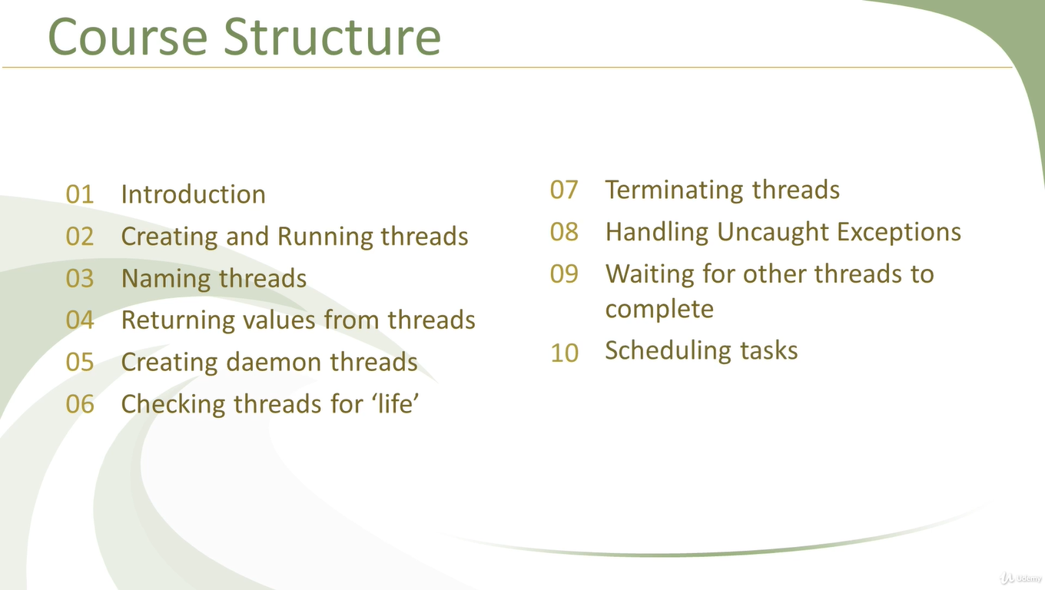

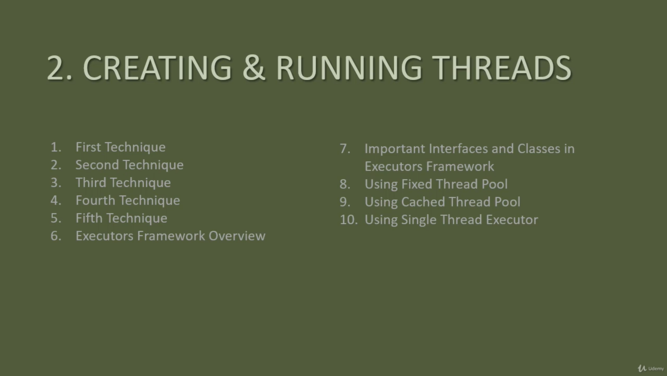

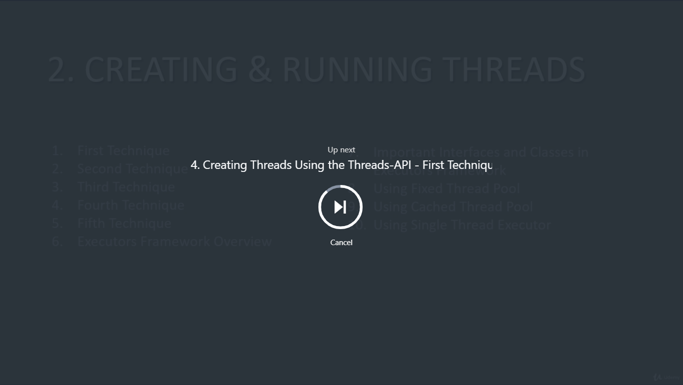

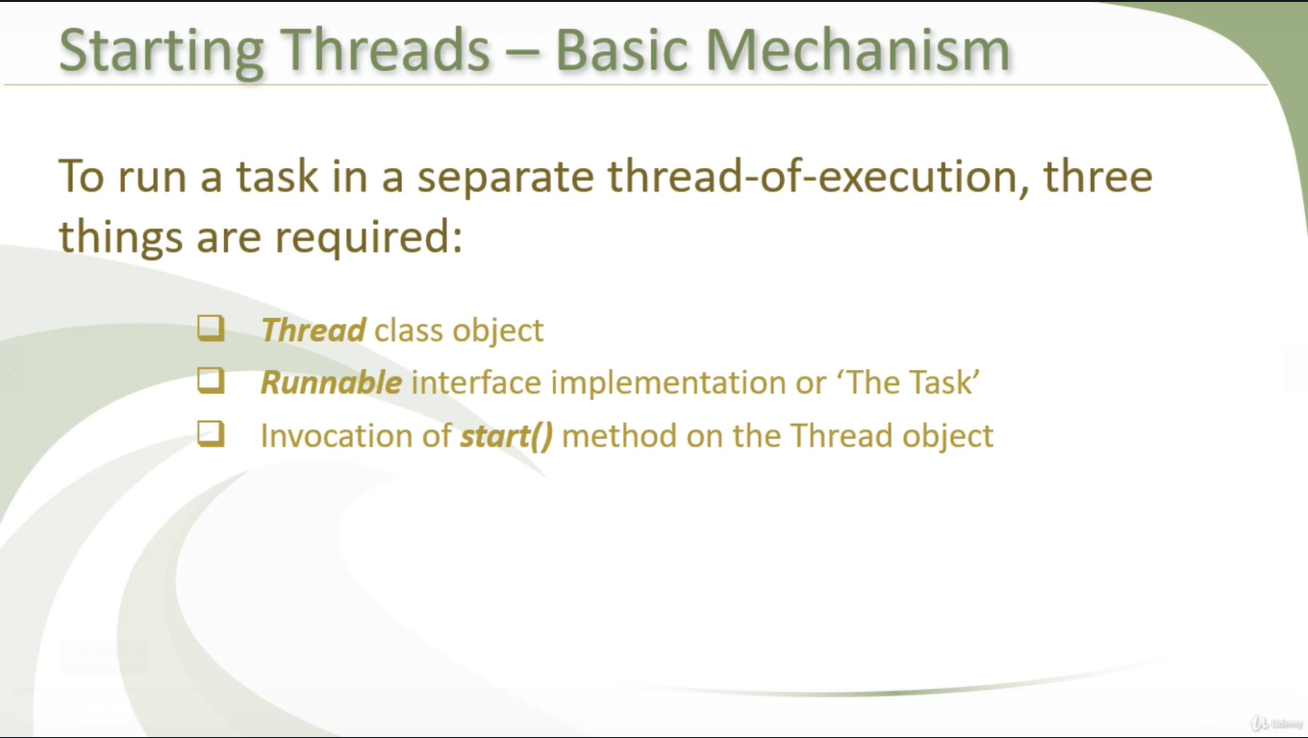

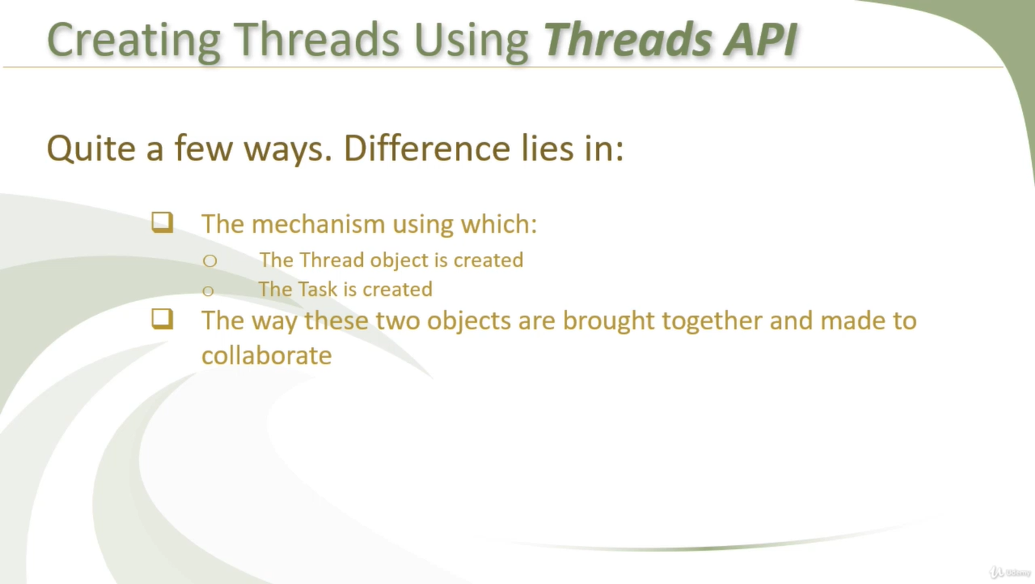

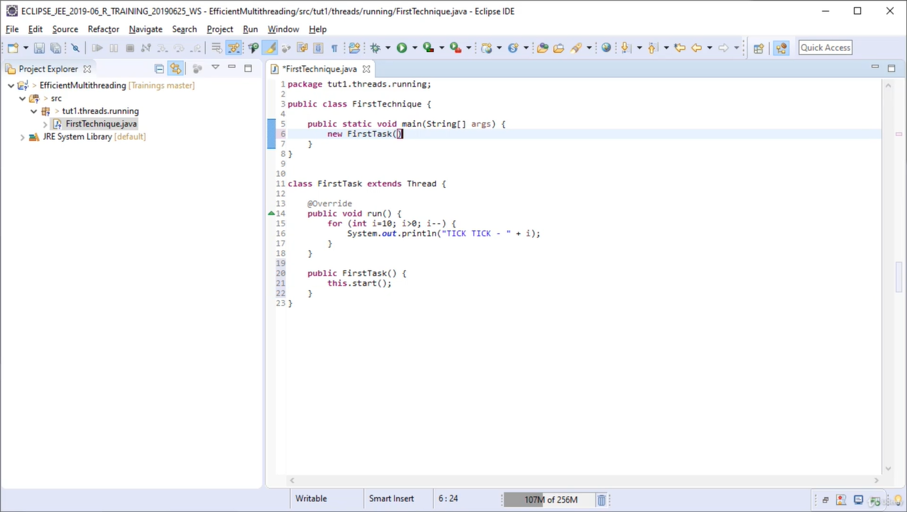

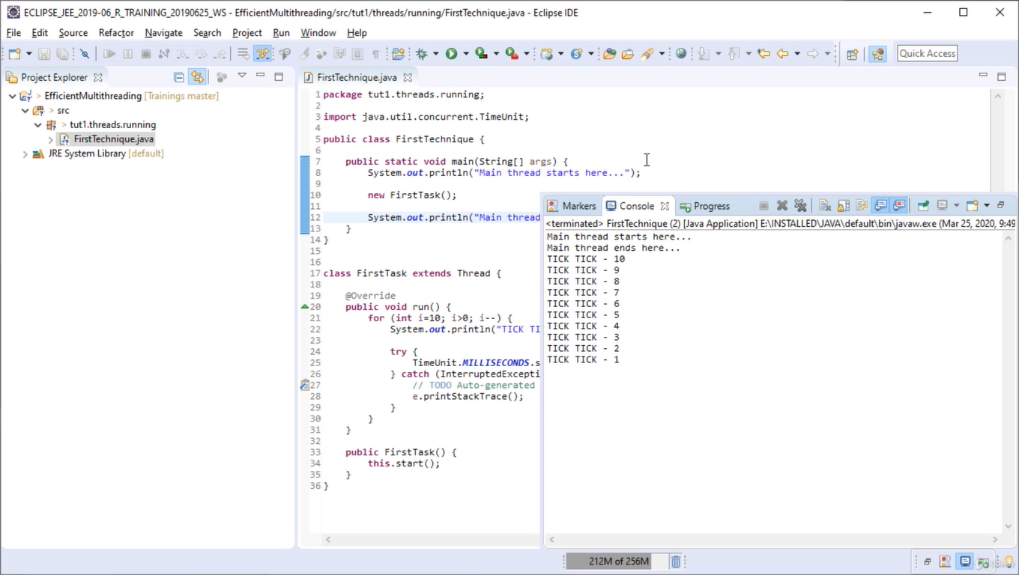

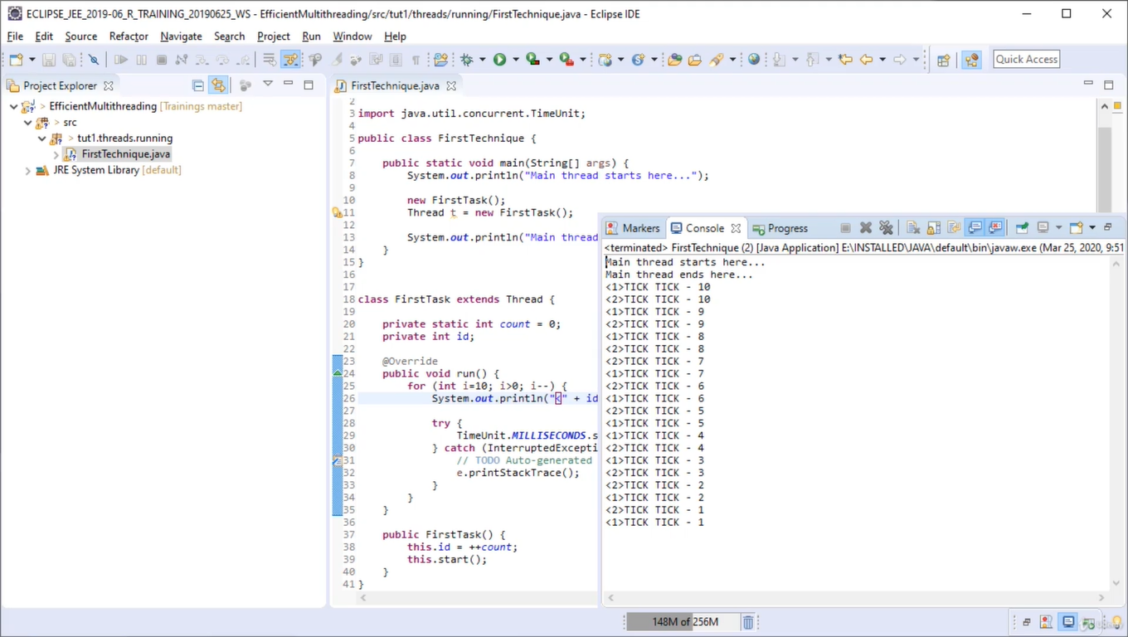

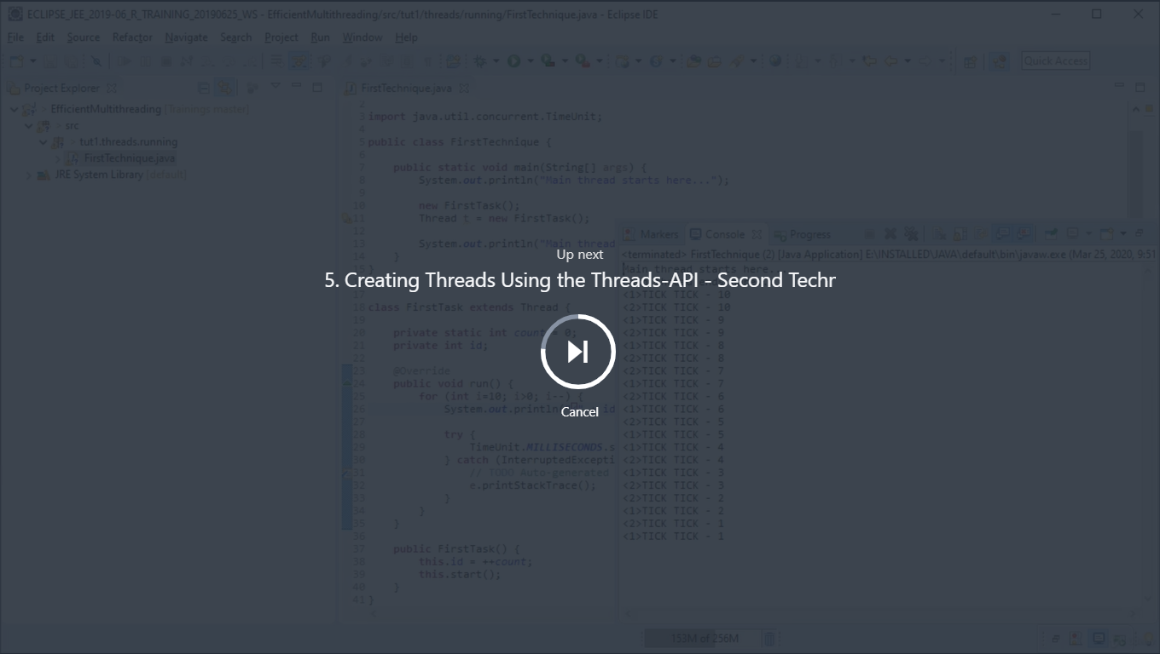

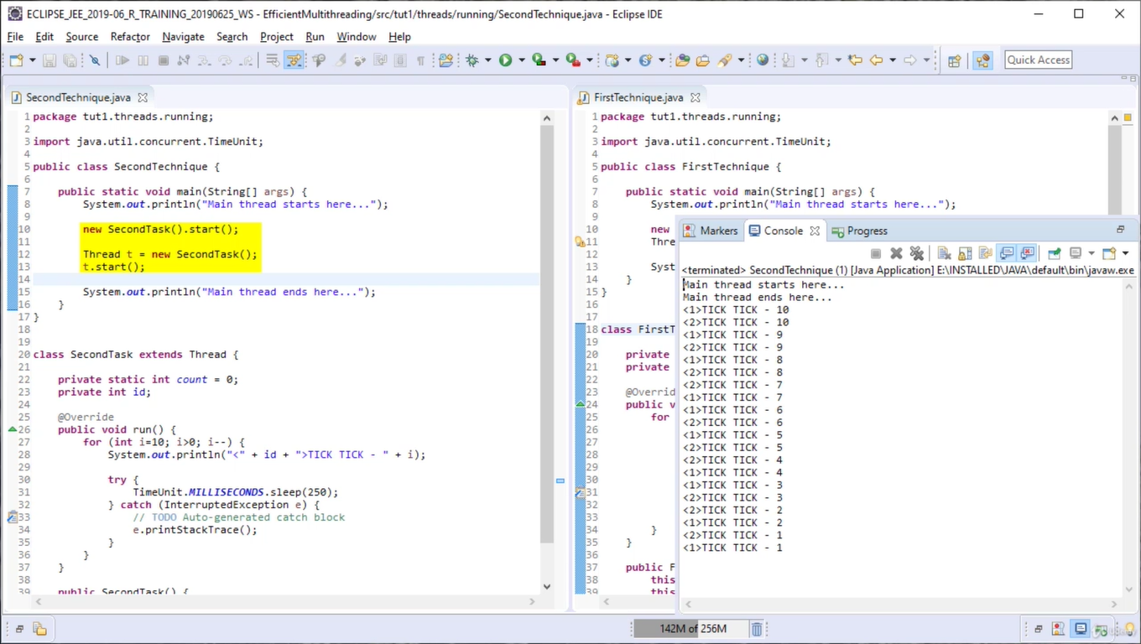

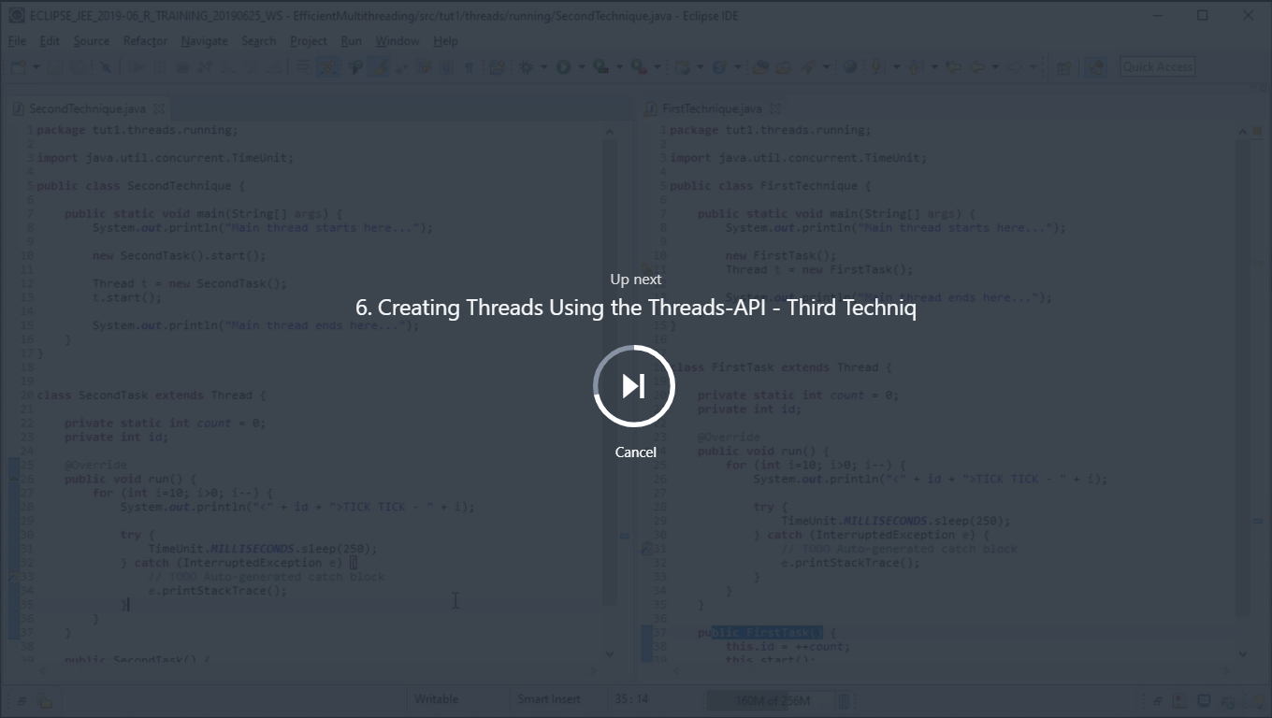

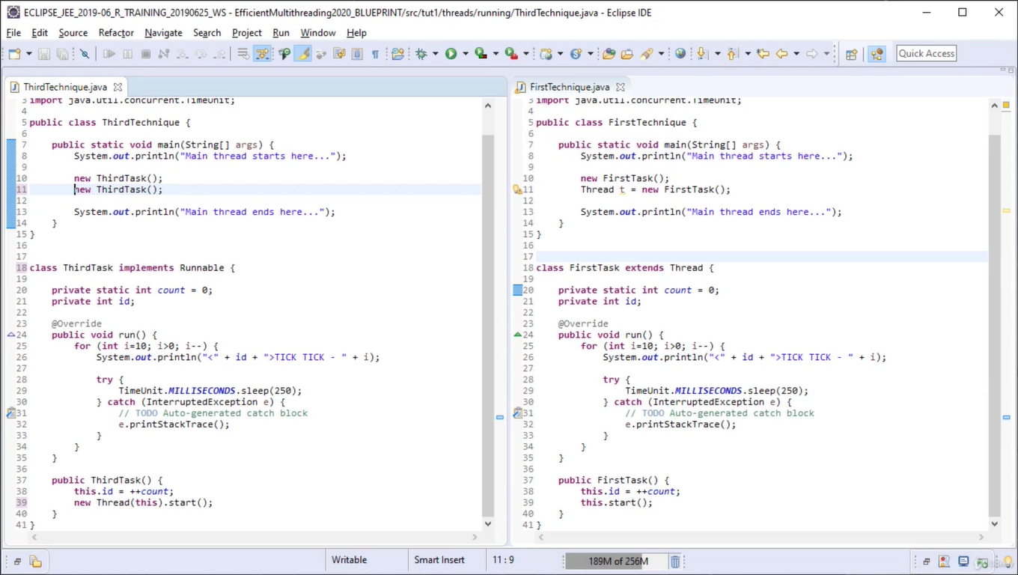

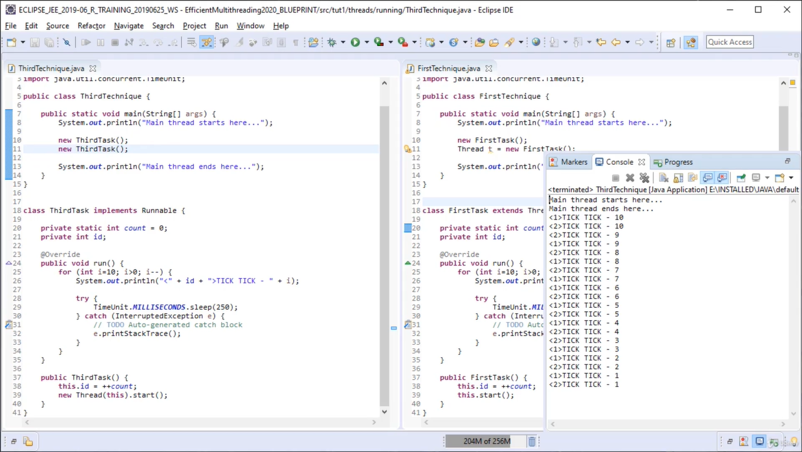

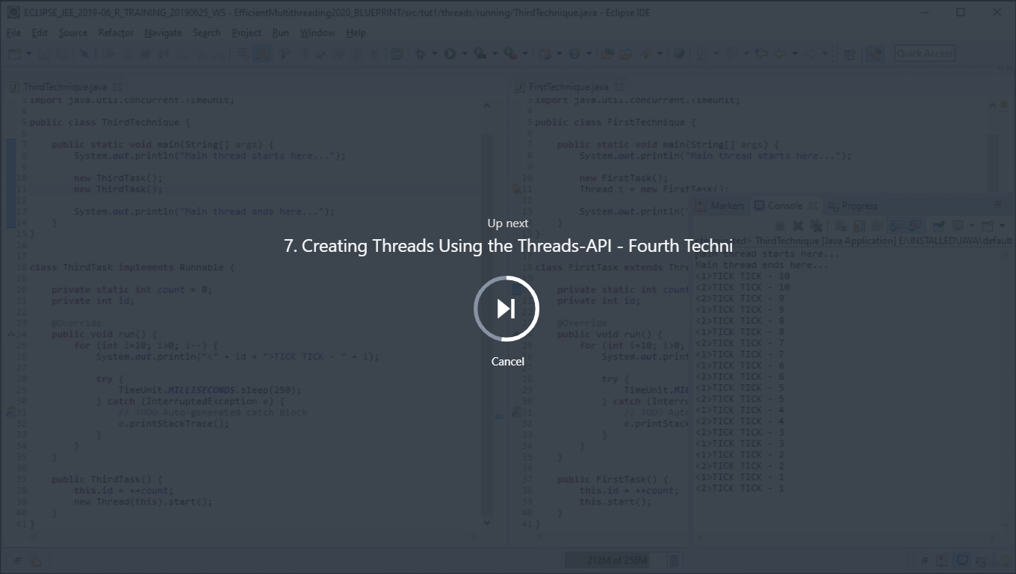

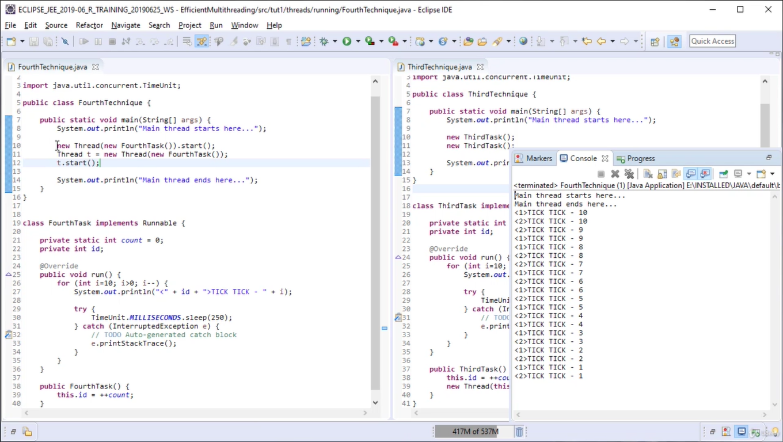

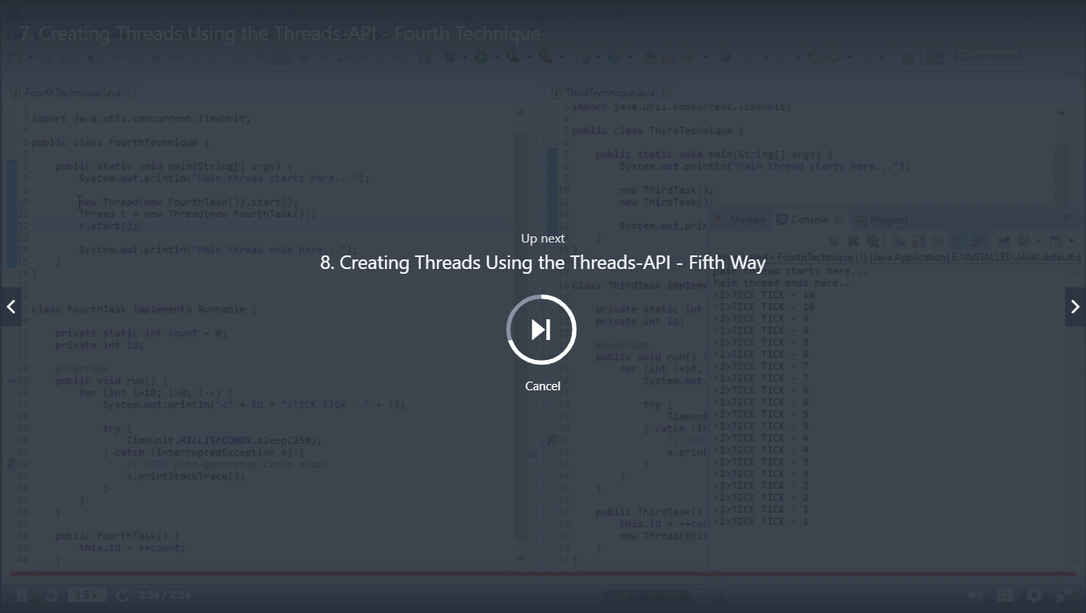

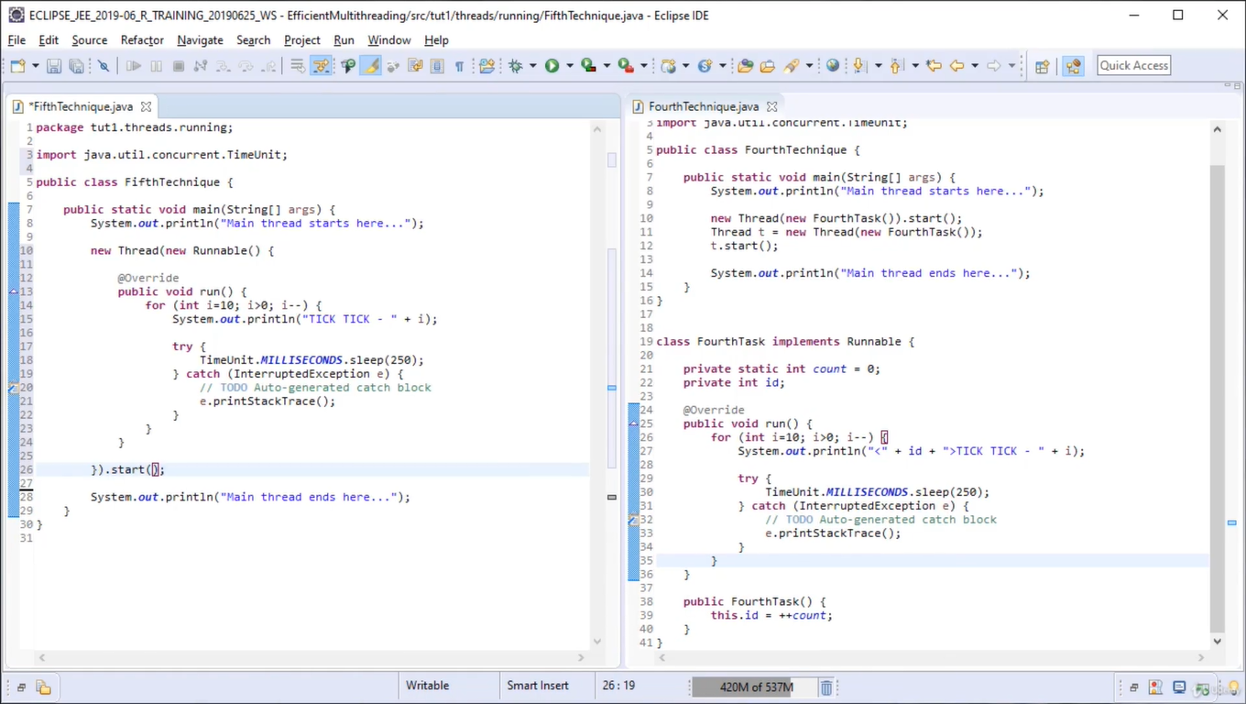

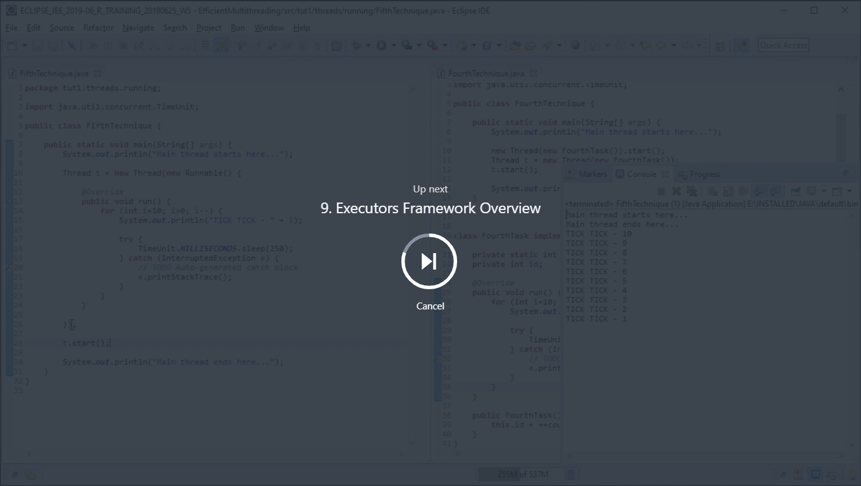

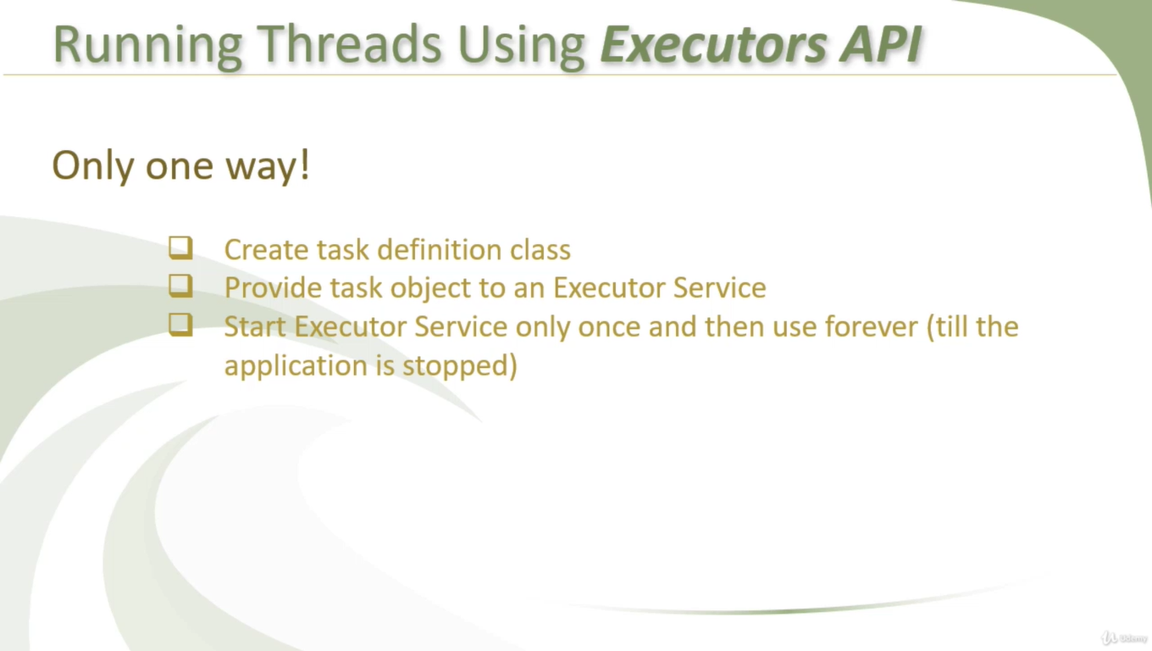

We can avoid low level coding using executor

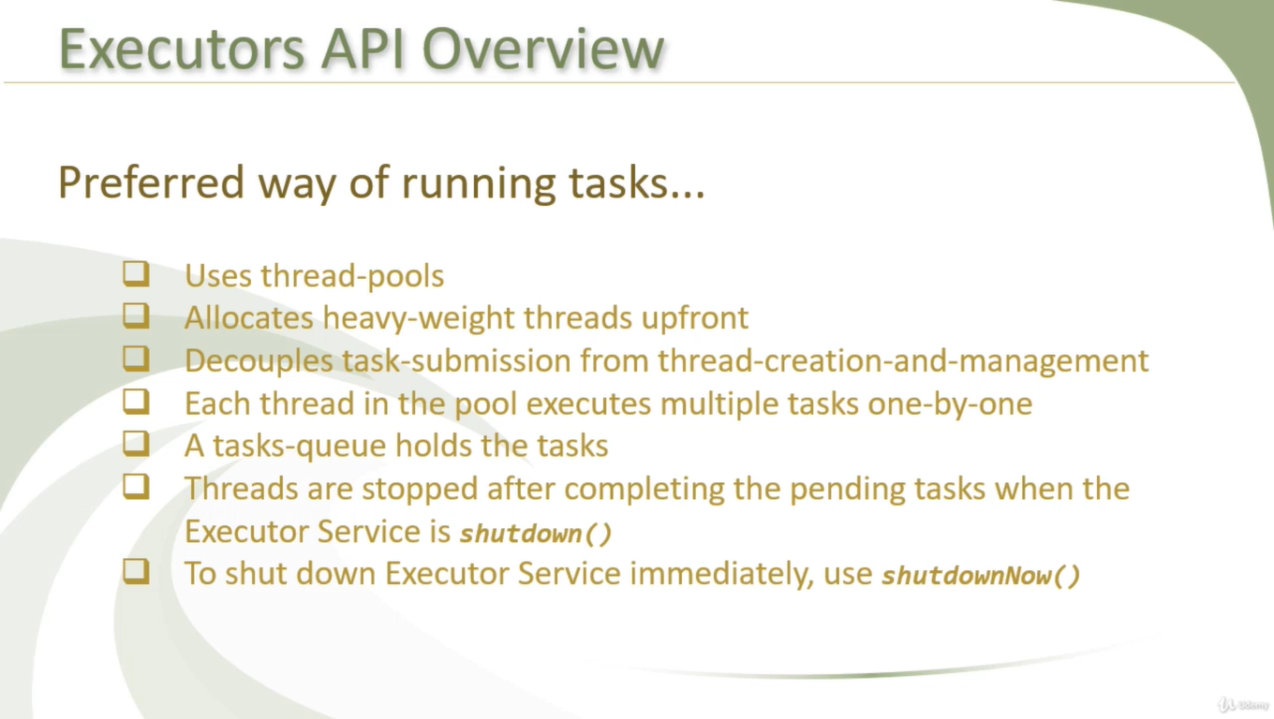

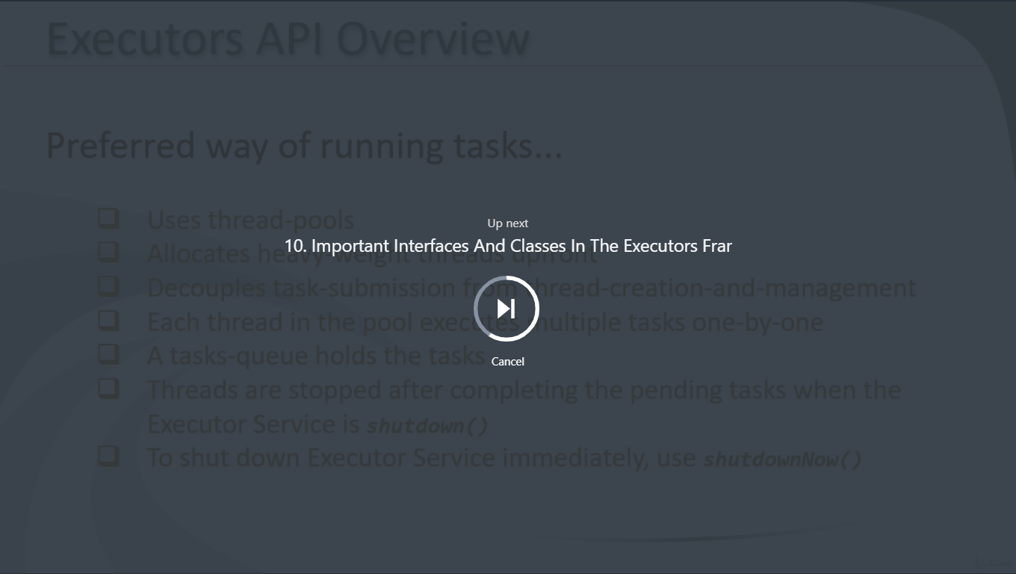

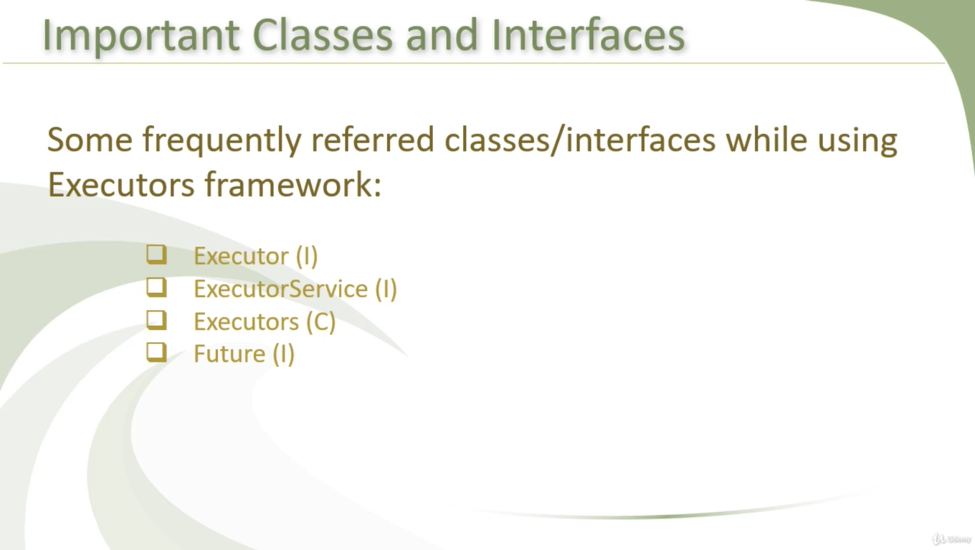

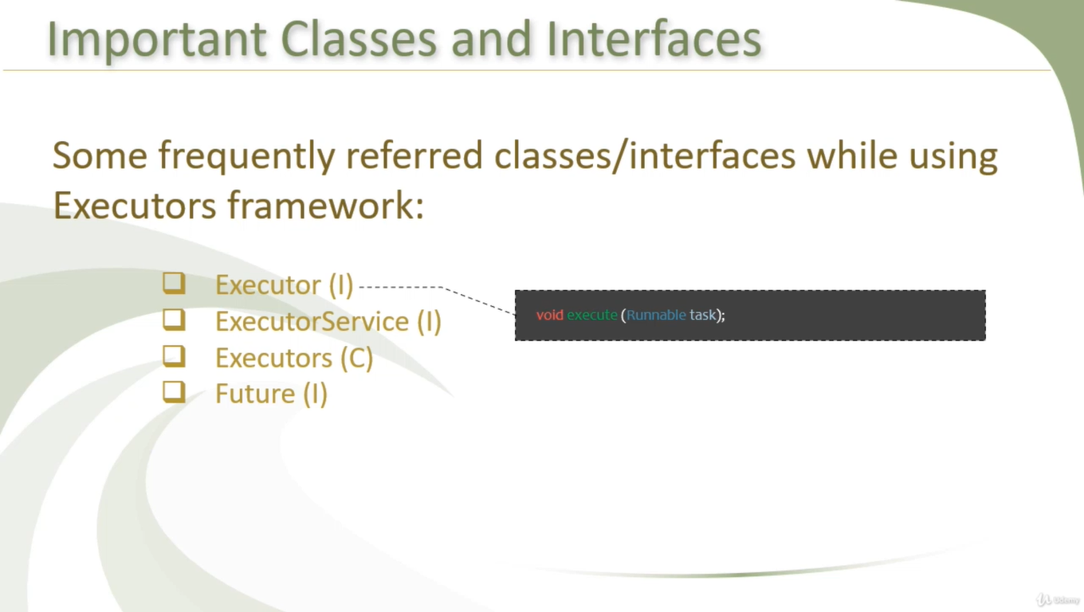

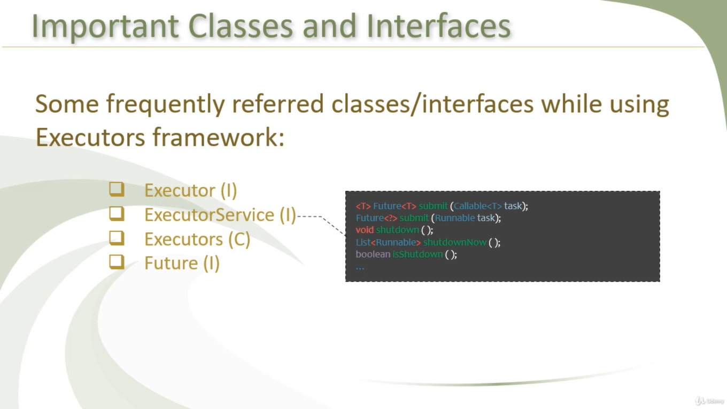

Executorservice extends executor interface

Executor service lifecycle has 3 phases :

initialization phase,

service phase (submit)

& destruction

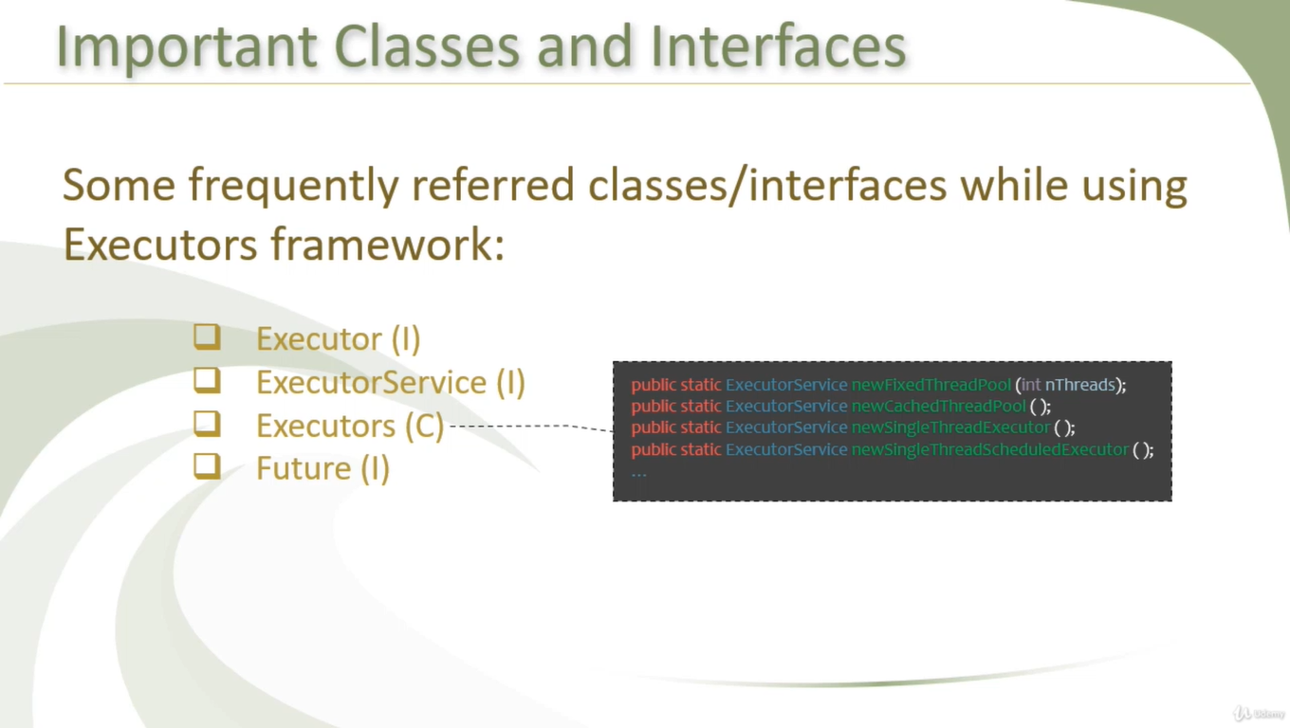

A simple way to create an executor that uses a fixed thread pool is to invoke the [newFixedThreadPool](https://docs.oracle.com/javase/8/docs/api/java/util/concurrent/Executors.html" \l "newFixedThreadPool-int-" \t "_blank) factory method in [java.util.concurrent.Executors](https://docs.oracle.com/javase/8/docs/api/java/util/concurrent/Executors.html" \t "_blank) This class also provides the following factory methods:

* The [newCachedThreadPool](https://docs.oracle.com/javase/8/docs/api/java/util/concurrent/Executors.html" \l "newCachedThreadPool-int-" \t "_blank) method creates an executor with an expandable thread pool. This executor is suitable for applications that launch many short-lived tasks.
* The [newSingleThreadExecutor](https://docs.oracle.com/javase/8/docs/api/java/util/concurrent/Executors.html" \l "newSingleThreadExecutor-int-" \t "_blank) method creates an executor that executes a single task at a time.
* Several factory methods are ScheduledExecutorService versions of the above executors.

If none of the executors provided by the above factory methods meet your needs, constructing instances of [java.util.concurrent.ThreadPoolExecutor](https://docs.oracle.com/javase/8/docs/api/java/util/concurrent/ThreadPoolExecutor.html) or [java.util.concurrent.ScheduledThreadPoolExecutor](https://docs.oracle.com/javase/8/docs/api/java/util/concurrent/ScheduledThreadPoolExecutor.html) will give you additional options.

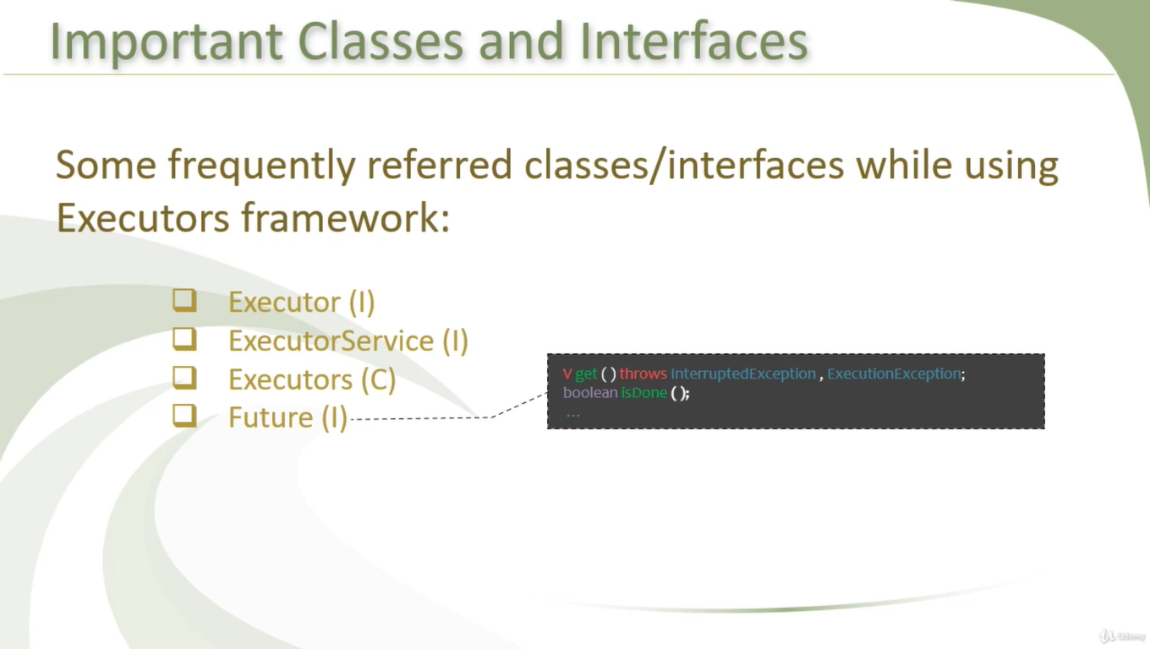

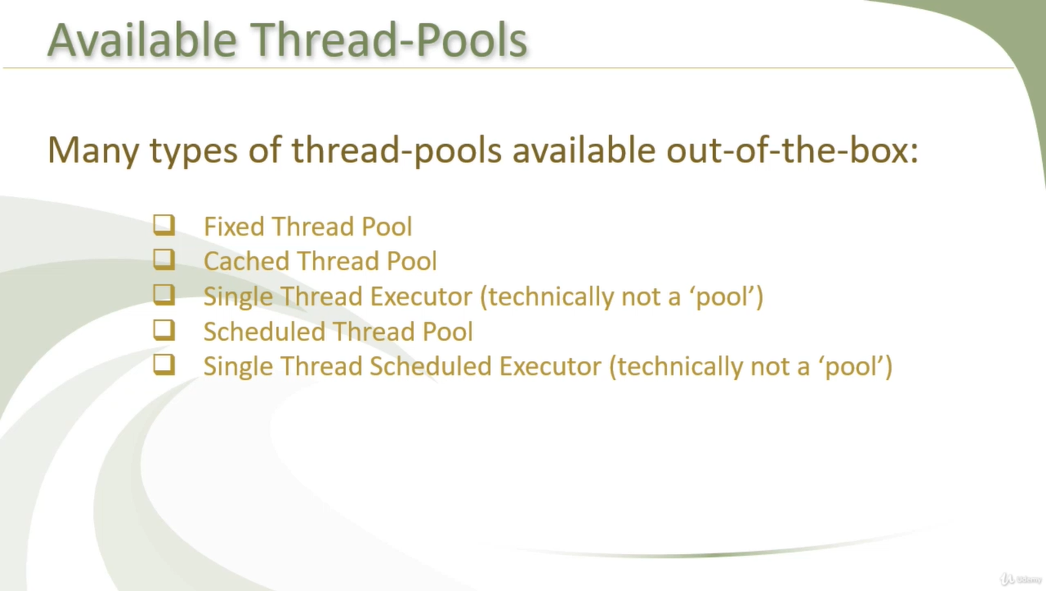

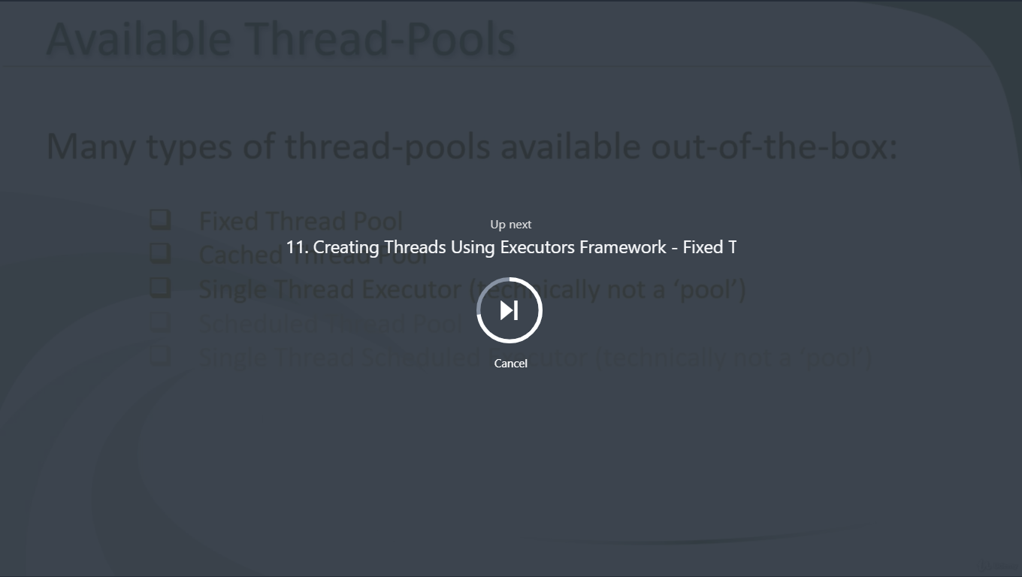

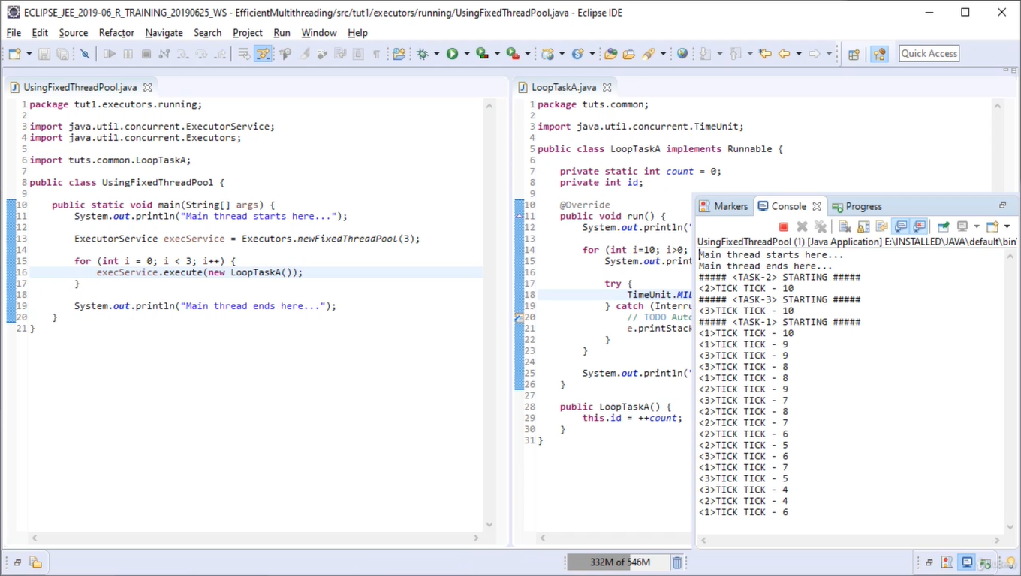

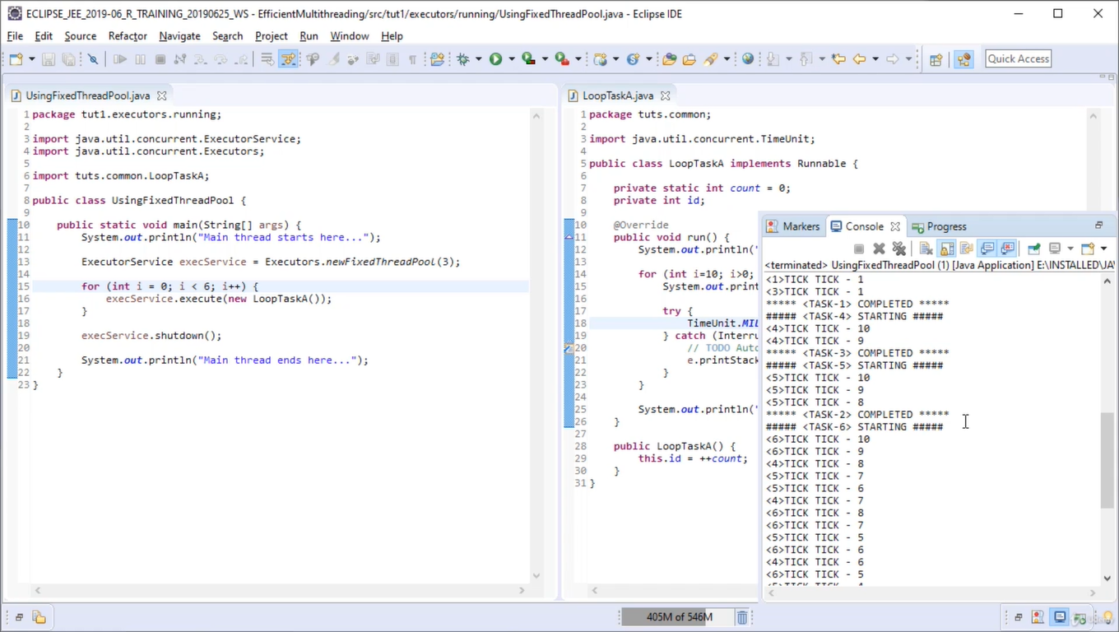

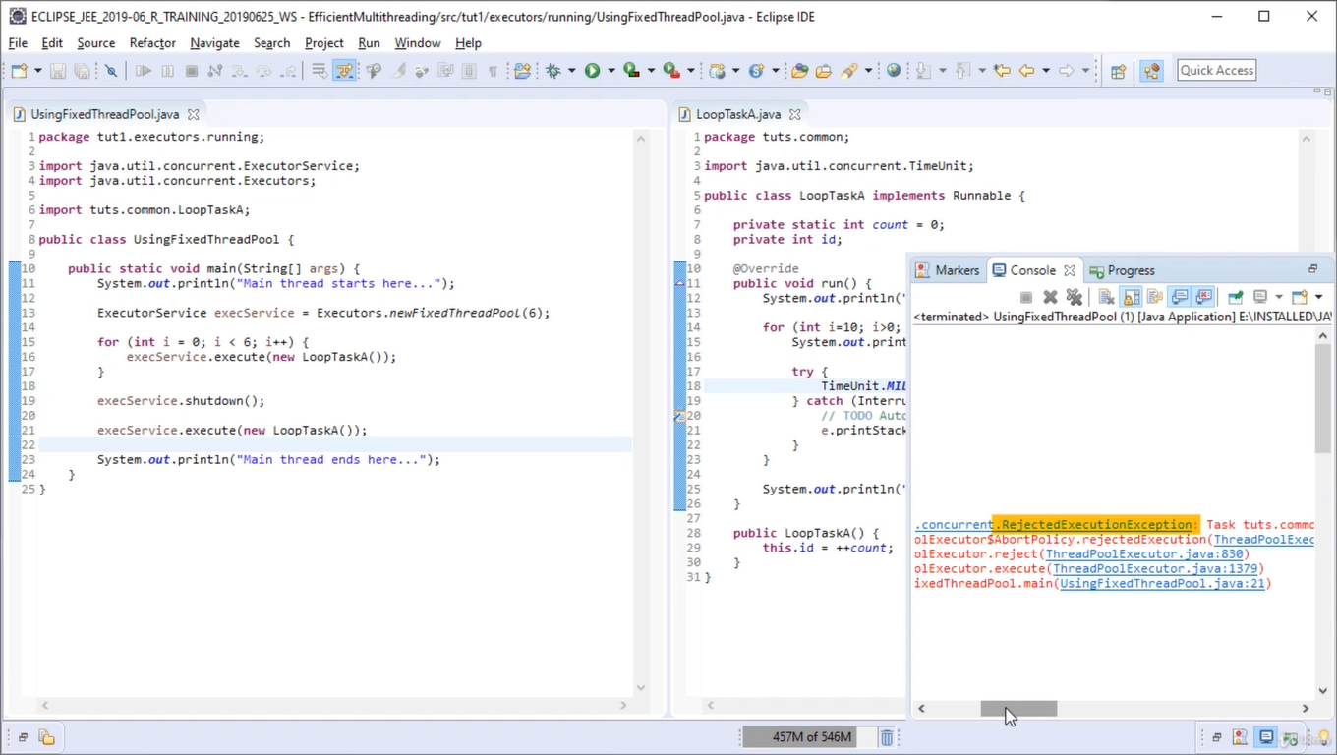

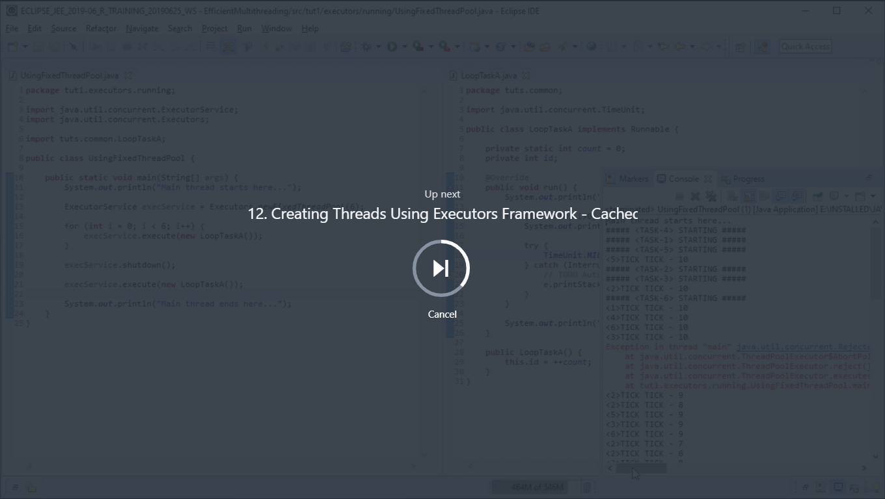

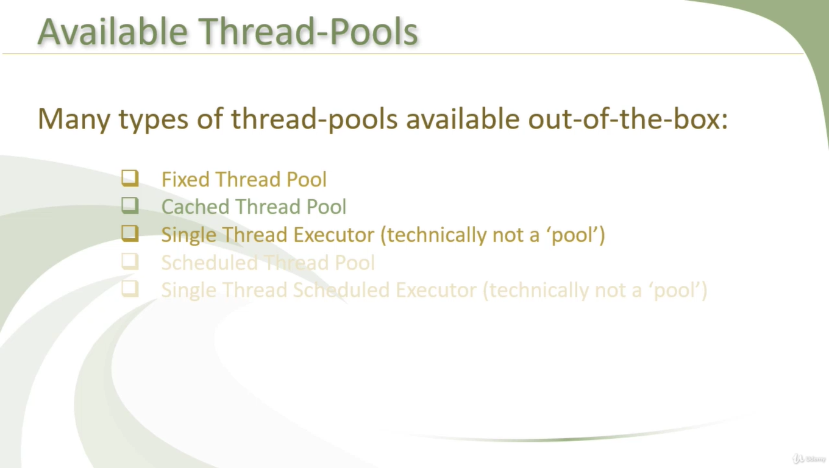

A CachedThreadPool is exactly what you should use for your situation as there are no negative consequence to using one for long running threads. The comment in the java doc about CachedThreadPools being suitable for short tasks merely suggest that they are particularly appropriate for such cases, not that they cannot or should not be used for tasks involving long running tasks.

To elaborate further, [Executors.newCachedThreadPool](http://docs.oracle.com/javase/8/docs/api/java/util/concurrent/Executors.html#newCachedThreadPool%28%29) and [Executors.newFixedThreadPool](http://docs.oracle.com/javase/8/docs/api/java/util/concurrent/Executors.html#newFixedThreadPool%28int%29) are both backed by the same thread pool implementation (at least in the open JDK) just with different parameters. The differences just being their thread minimum, maximum, thread kill time, and queue type.

public static ExecutorService newFixedThreadPool(int nThreads) {

return new ThreadPoolExecutor(nThreads, nThreads,

0L, TimeUnit.MILLISECONDS,

new LinkedBlockingQueue<Runnable>());

}

public static ExecutorService newCachedThreadPool() {

return new ThreadPoolExecutor(0, Integer.MAX\_VALUE,

60L, TimeUnit.SECONDS,

new SynchronousQueue<Runnable>());

}

A FixedThreadPool does have its advantages when you do in fact want to work with a fixed number of threads, since then you can submit any number of tasks to the executor service while knowing that the number of threads will be maintained at the level you specified. If you explicitly want to grow the number of threads, then this is not the appropriate choice.

This does however mean that the one issue that you may have with the CachedThreadPool is in regards to limiting the number of threads that are running concurrently. The CachedThreadPool will not limit them for you, so you may need to write your own code to ensure that you do not run too many threads. This really depends on the design of your application and how tasks are submitted to the executor service.

the **SynchronousQueue** is more of a handoff, whereas the **LinkedBlockingQueue** just allows a single element. The difference being that the put() call to a SynchronousQueue *will not return* until there is a corresponding take() call, but with a LinkedBlockingQueue of size 1, the put() call (to an empty queue) will return immediately.

I can't say that i have ever used the SynchronousQueue directly myself, but it is the default BlockingQueue used for the Executors.newCachedThreadPool() methods. It's essentially the BlockingQueue implementation for when you don't *really* want a queue (you don't want to maintain any pending data).

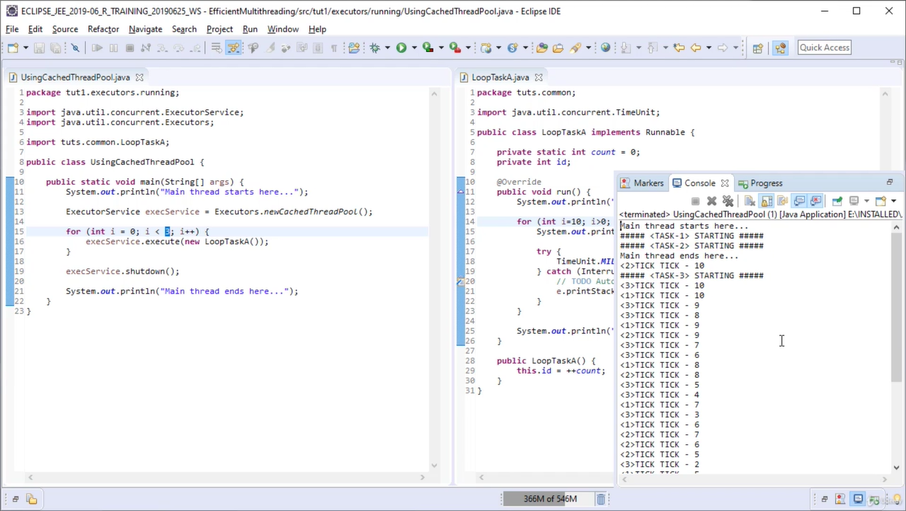

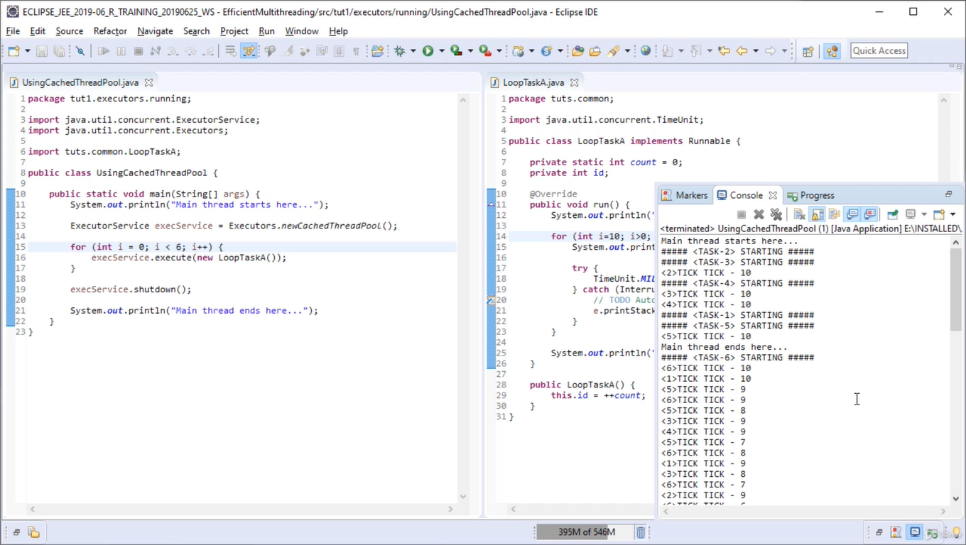

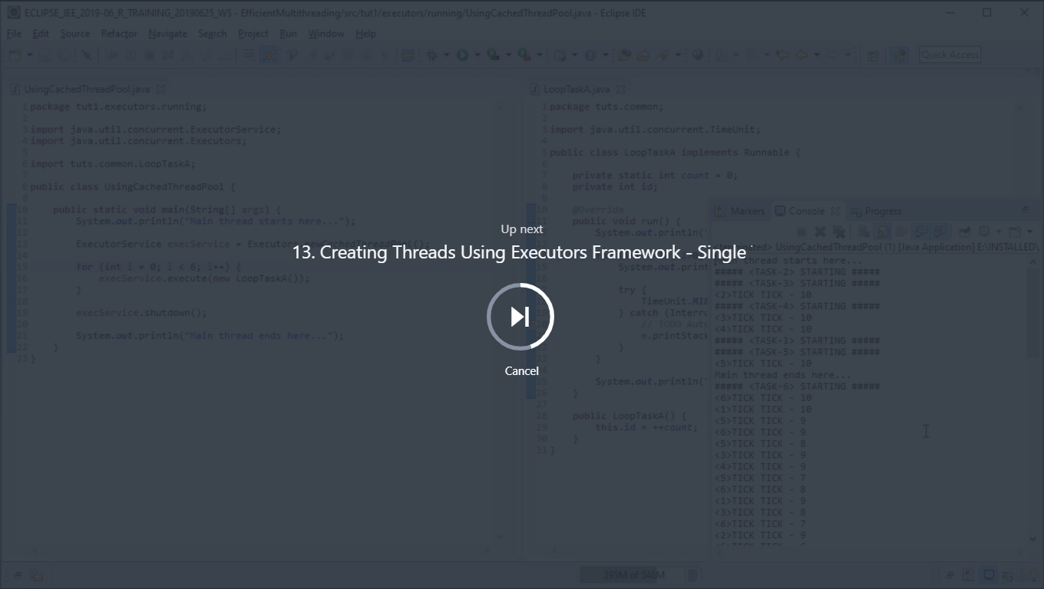

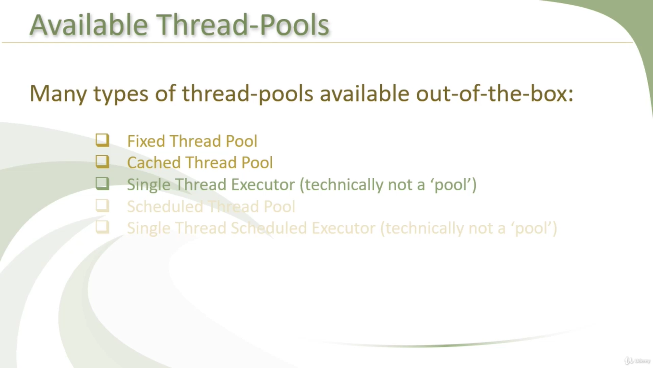

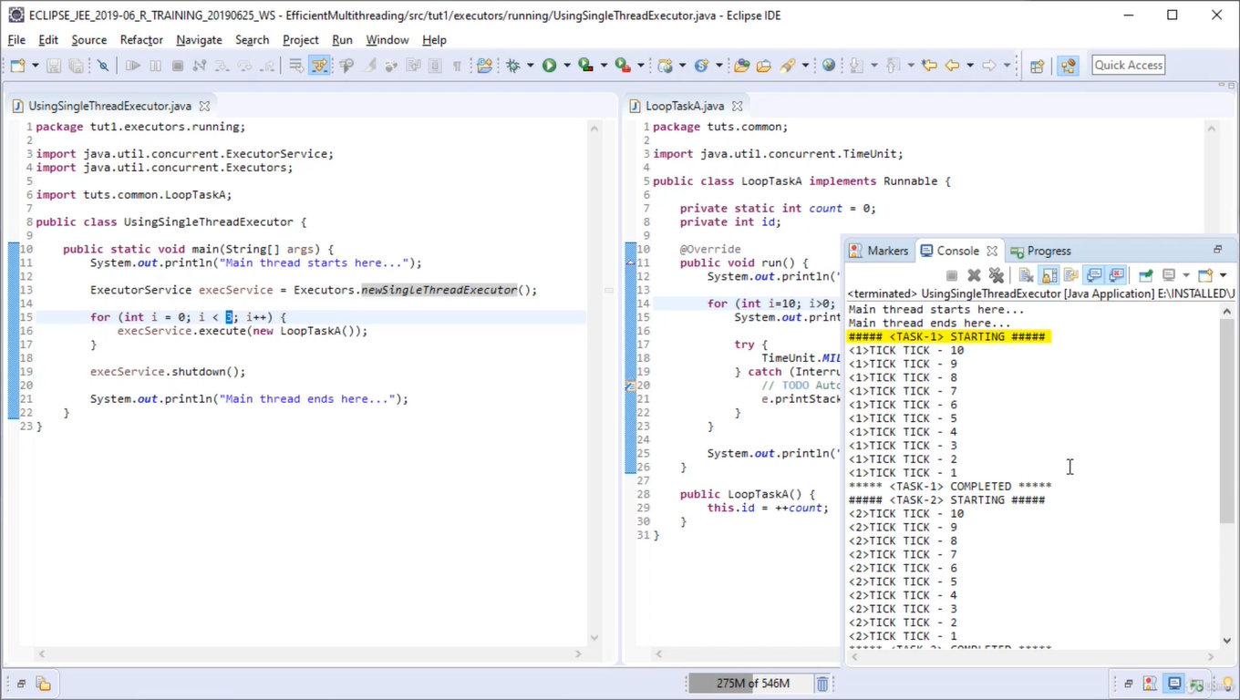

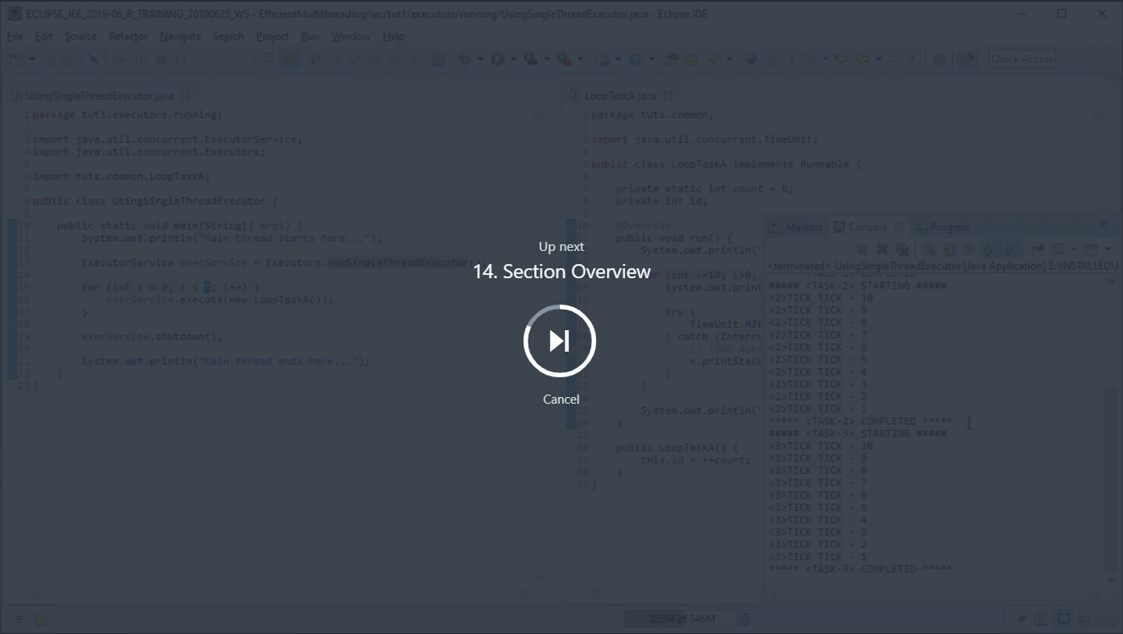



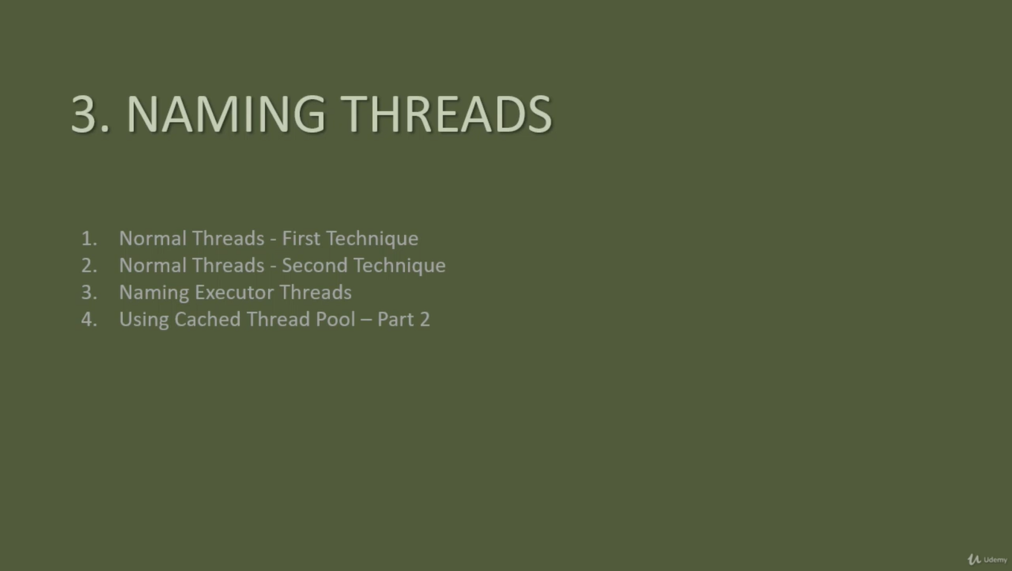

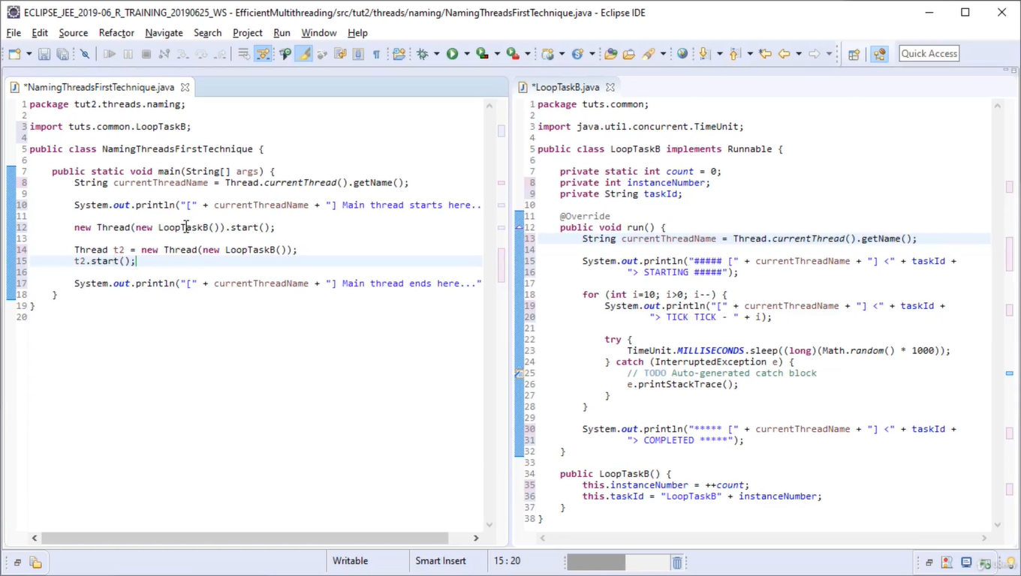

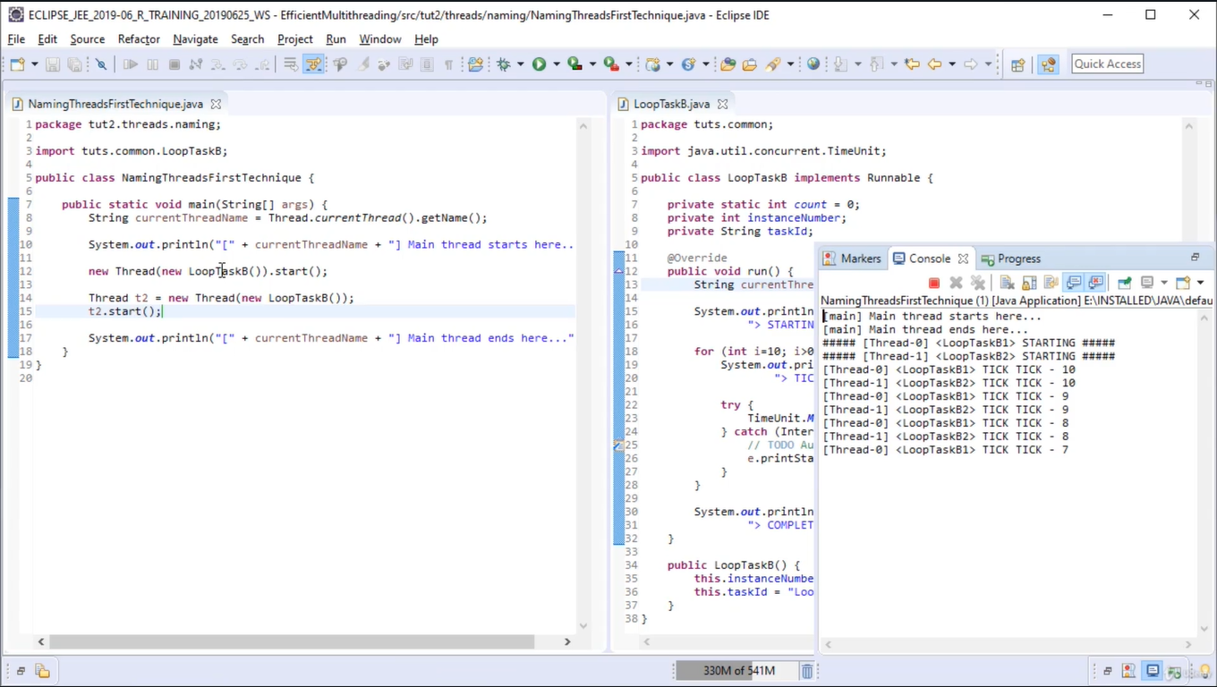

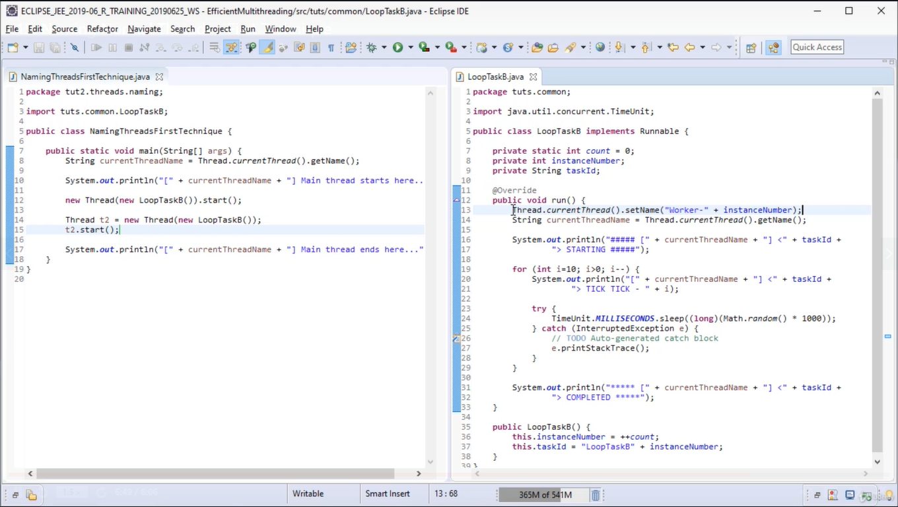

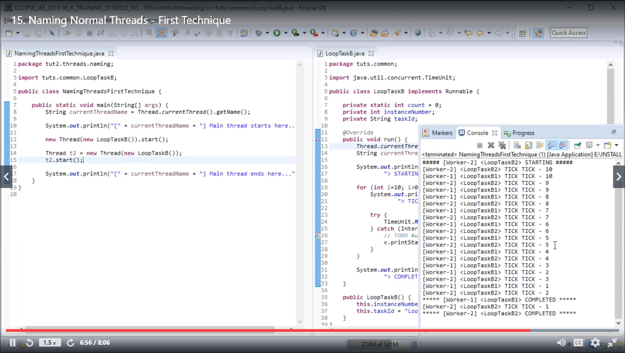

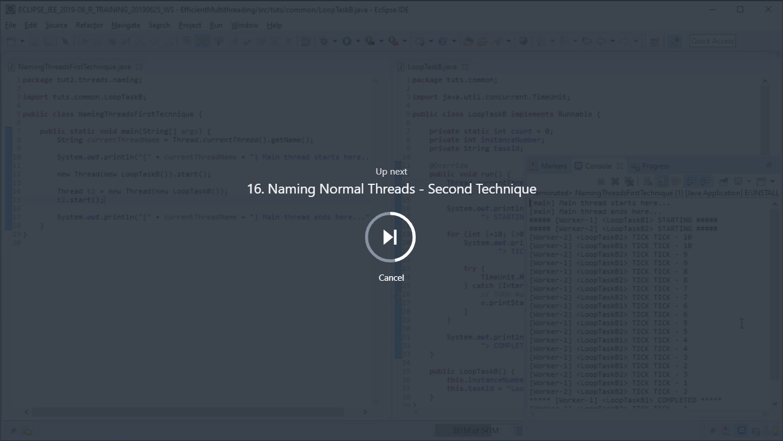

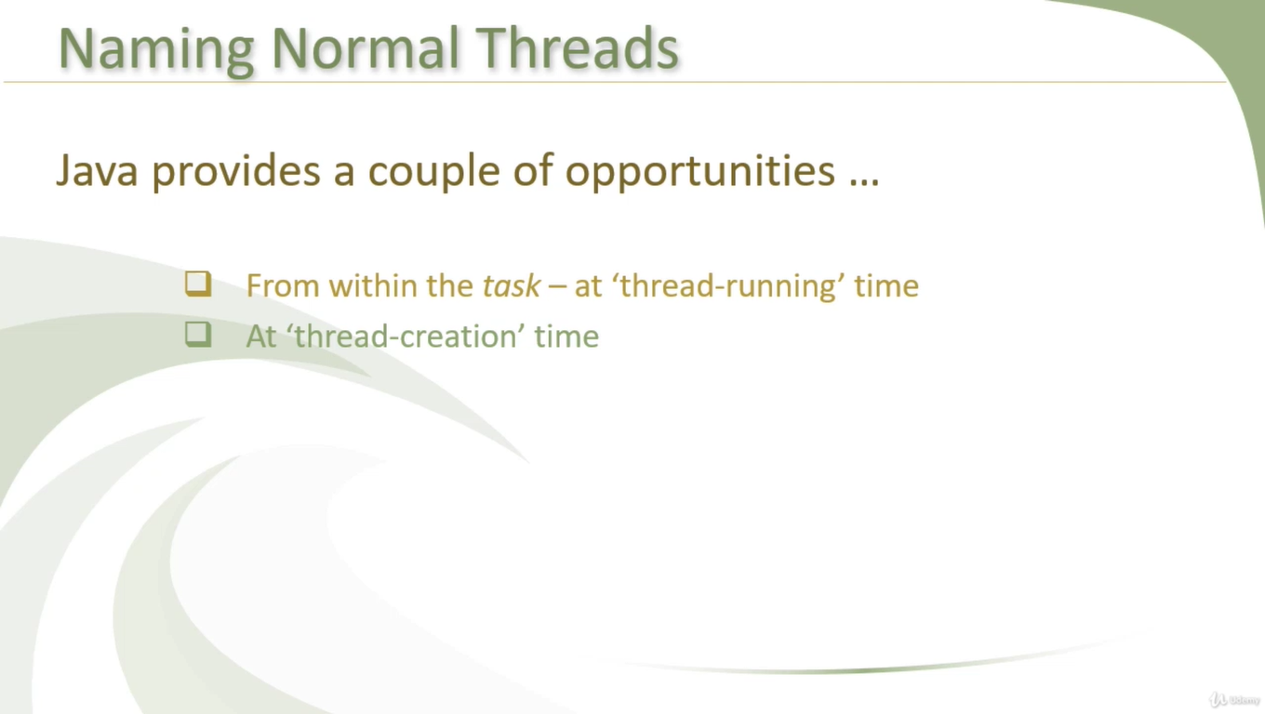

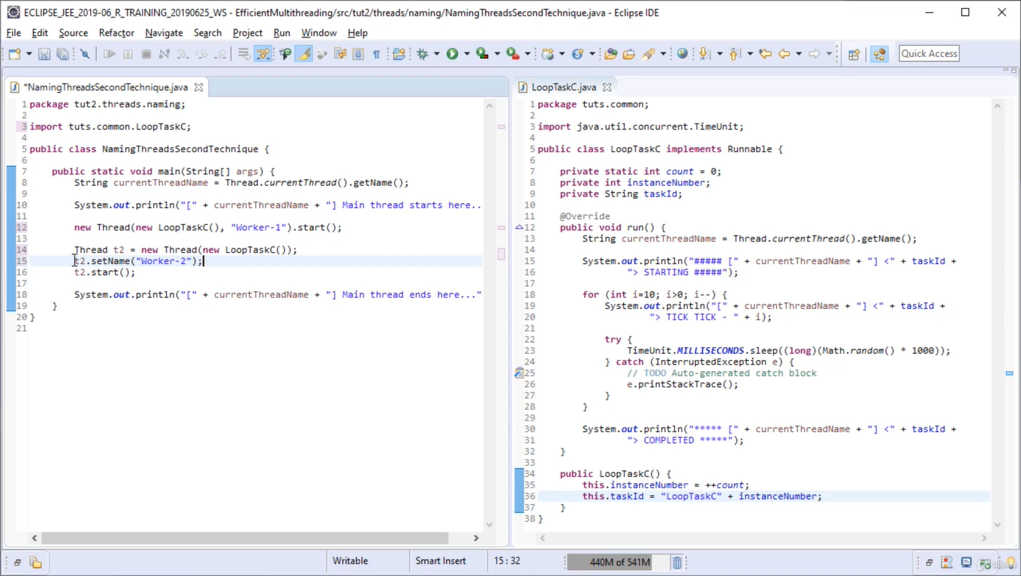

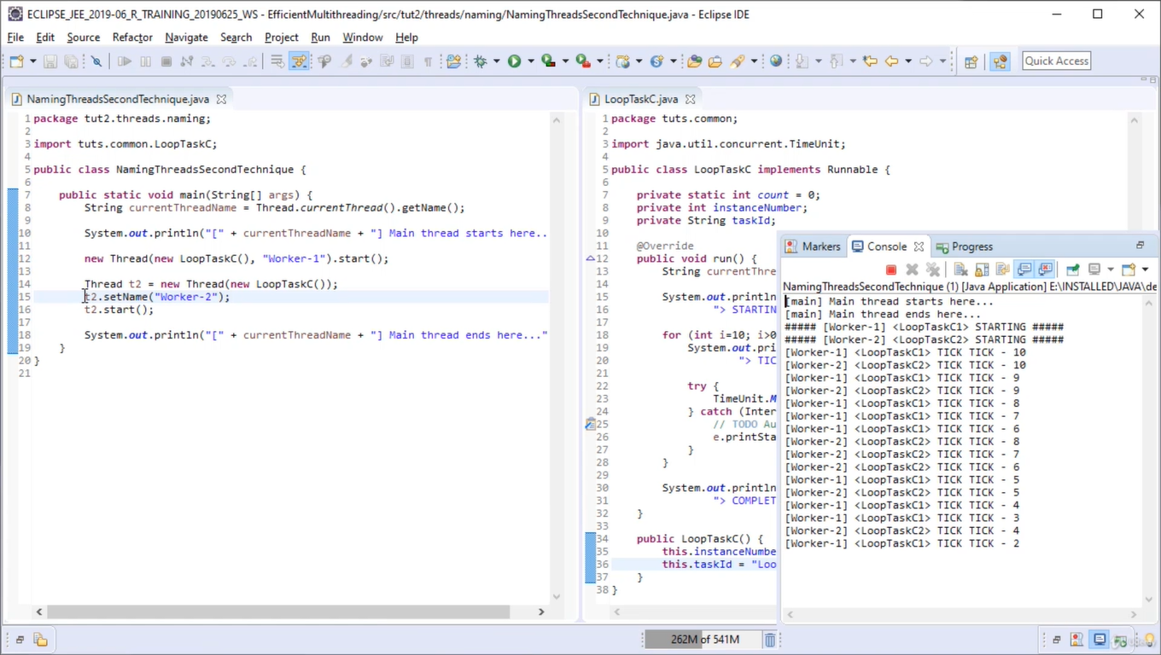

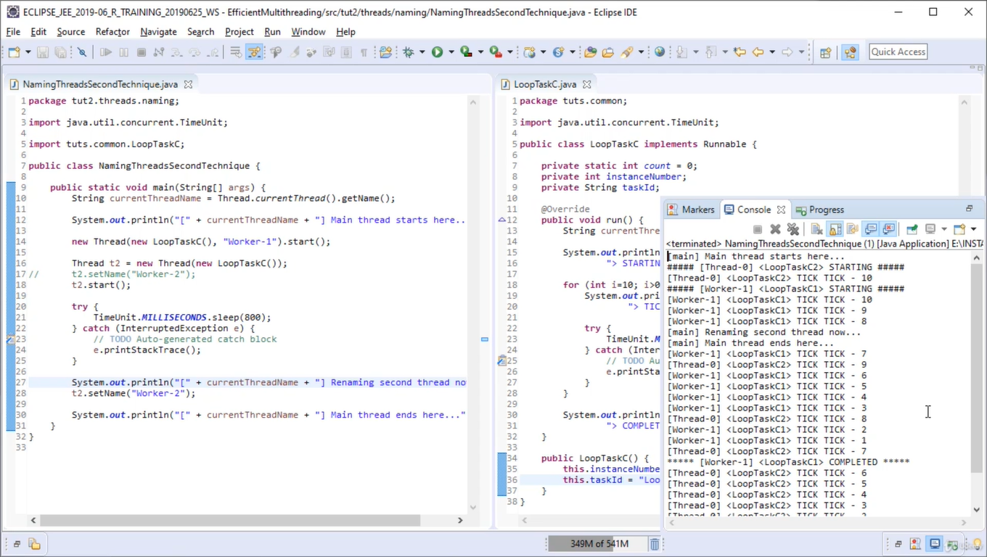

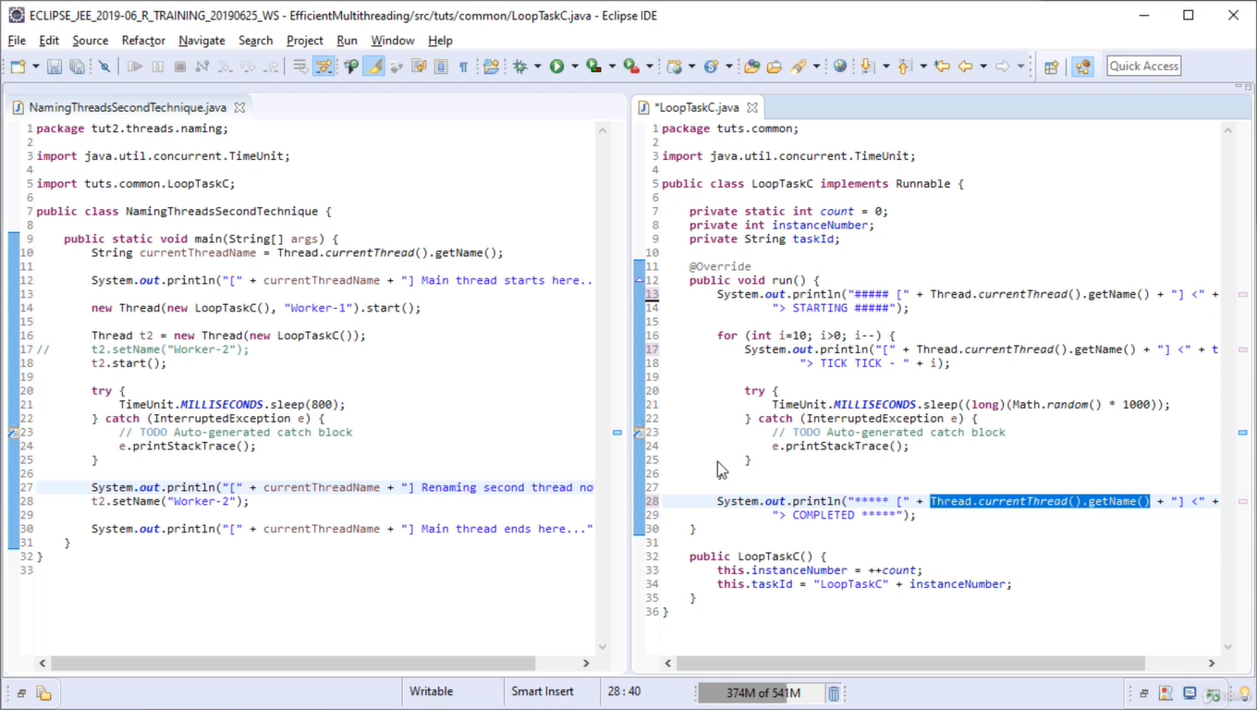

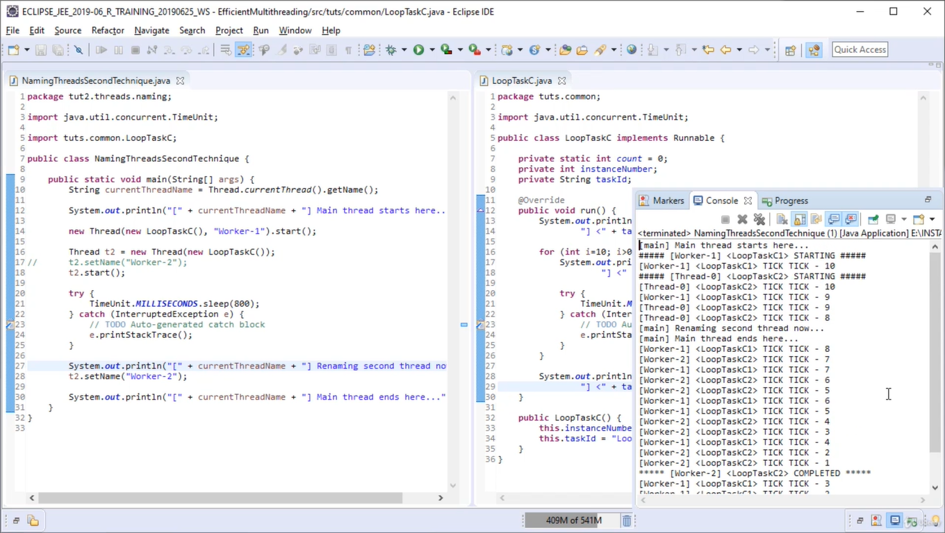

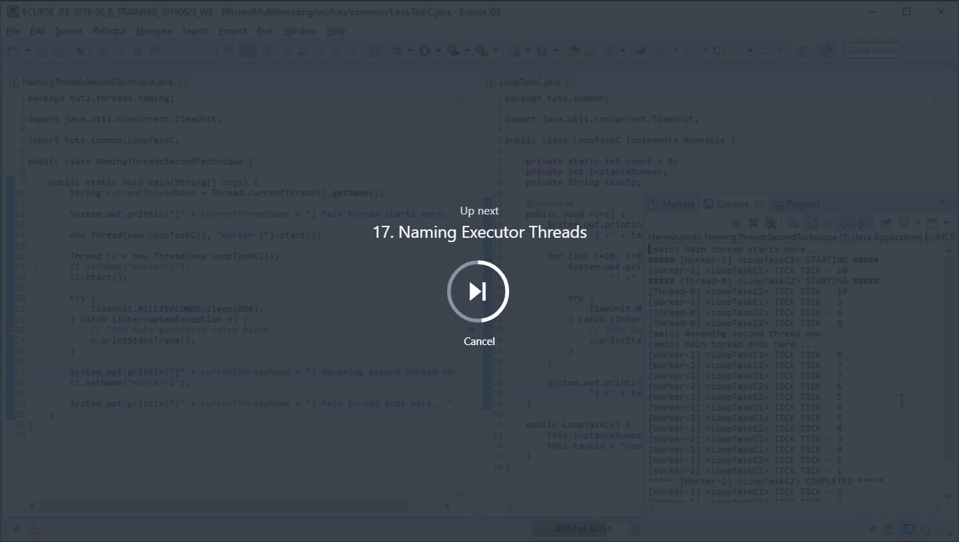

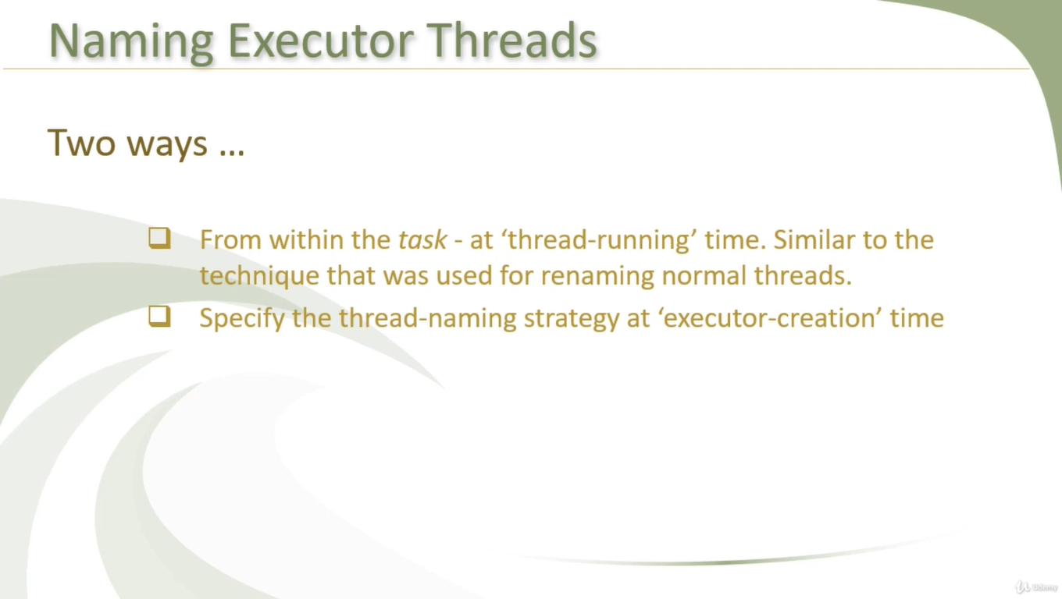

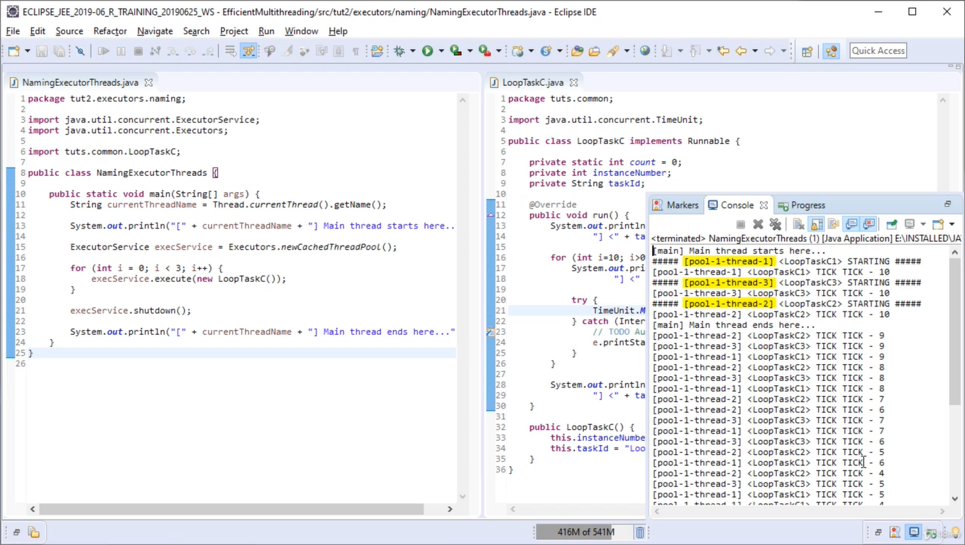

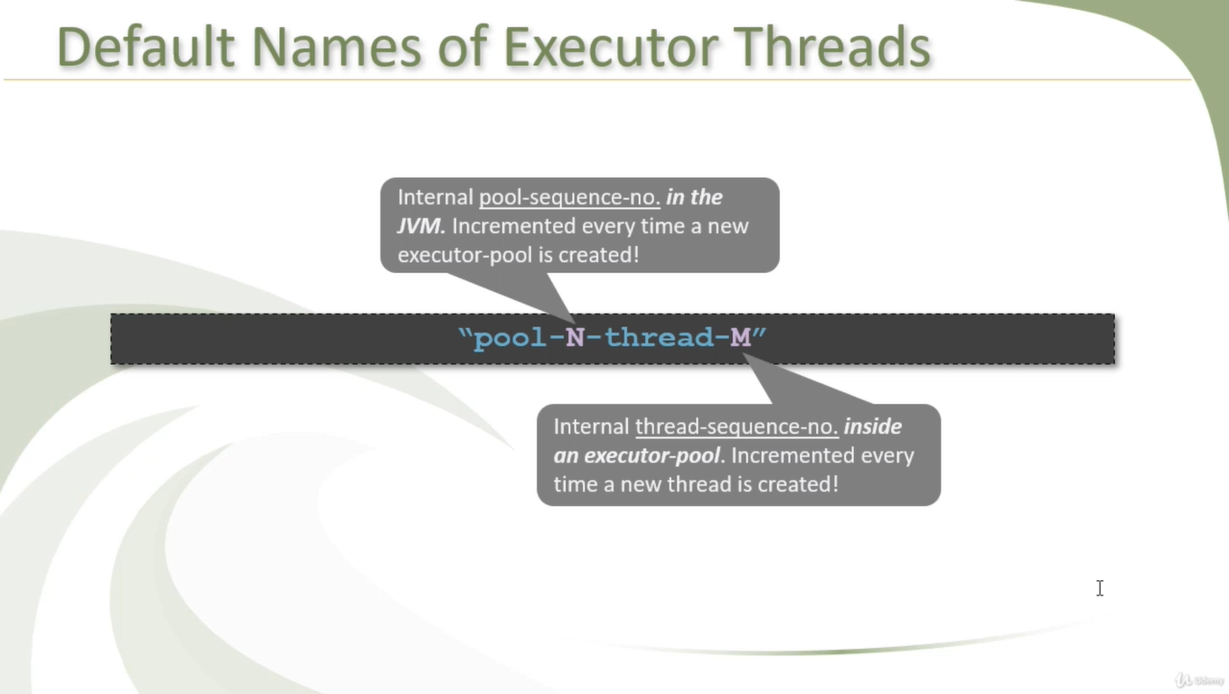

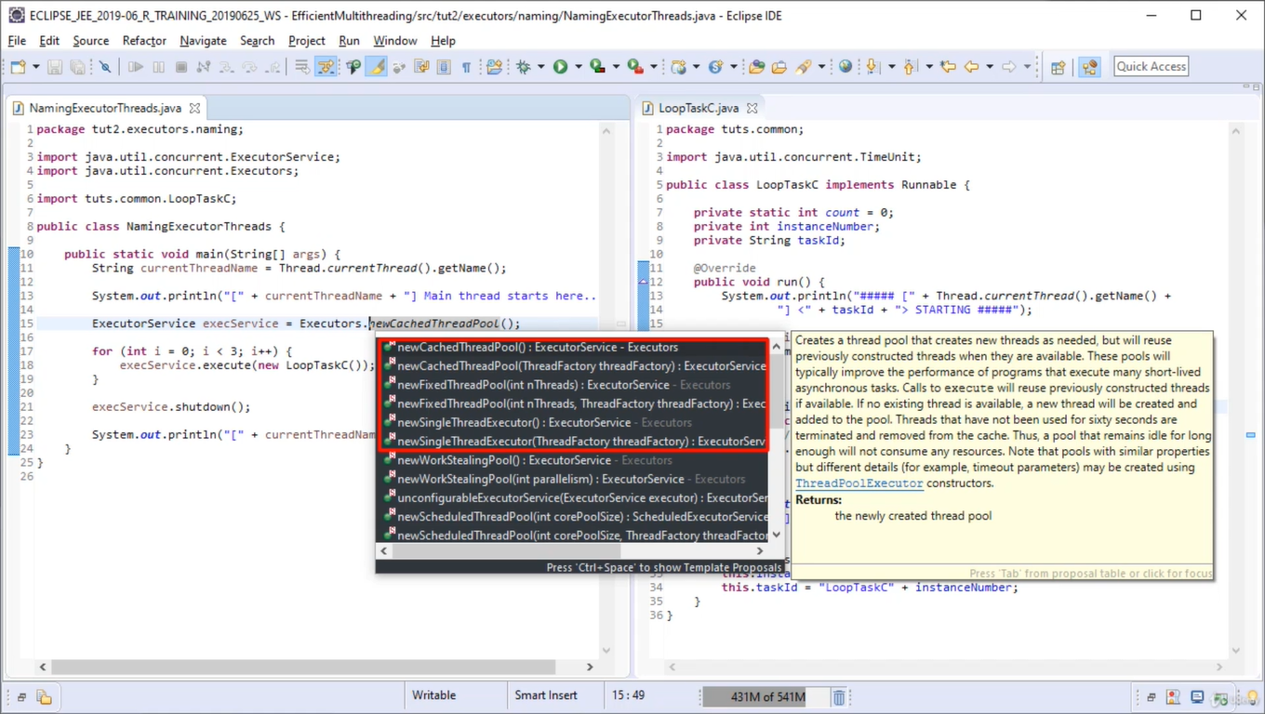

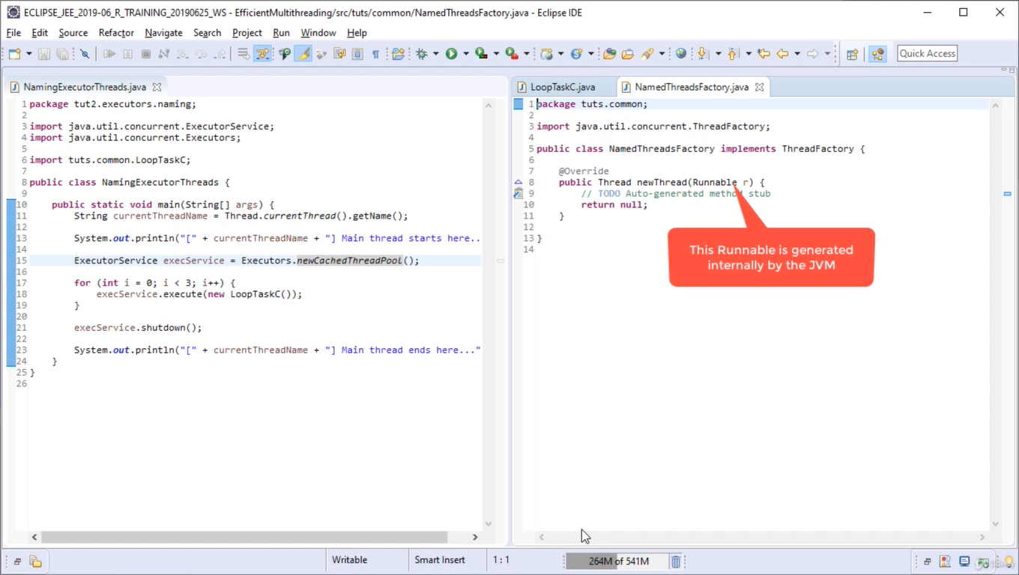

/\*\*

\* Returns a default thread factory used to create new threads.

\* This factory creates all new threads used by an Executor in the

\* same {@link ThreadGroup}. If there is a {@link

\* java.lang.SecurityManager}, it uses the group of {@link

\* System#getSecurityManager}, else the group of the thread

\* invoking this {@code defaultThreadFactory} method. Each new

\* thread is created as a non-daemon thread with priority set to

\* the smaller of {@code Thread.NORM\_PRIORITY} and the maximum

\* priority permitted in the thread group. New threads have names

\* accessible via {@link Thread#getName} of

\* <em>pool-N-thread-M</em>, where <em>N</em> is the sequence

\* number of this factory, and <em>M</em> is the sequence number

\* of the thread created by this factory.

\* **@return** a thread factory

\*/

**public** **static** ThreadFactory defaultThreadFactory() {

**return** **new** DefaultThreadFactory();

}

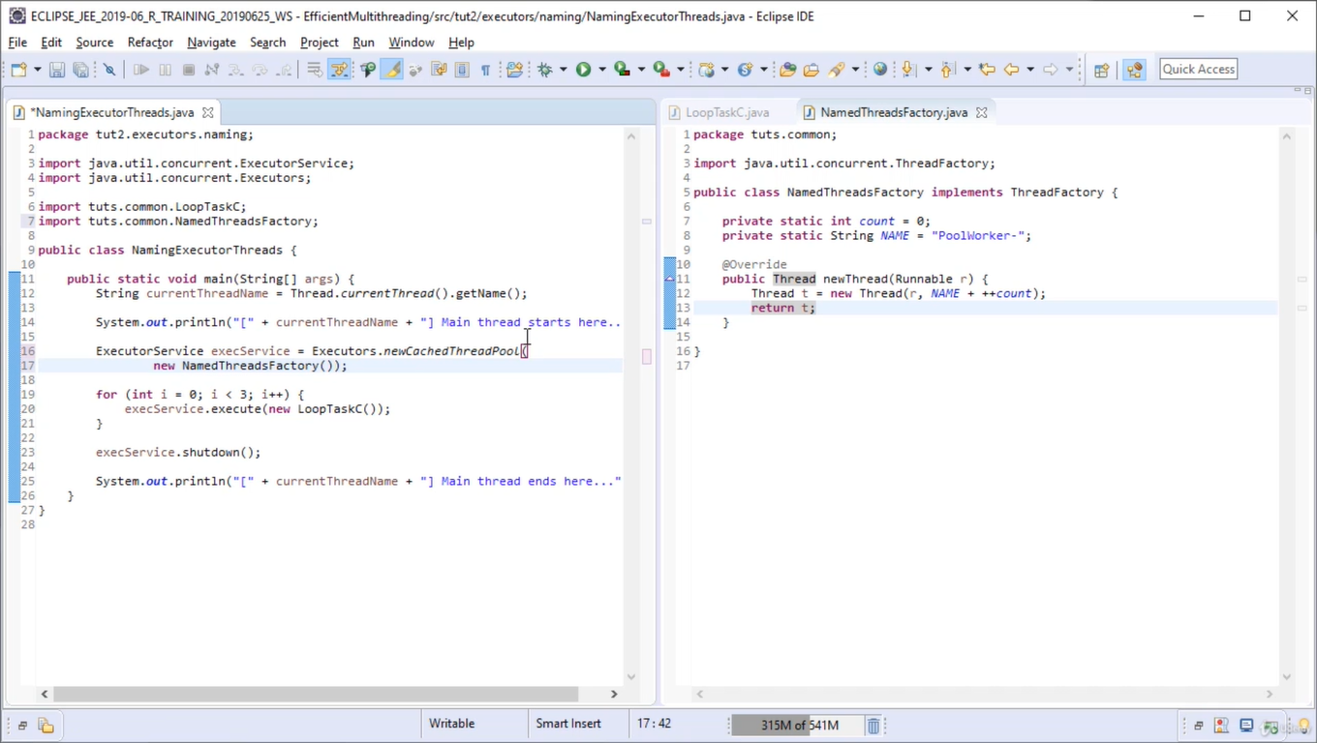

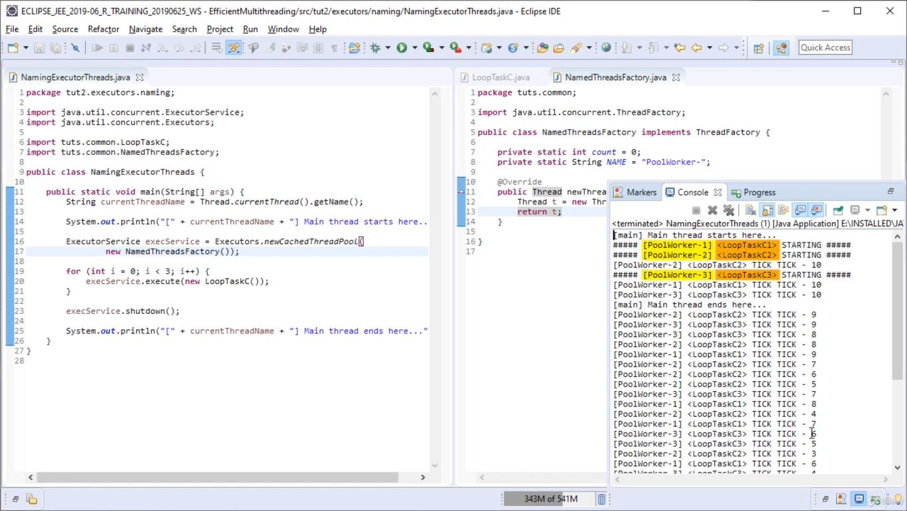

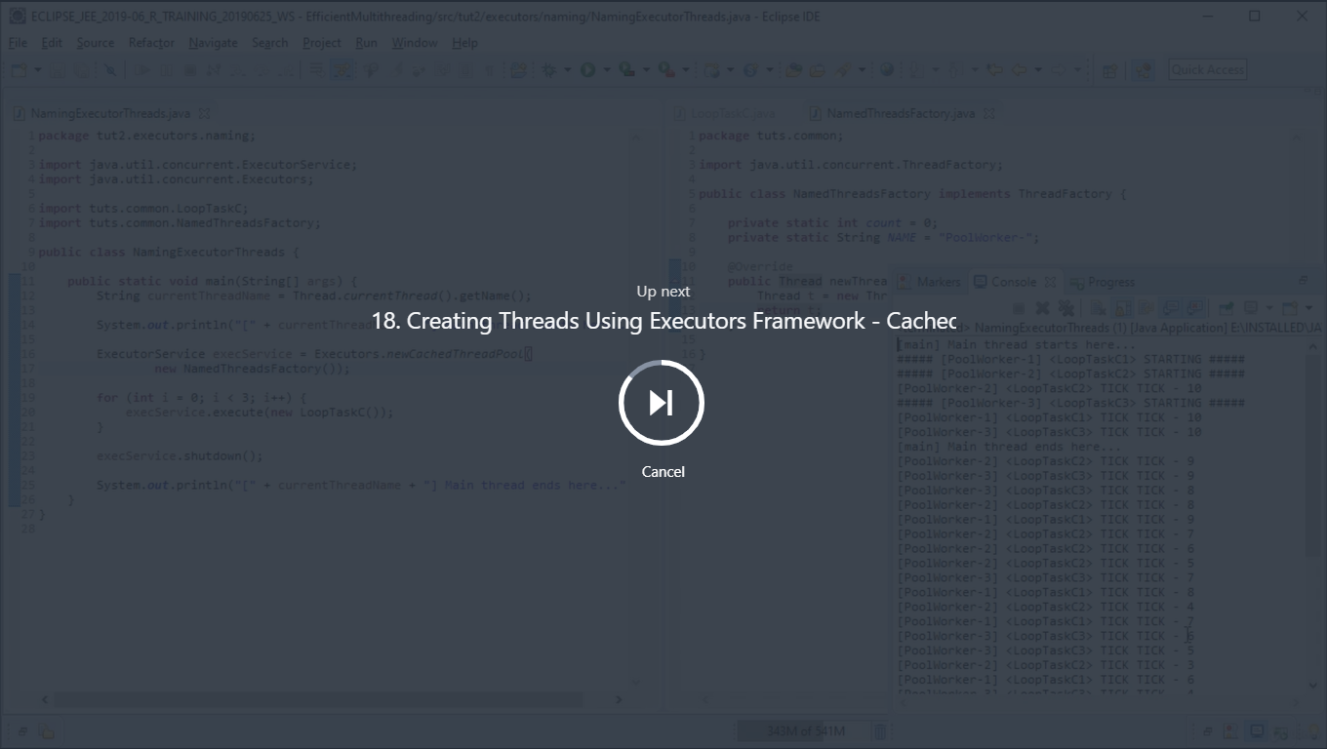

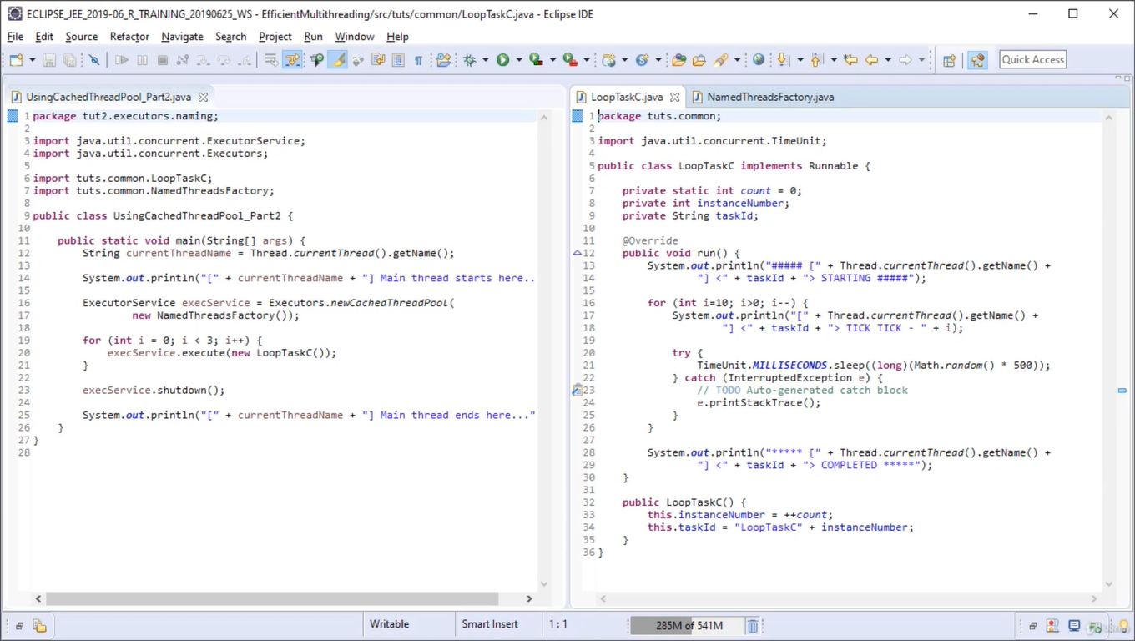

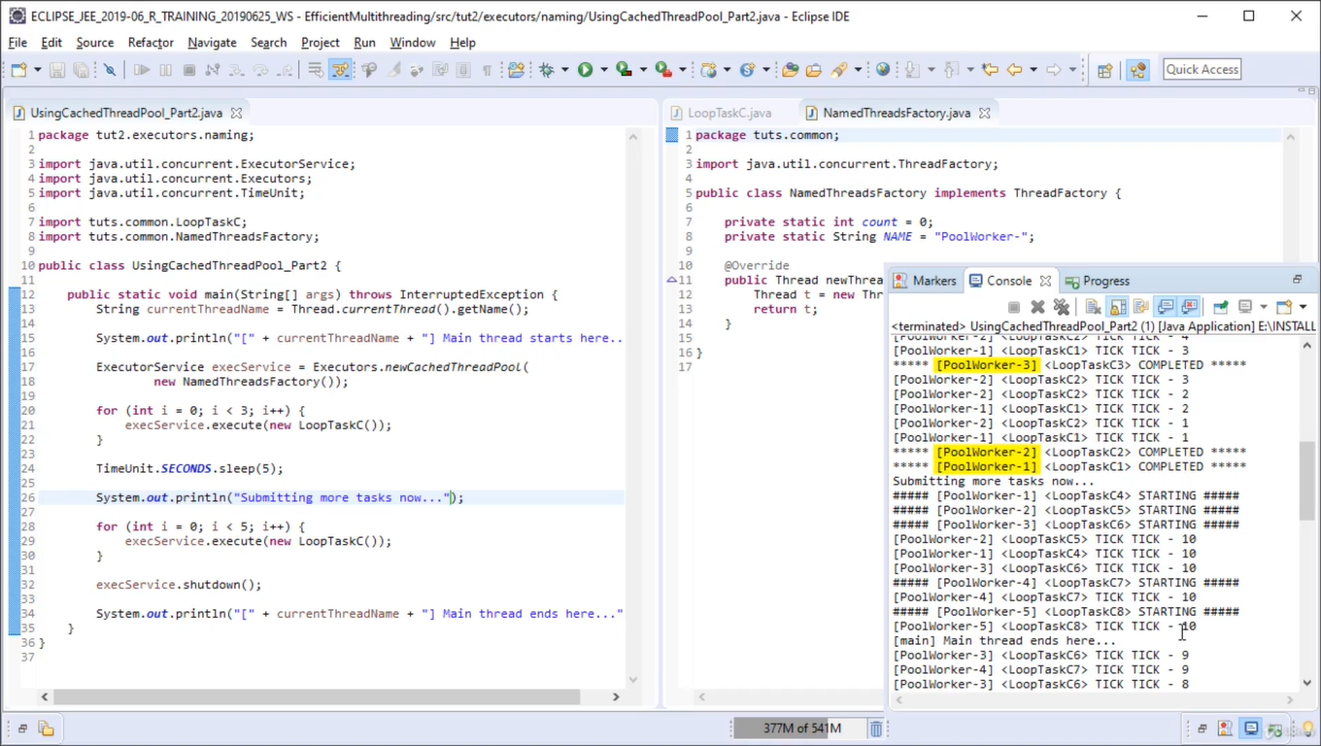

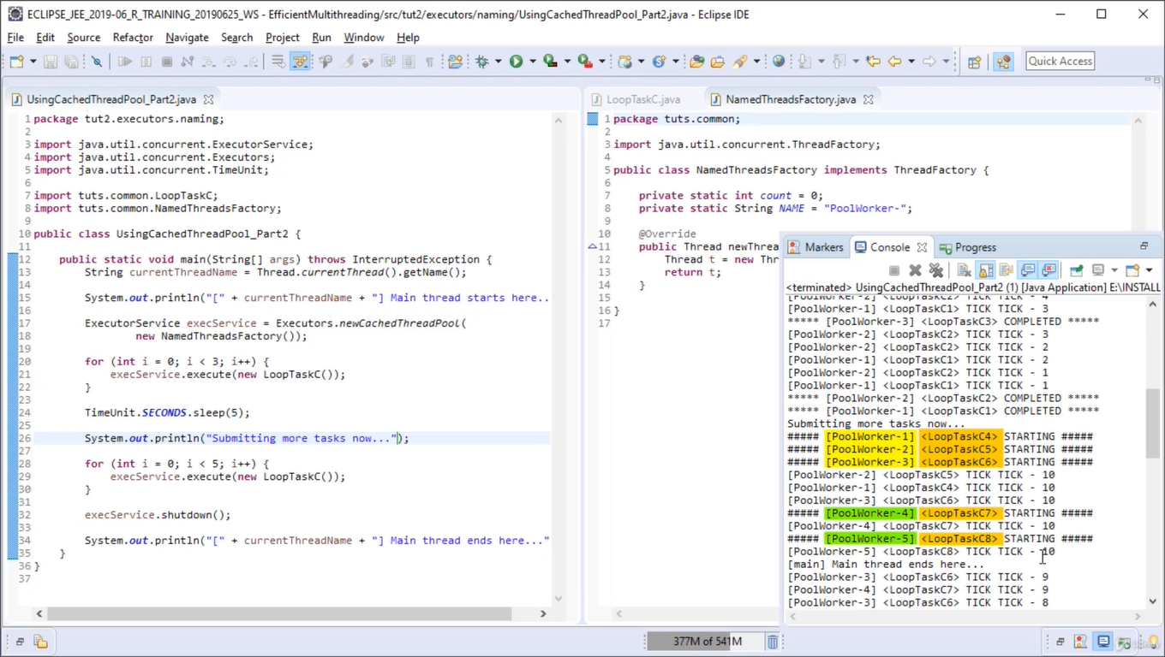

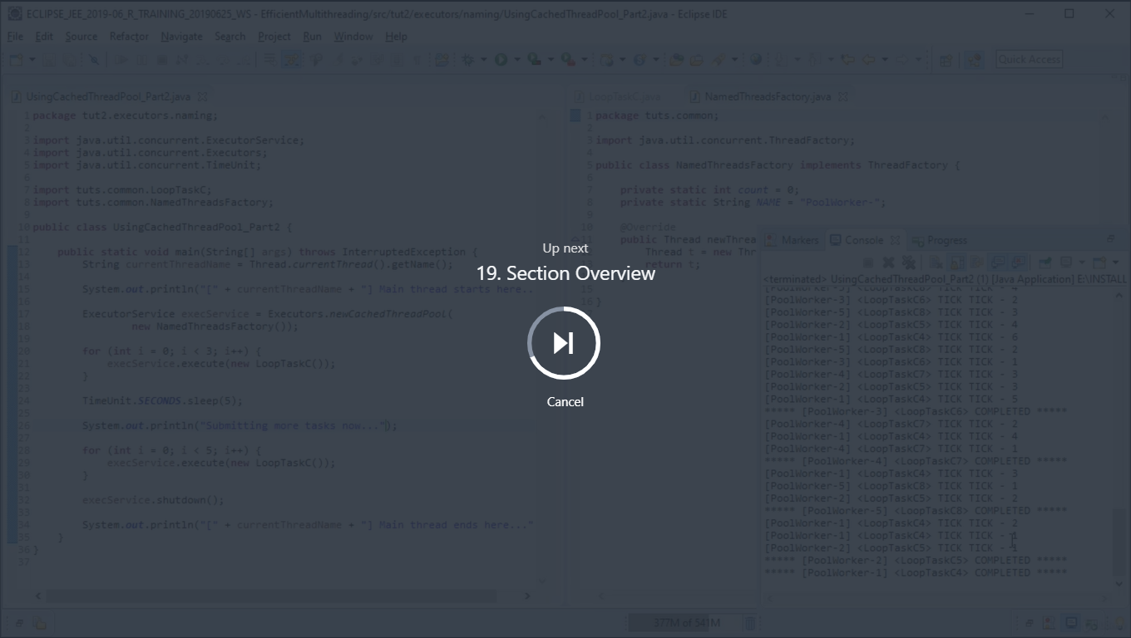

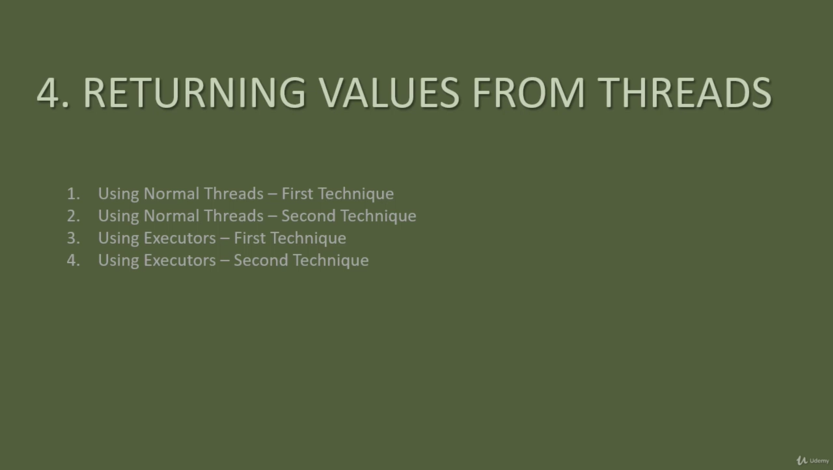

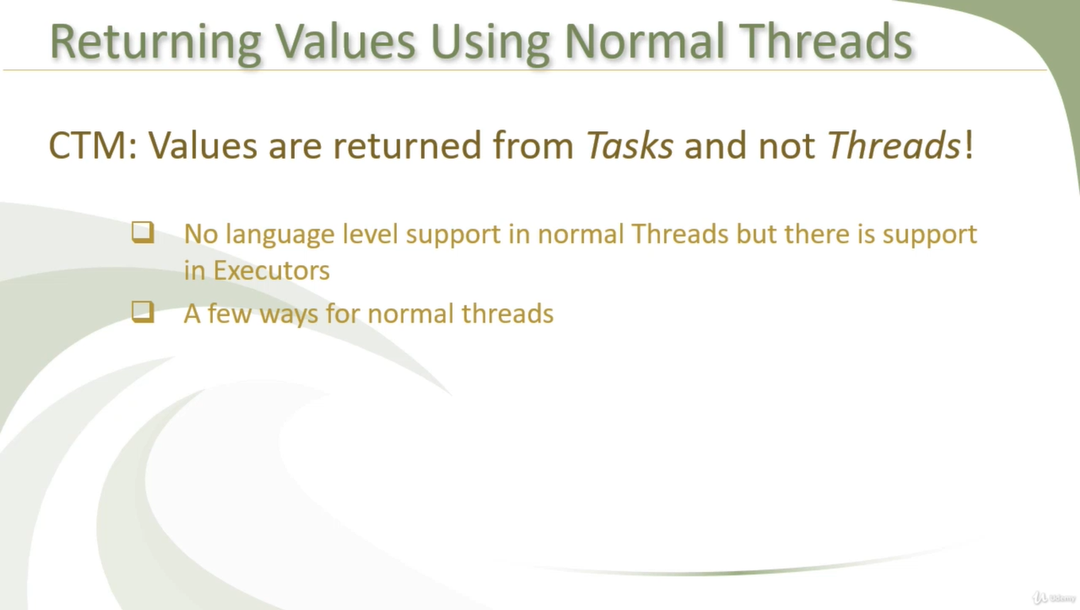



This is blocking technique here main thread blocks/wait to get first thread result eventhough the other threads completed

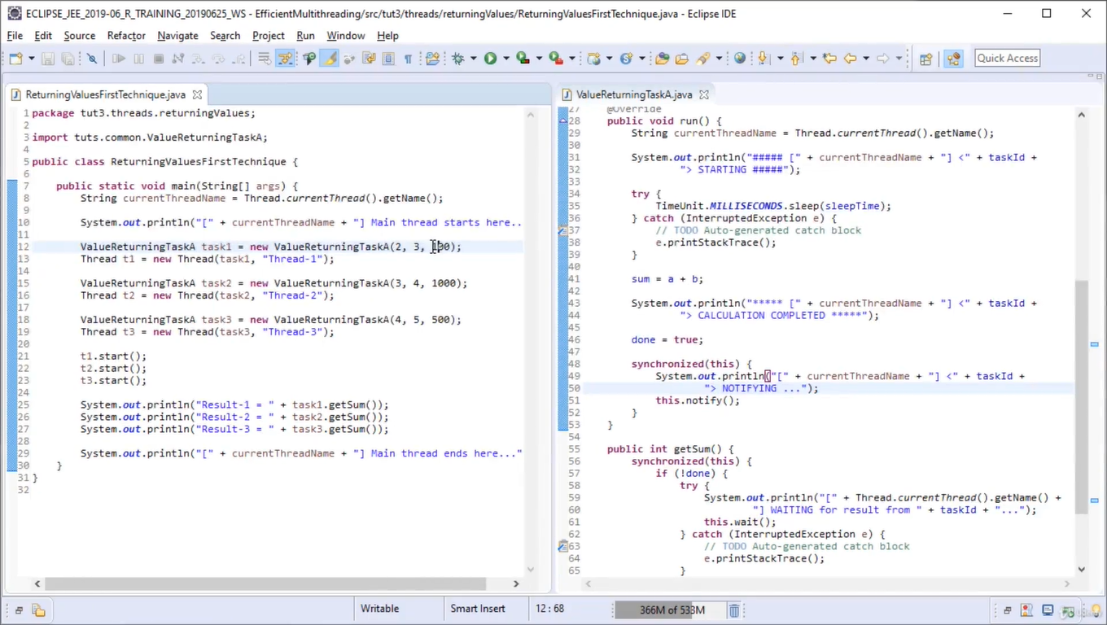

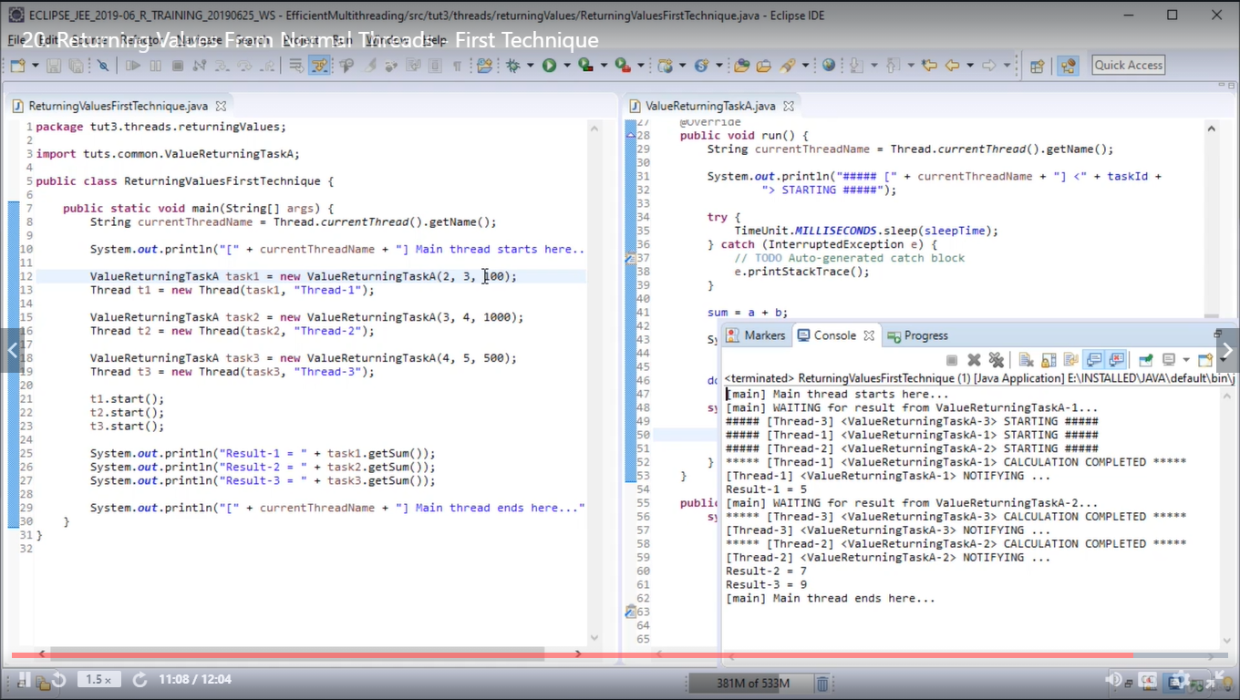

Here task1 Line# 25 is stuck/waiting to get the result eventhough task2/3 if it would have been complted that’s how we coded, that is the limitation of this code.

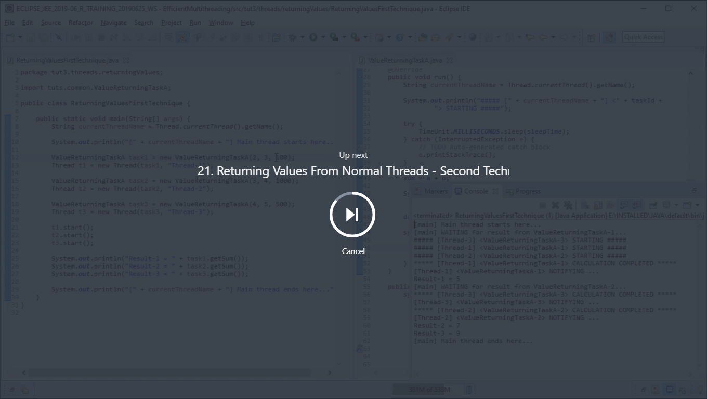

Using observer pattern

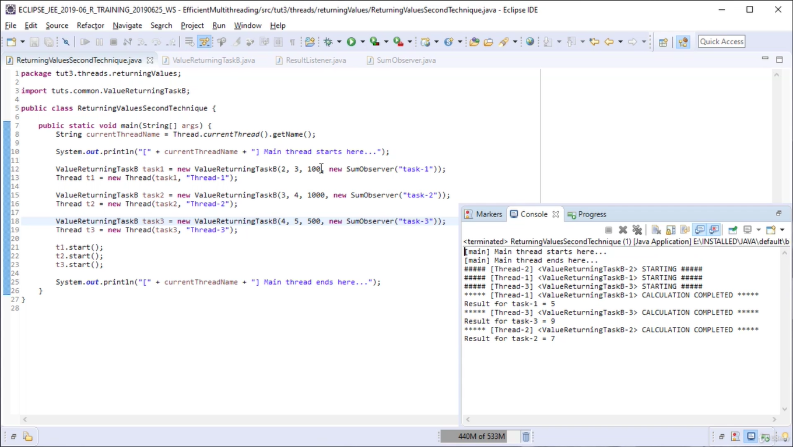

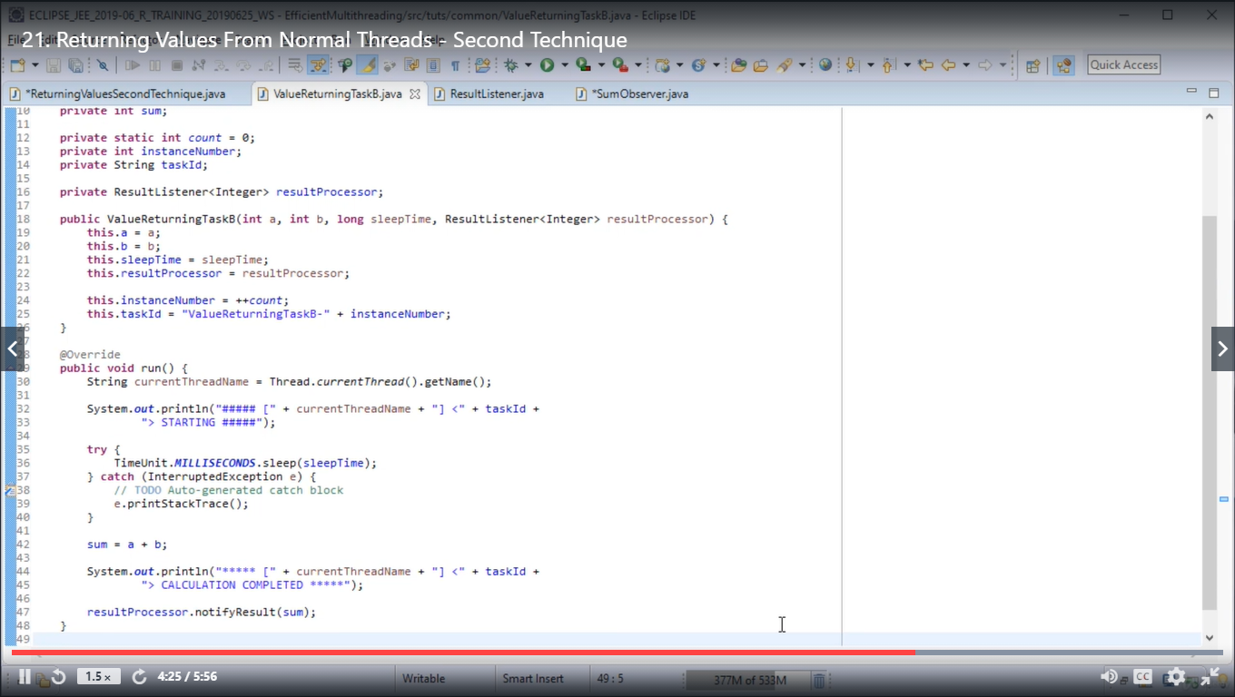

Observer

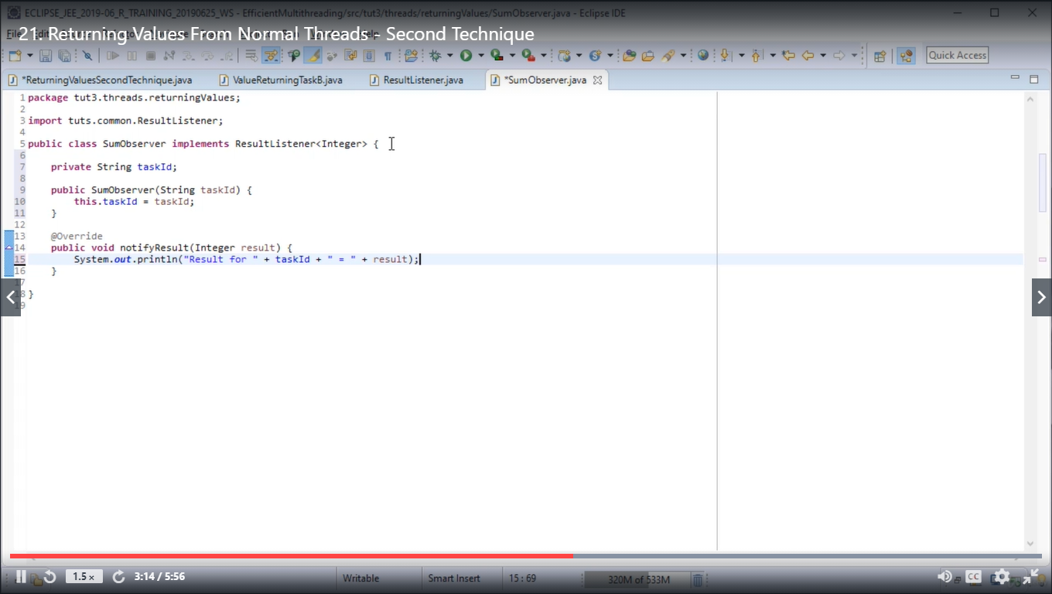

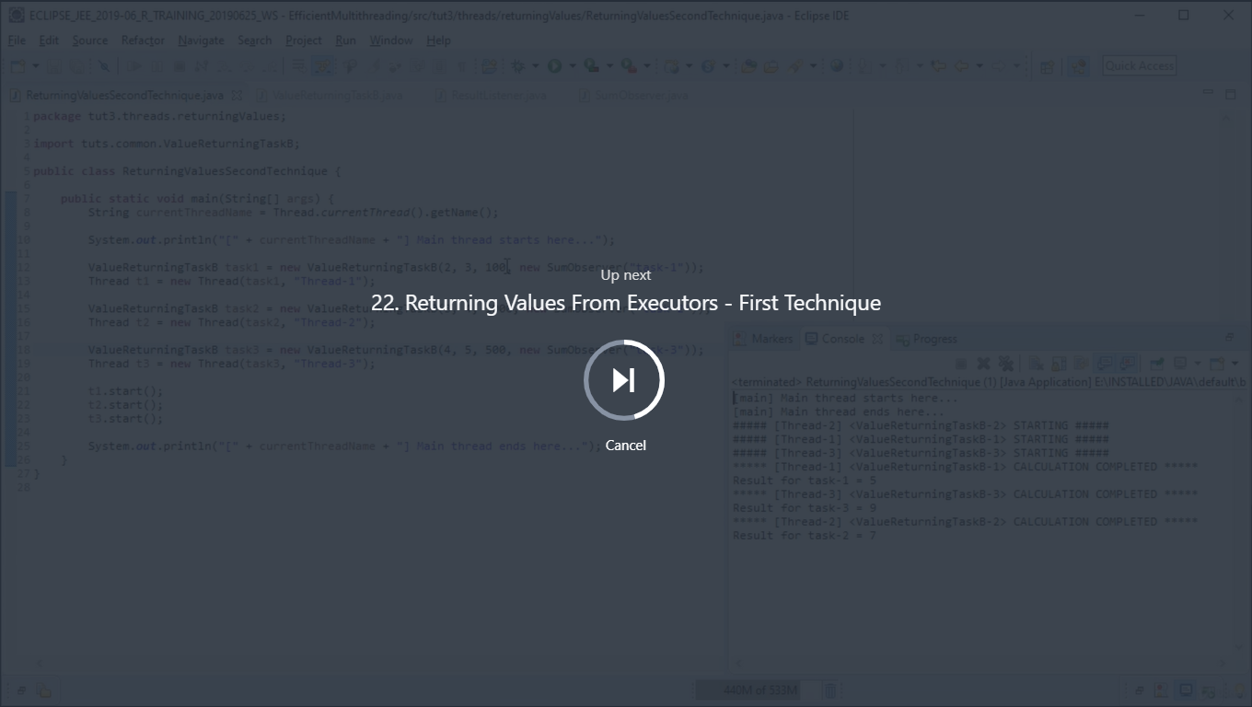

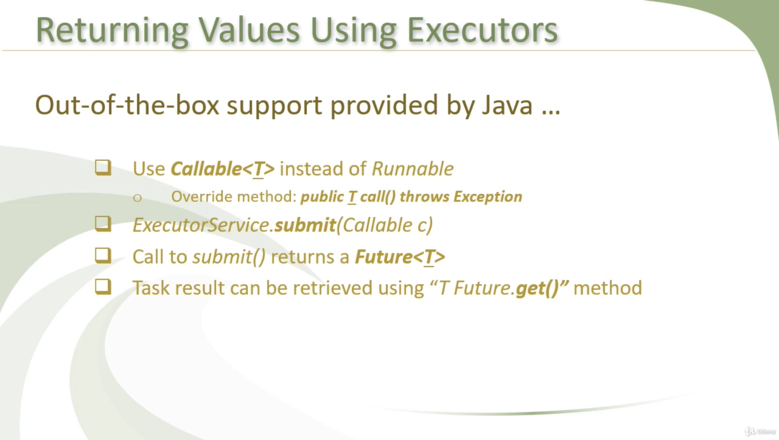

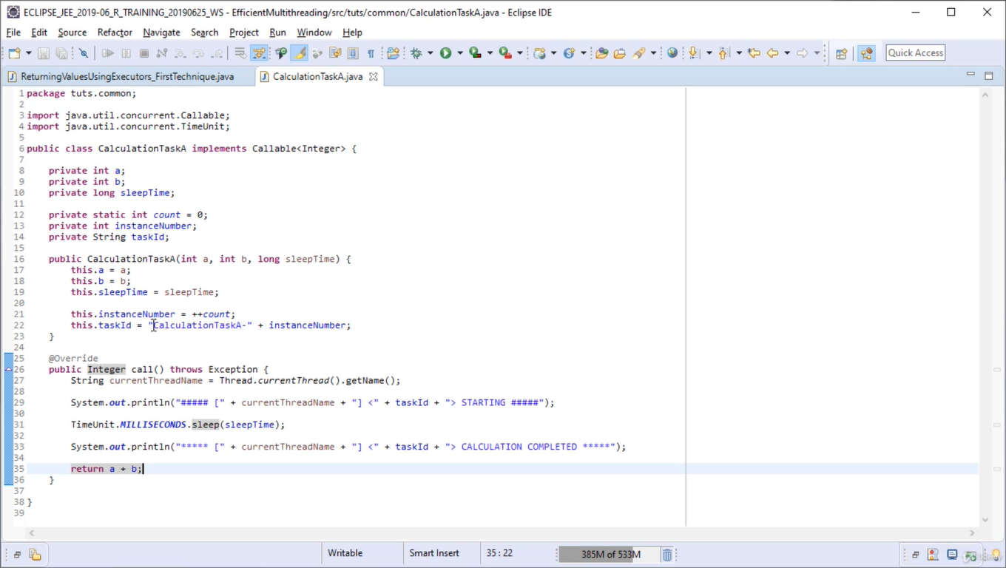

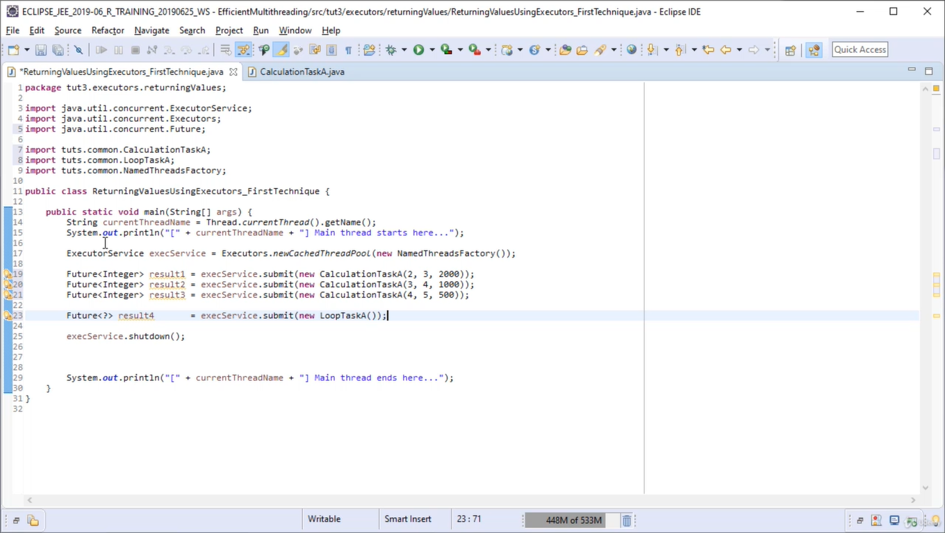

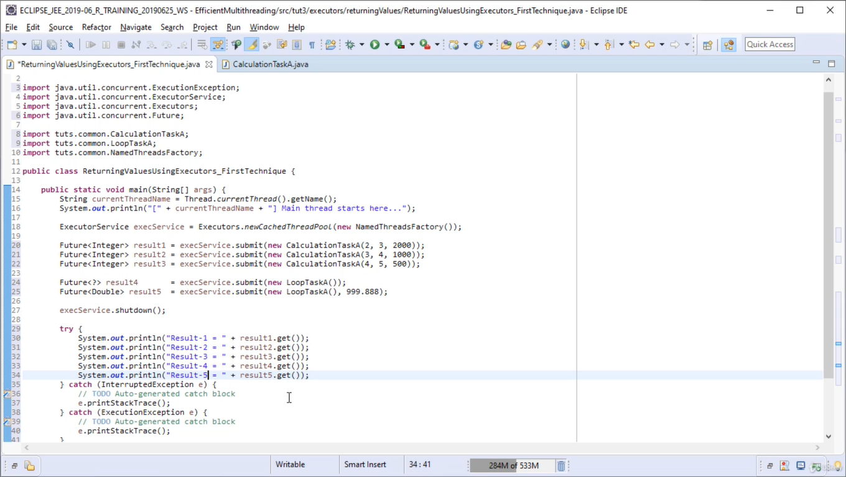

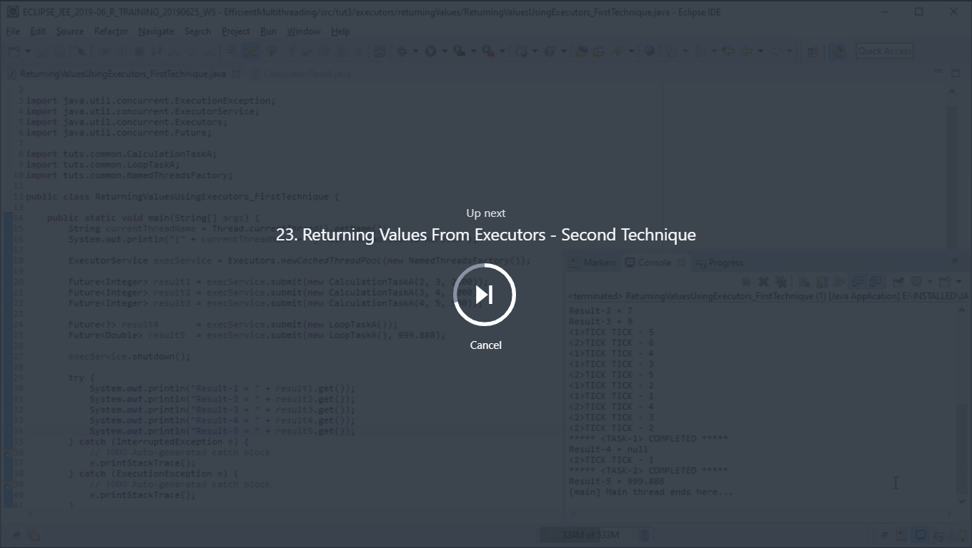

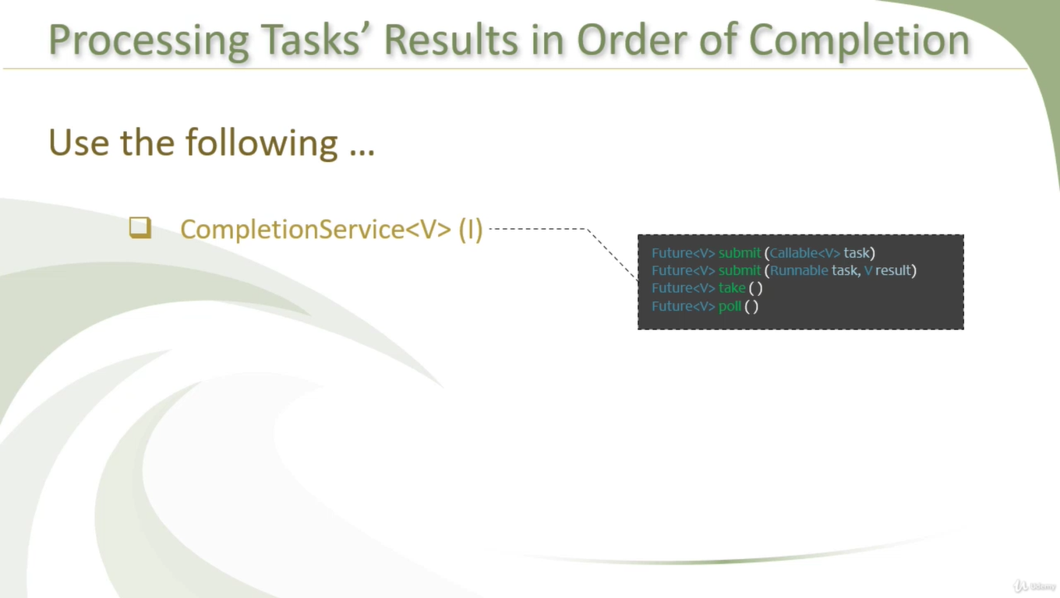

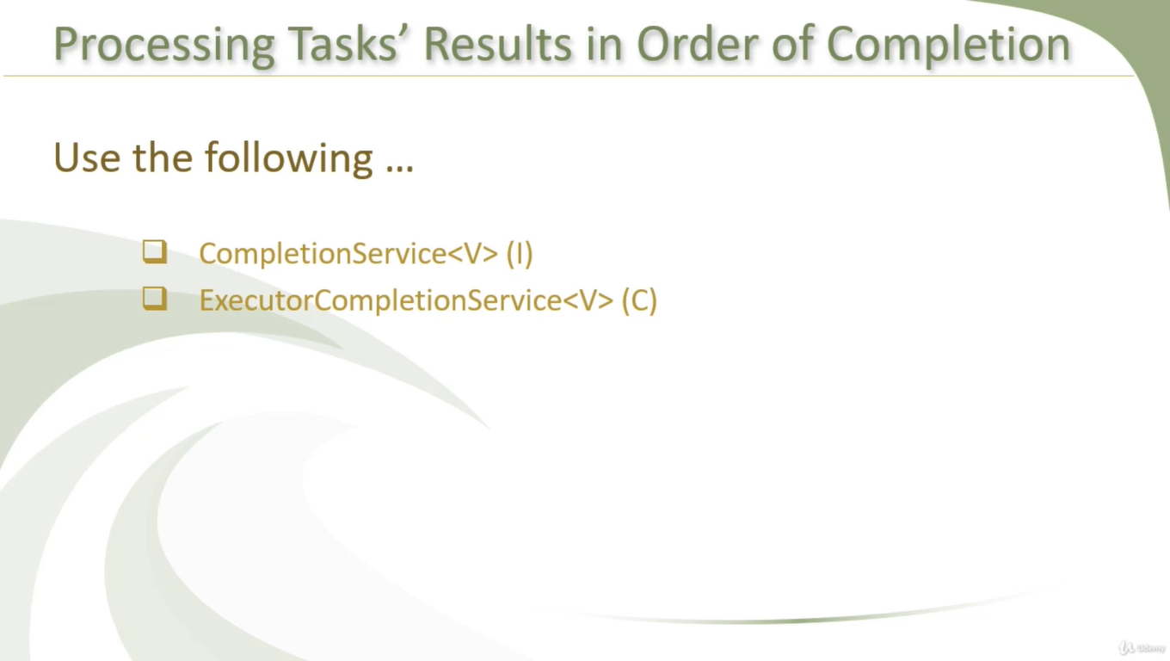

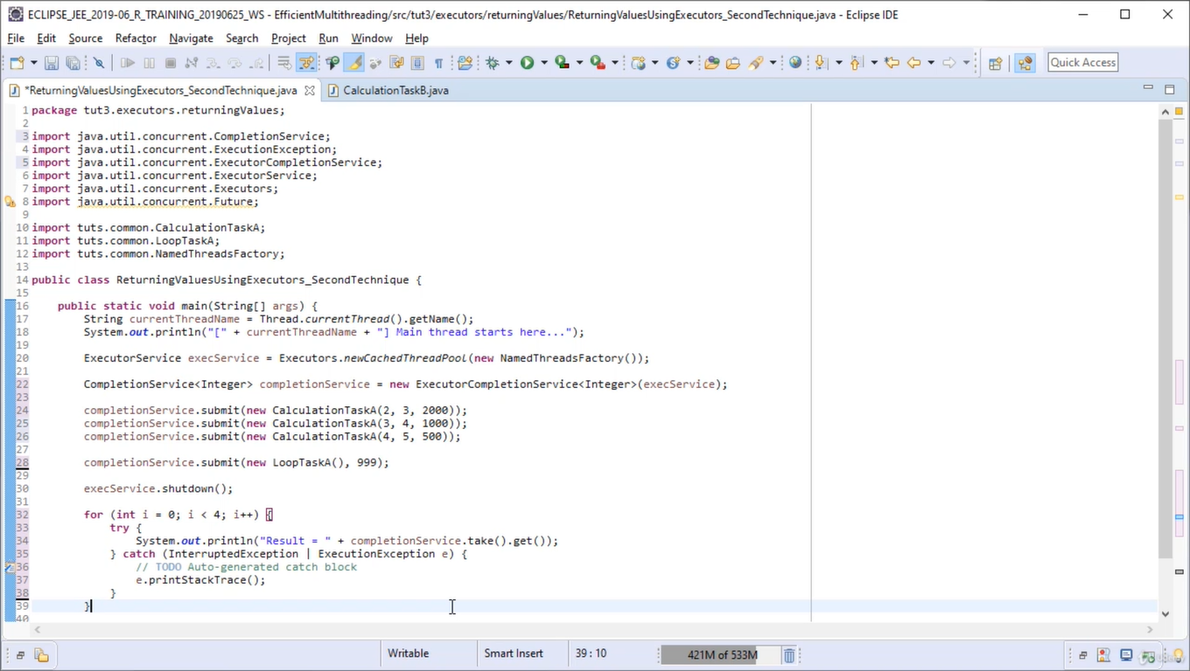

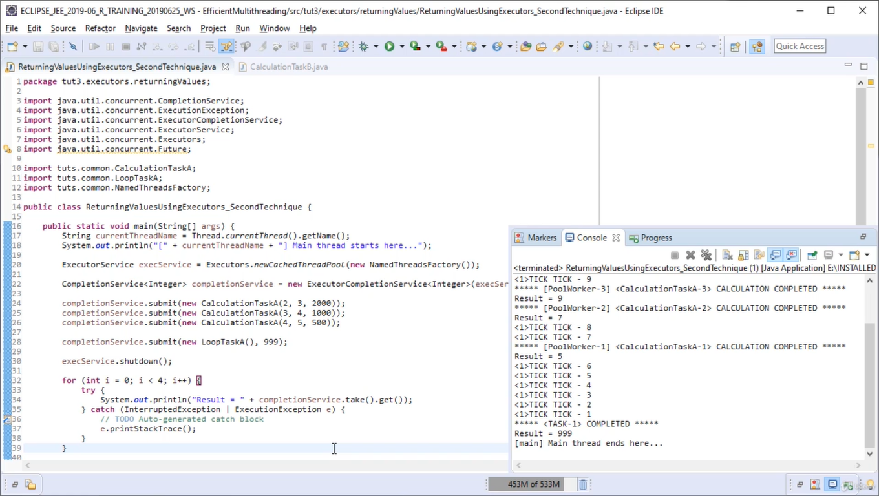

Here the problem is we can identify the result is for which task to do that we’ll return object

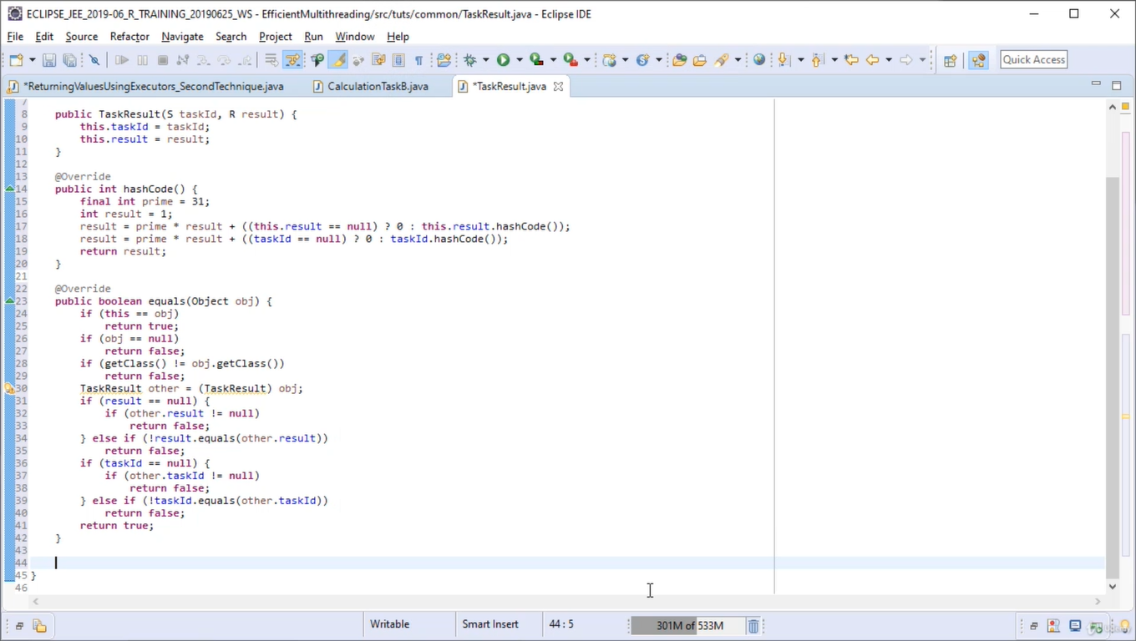

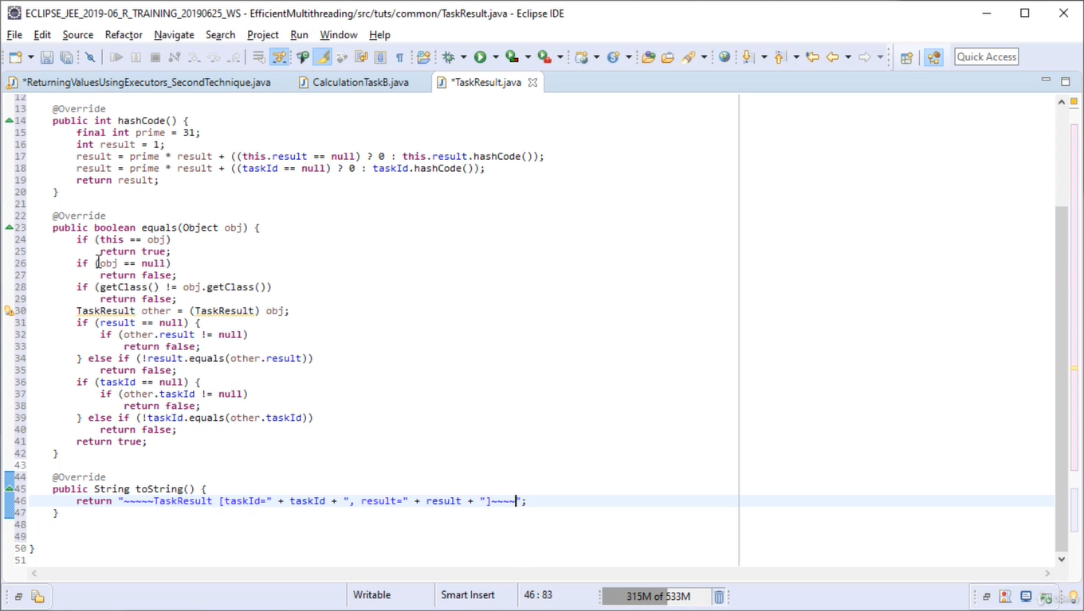

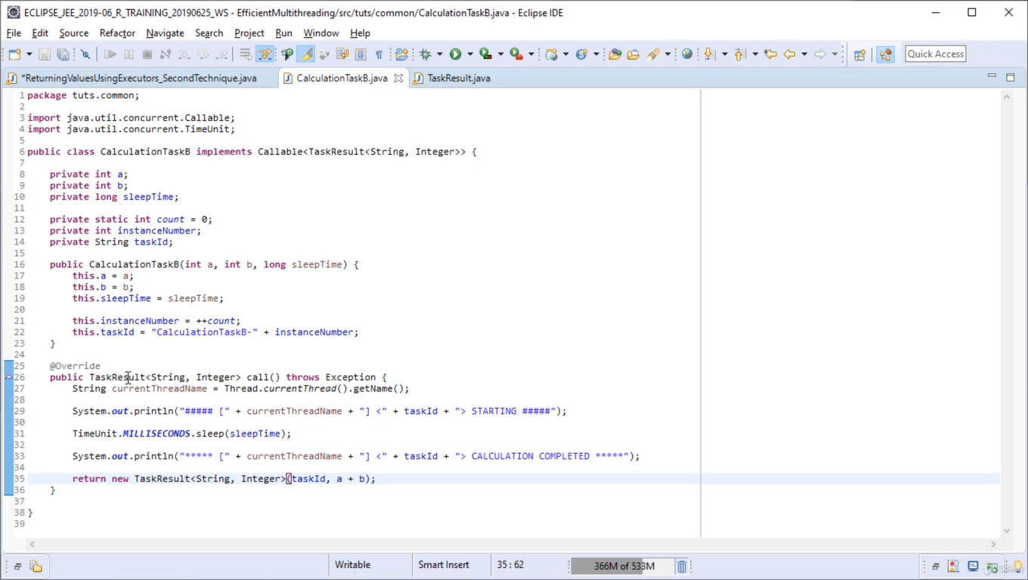

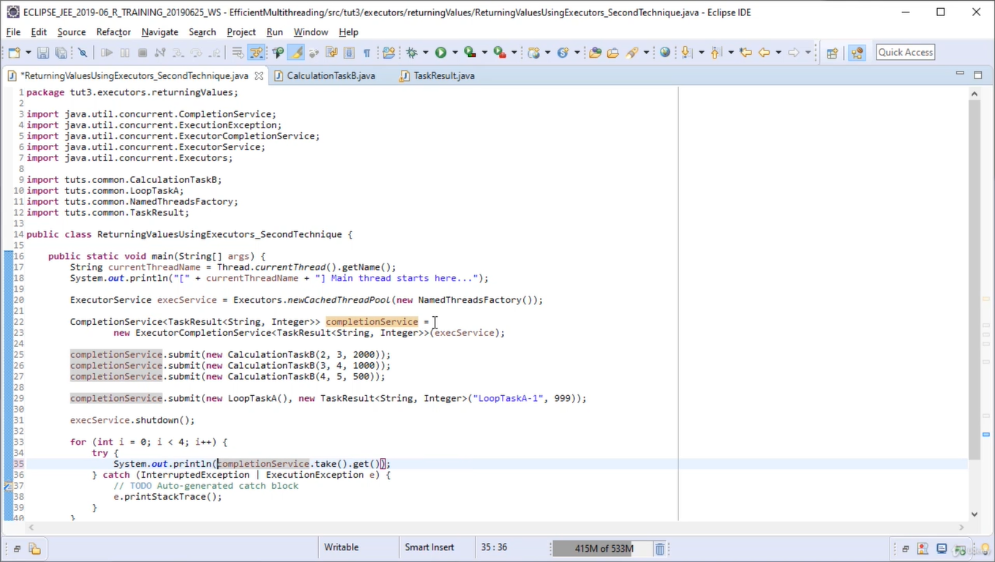

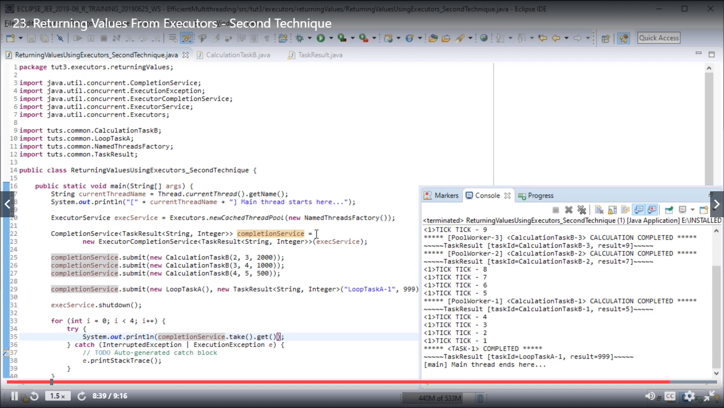

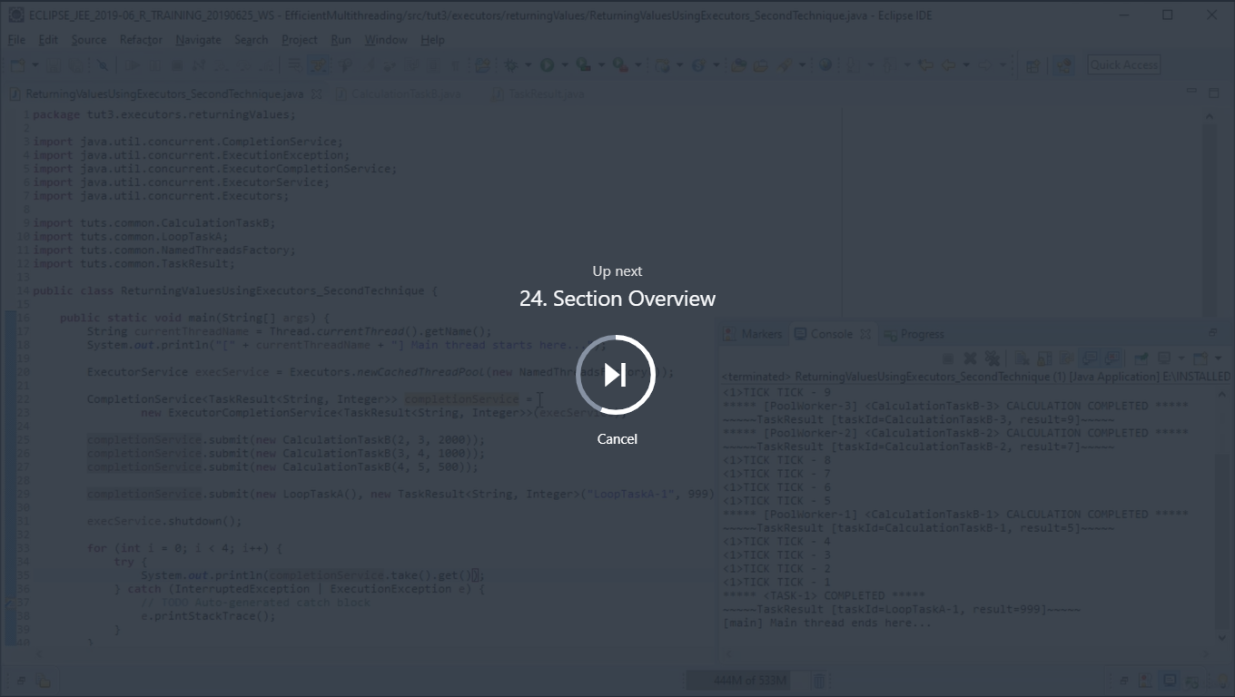



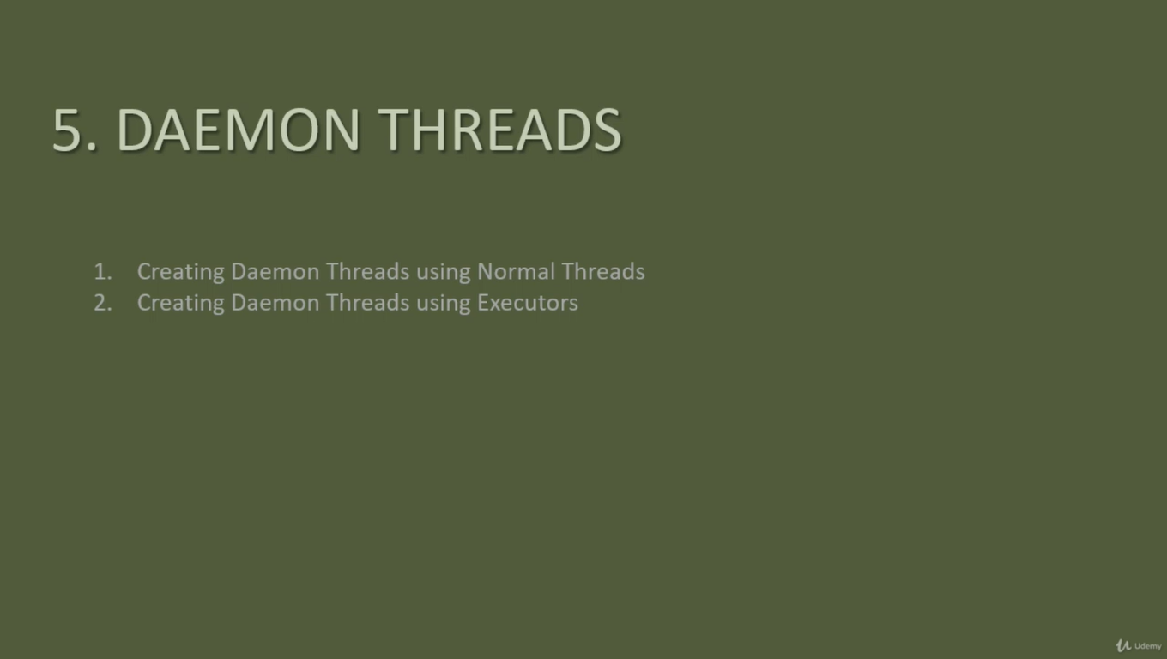



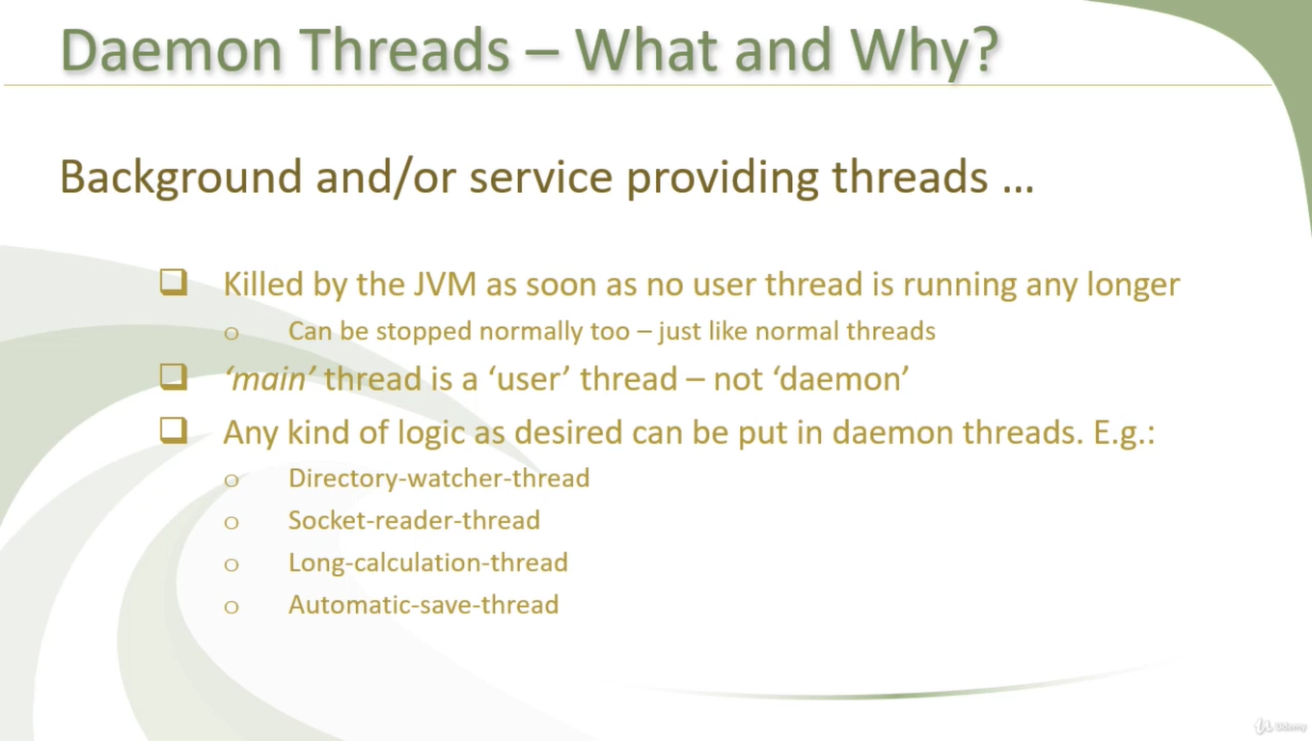

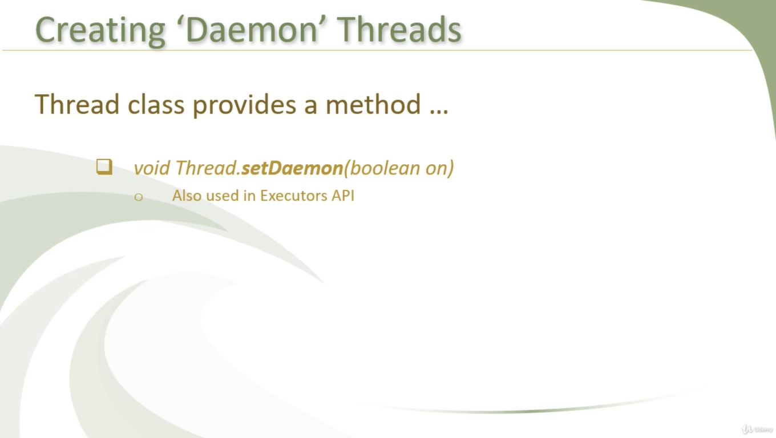

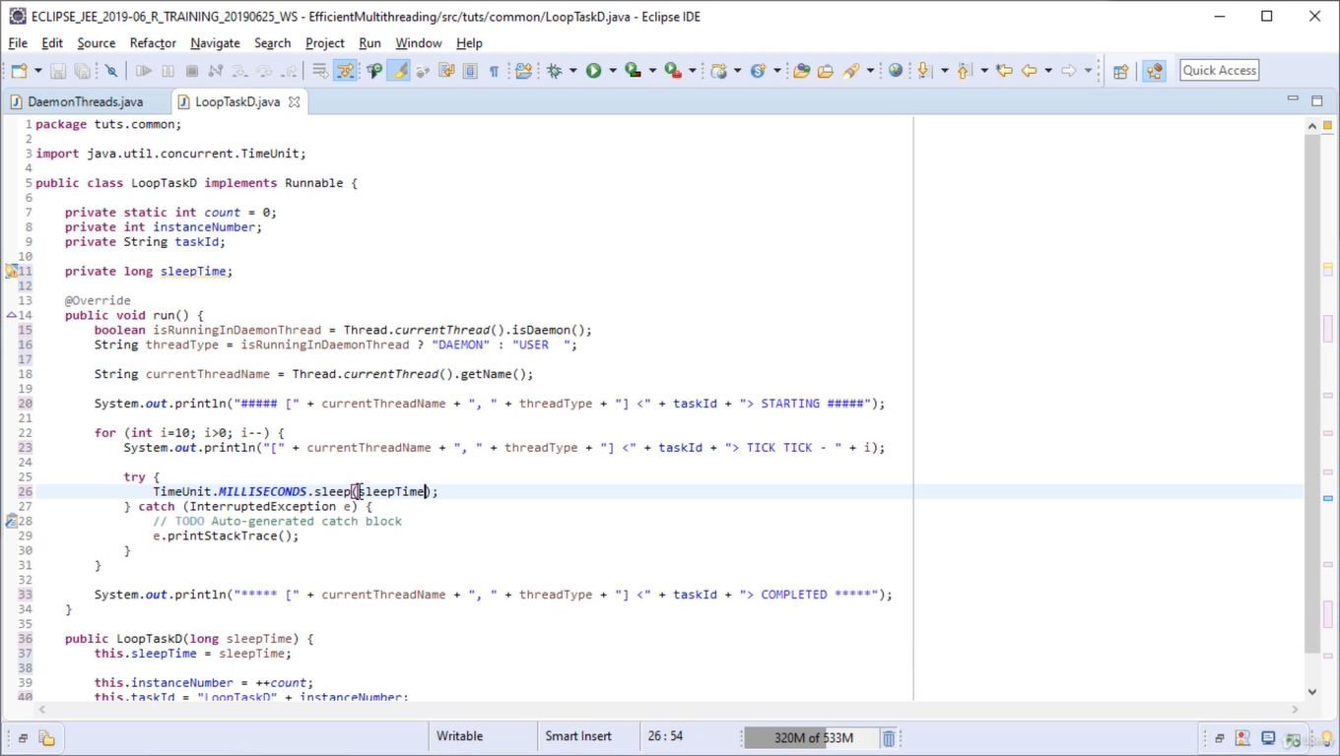

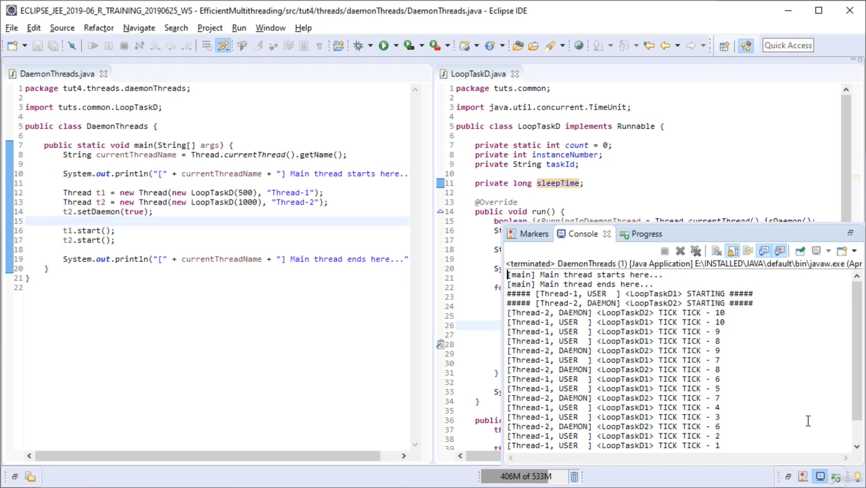

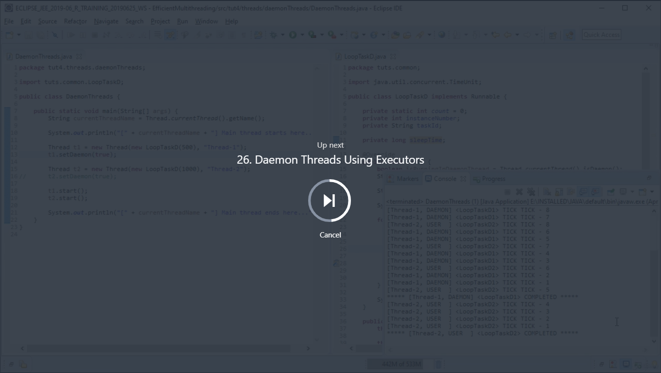

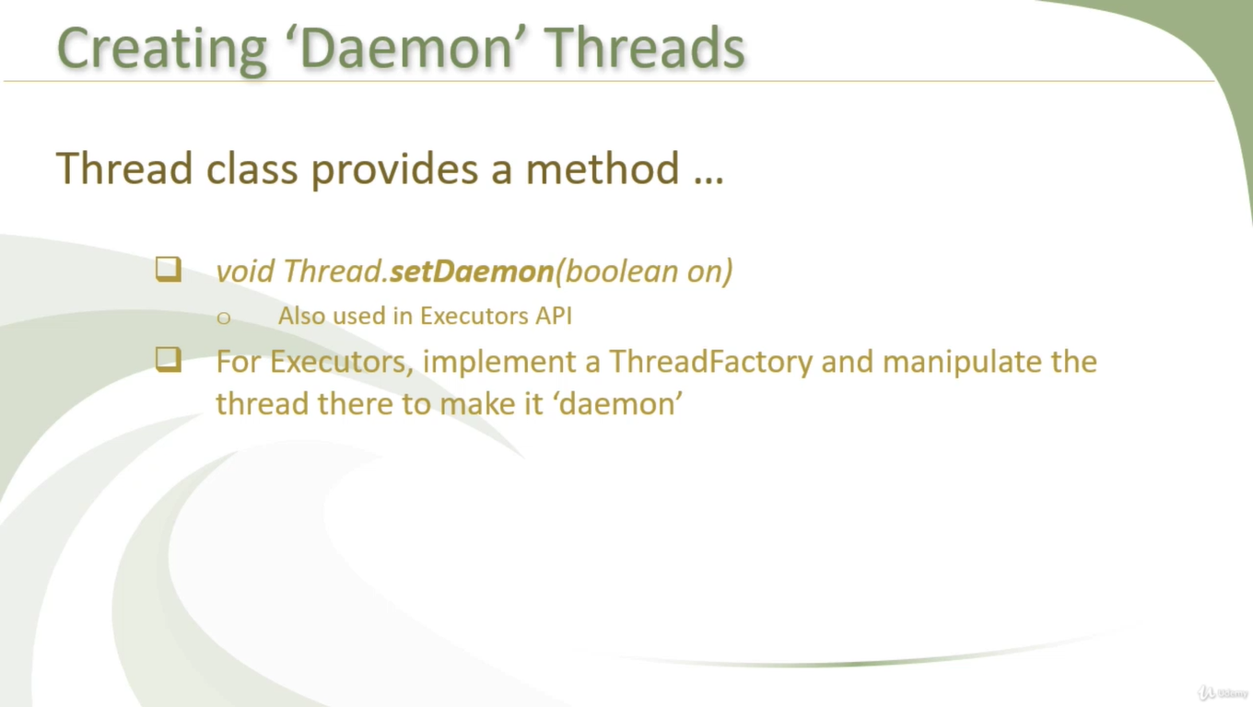

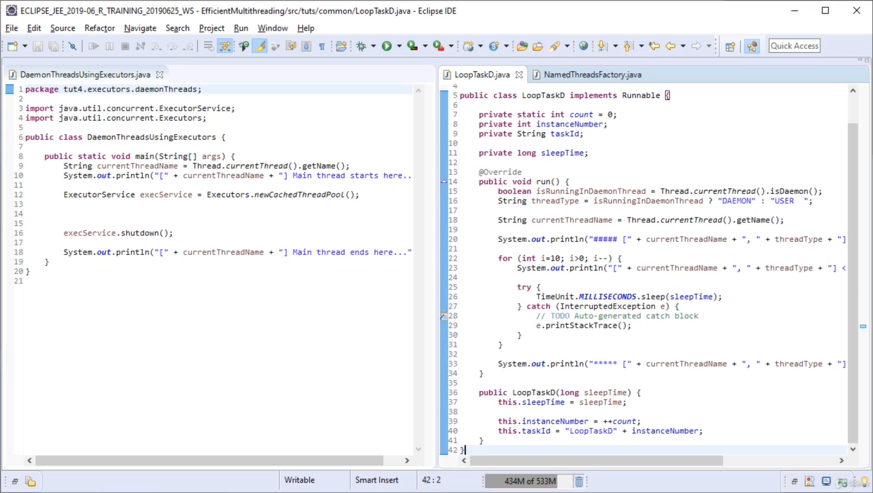

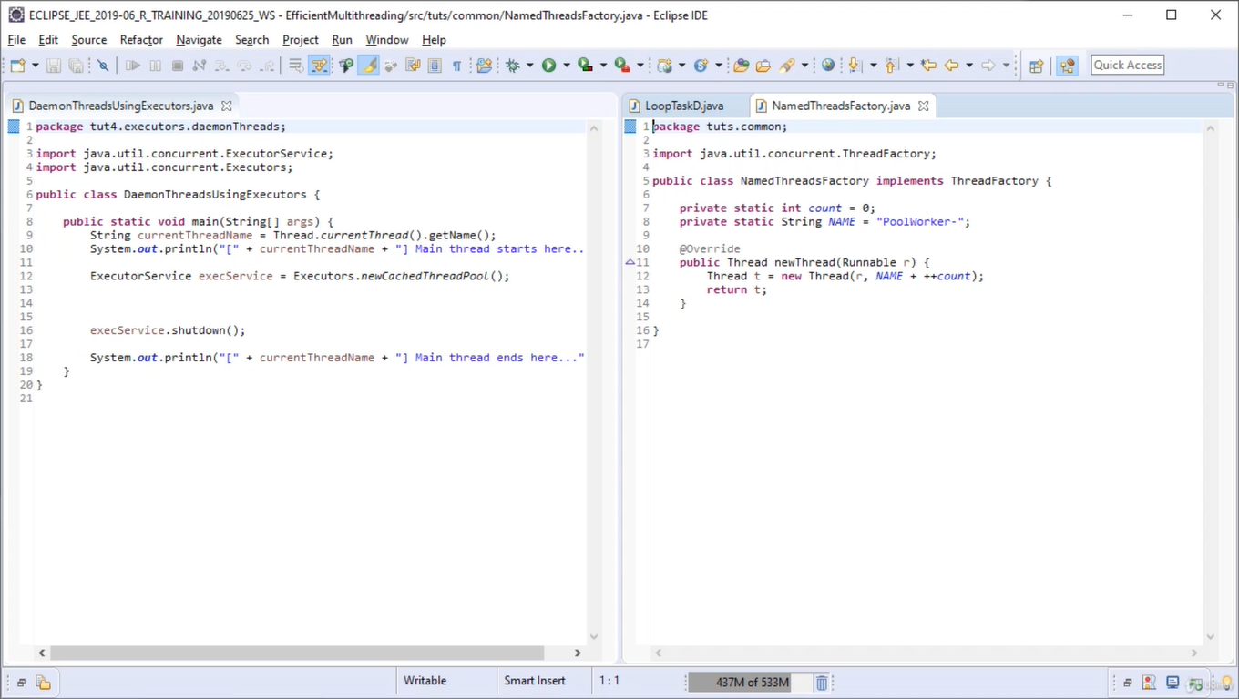

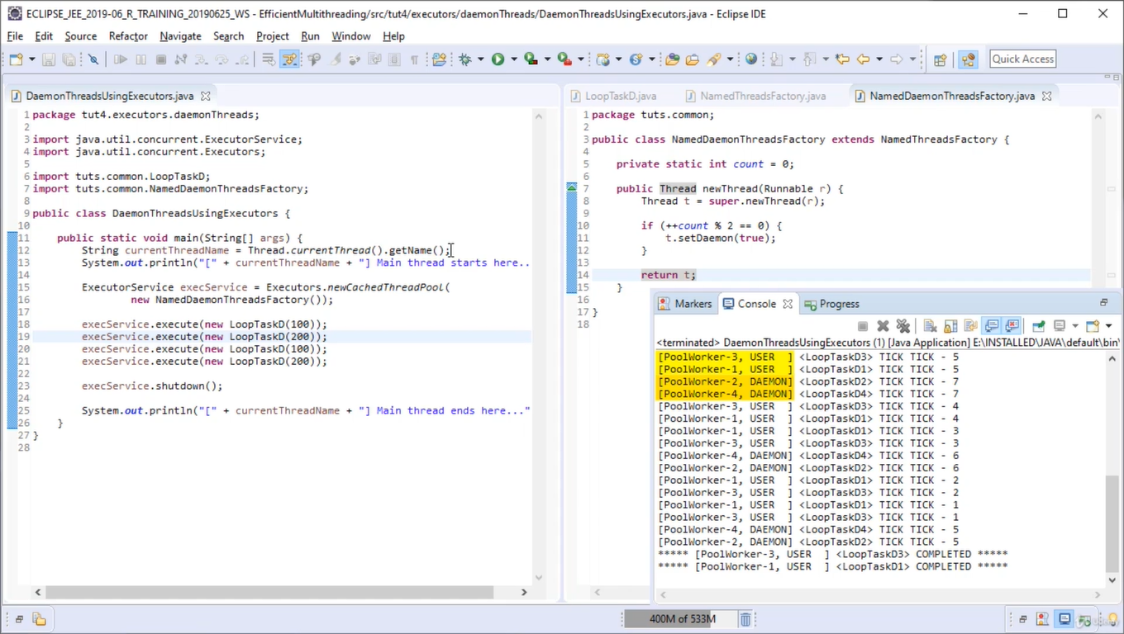

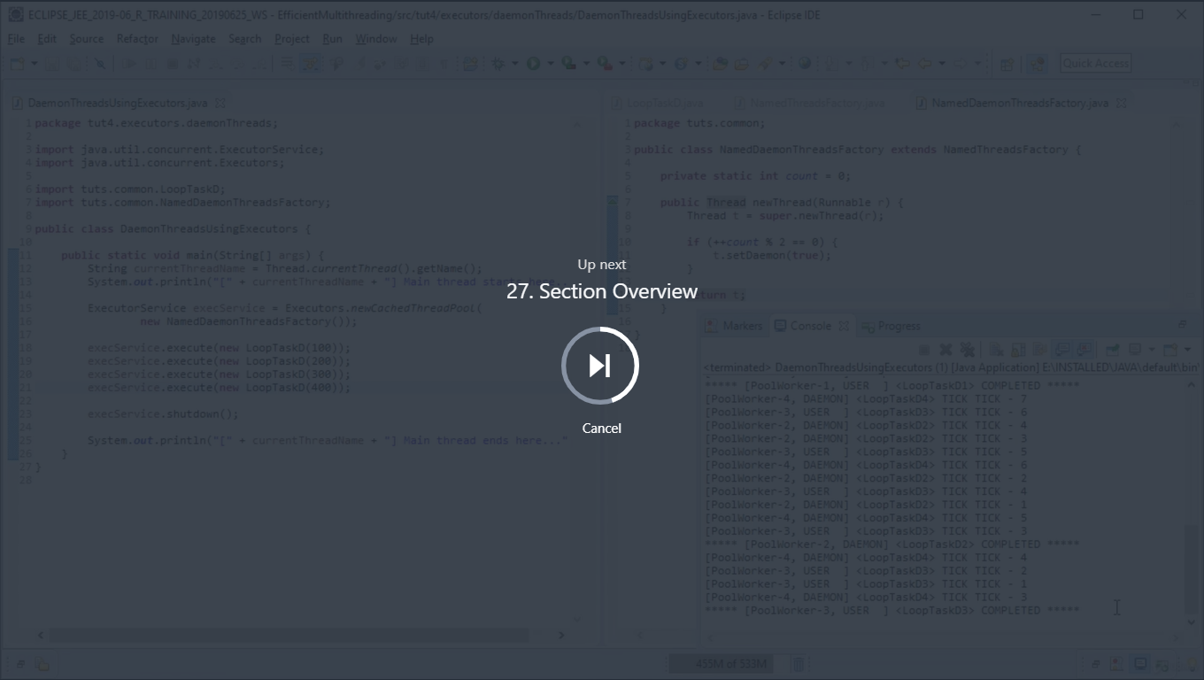

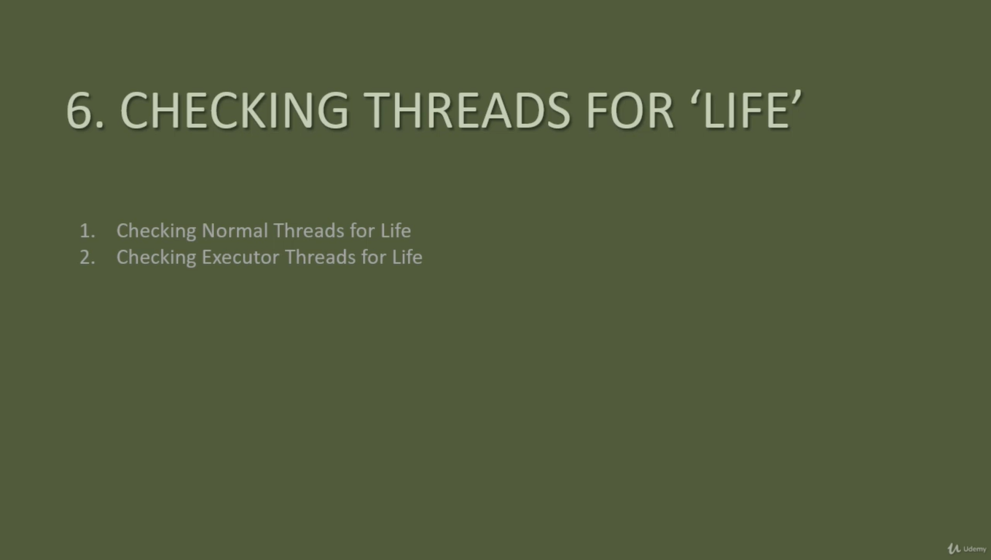



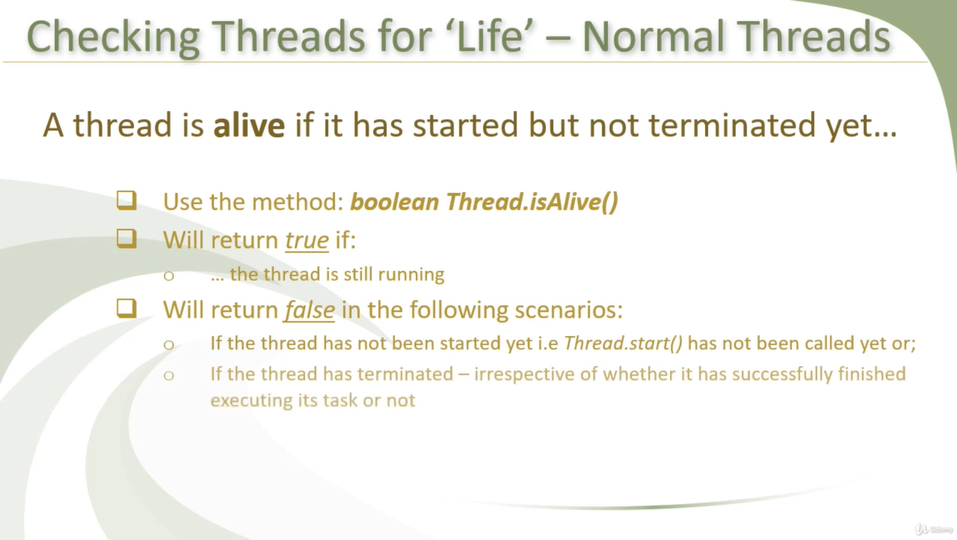

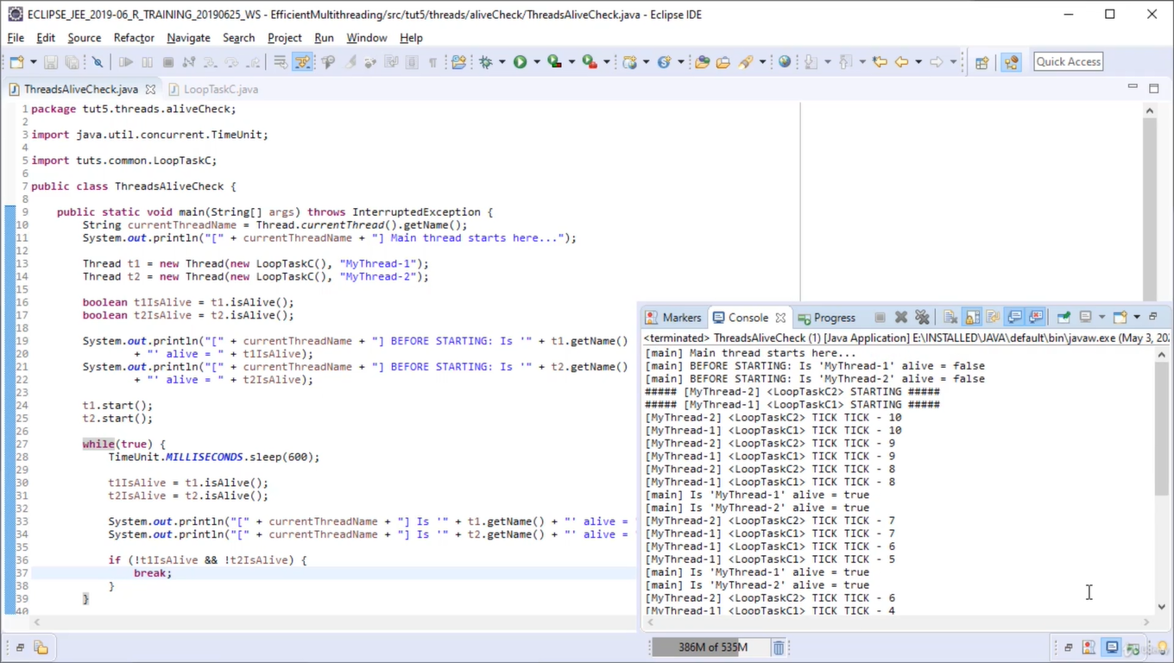

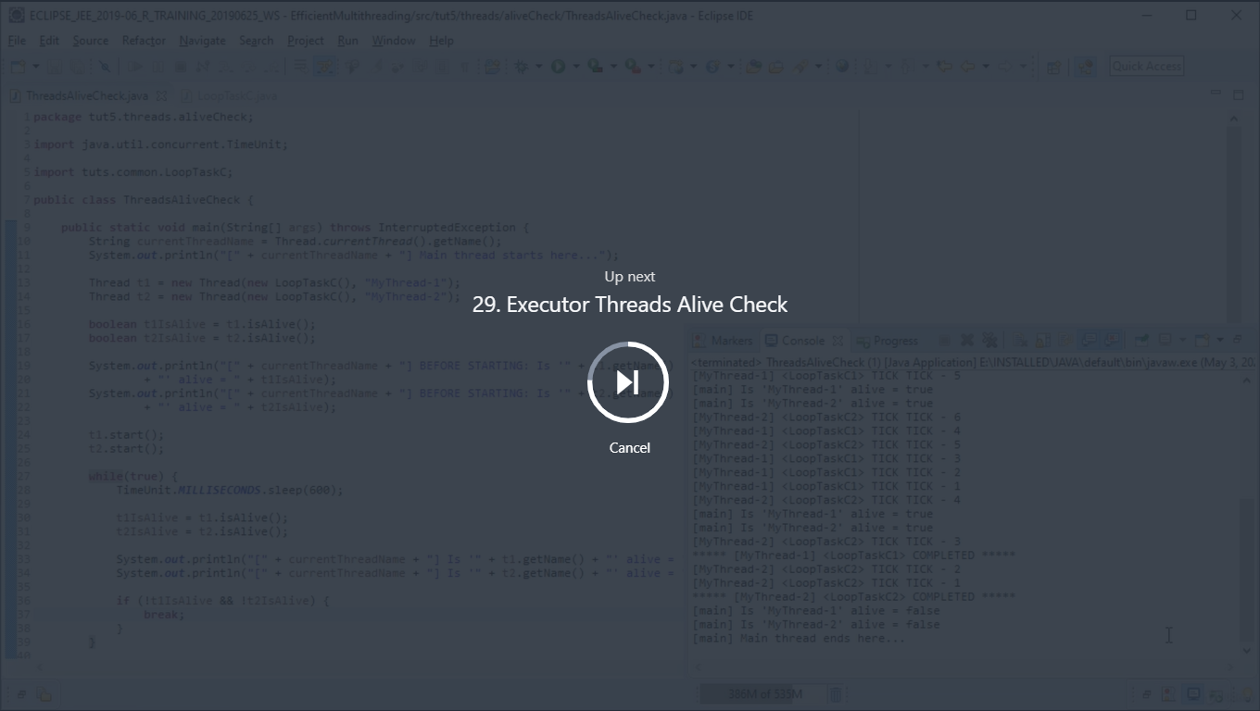

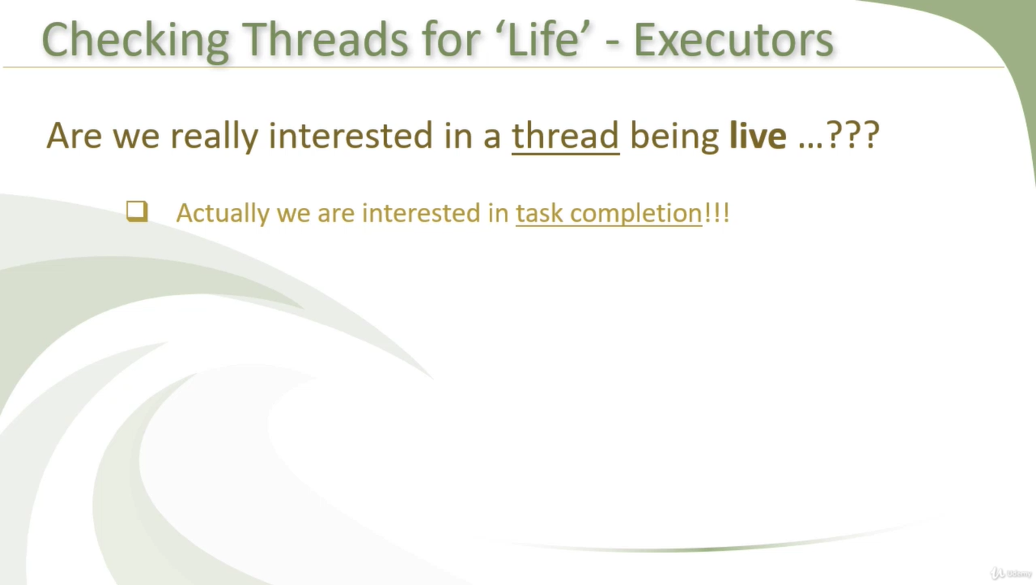

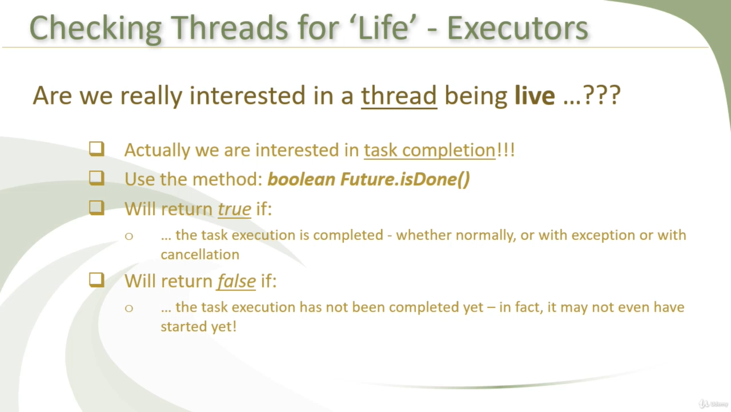

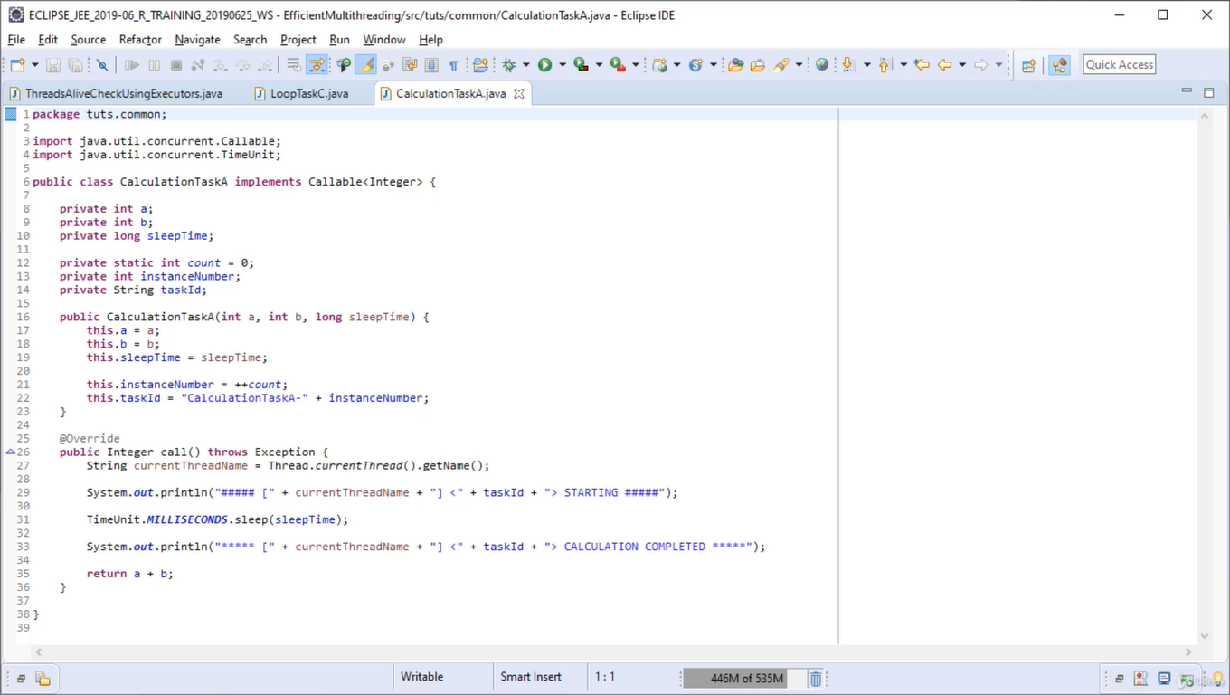

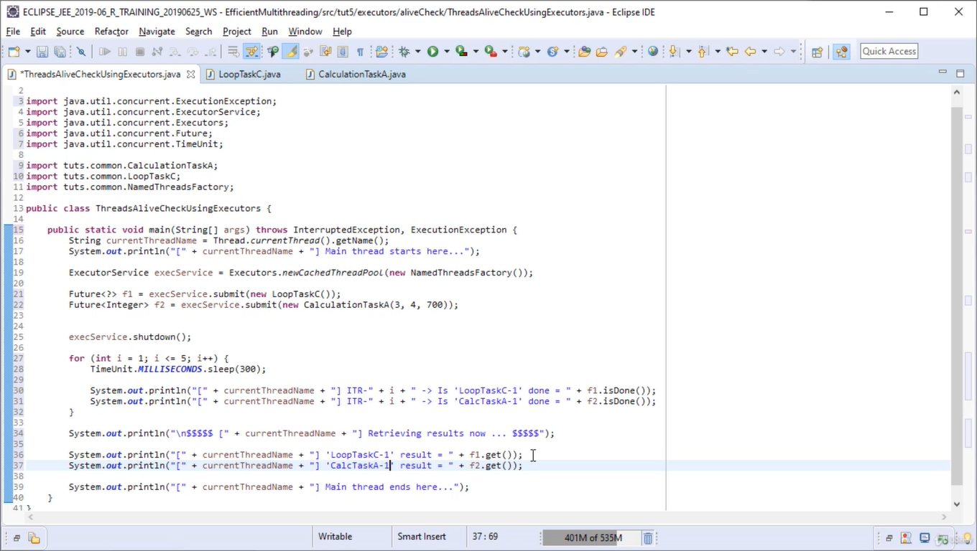

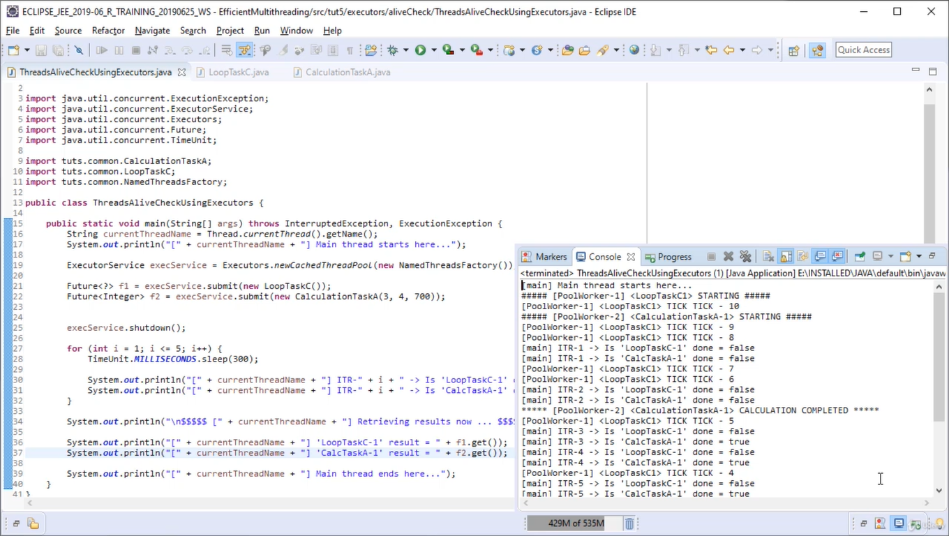

Lets create few future task

**Prerequisite:** [**Future and callable**](https://www.geeksforgeeks.org/callable-future-java/)

**Future:**

A **Future** interface provides methods **to check if the computation is complete, to wait for its completion and to retrieve the results of the computation**. The result is retrieved using Future’s get() method when the computation has completed, and it blocks until it is completed.

Future and FutureTask both are available in **java.util.concurrent package** from Java 1.5.

**FutureTask:**

1. FutureTask implementation Future interface and RunnableFuture Interface, means one can use FutureTask as Runnable and can be submitted to ExecutorService for execution.
2. When one call Future.submit() Callable or Runnable objects then most of time ExecutorService creates FutureTask, and one can create it manually also.
3. FutureTask acts like a latch.
4. Computation represent by FutureTask is implemented with Callable interface.
5. It implements Future or Callable interface.
6. Behaviour of get() method depends on the state of the task. If tasks are not completed get() method waits or blocks till the task is completed. Once task completed, it returns the result or throws an ExecutionException.

An example of using Future is working with **Thread pools**. When one submit a task to ExecutorService which is take a long running time, then it returns a Future object immediately. This Future object can be used for task completion and getting result of computation.

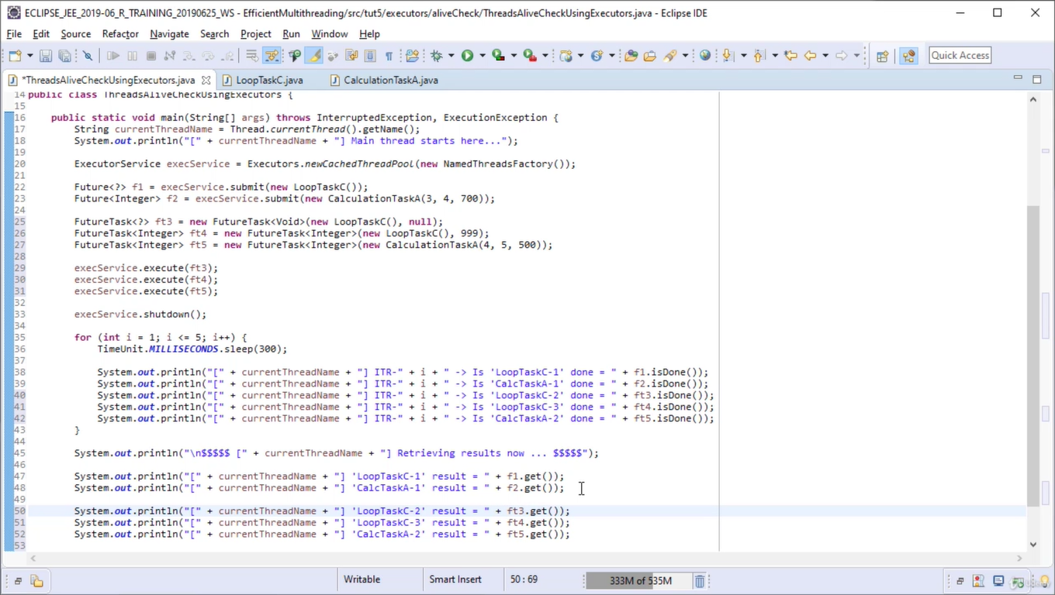

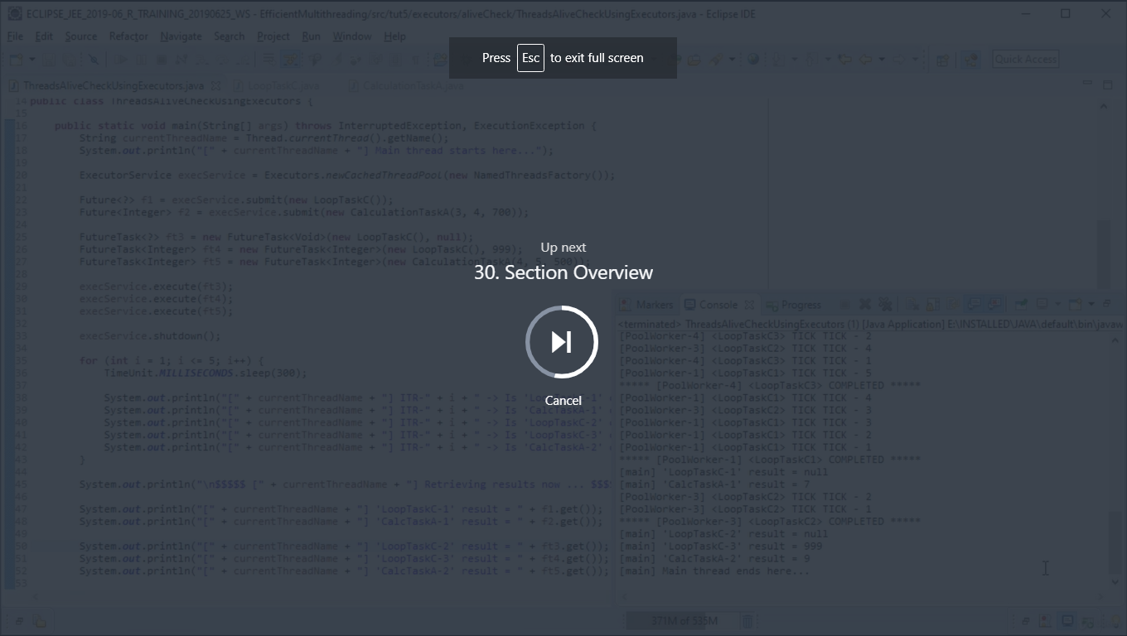

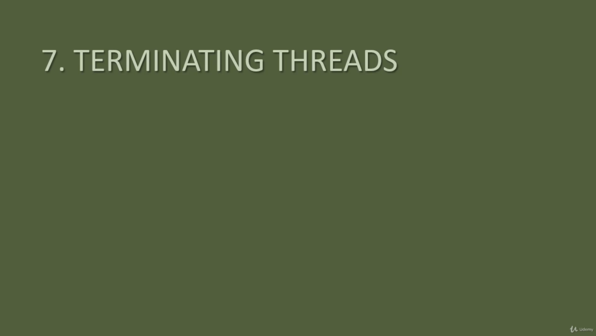

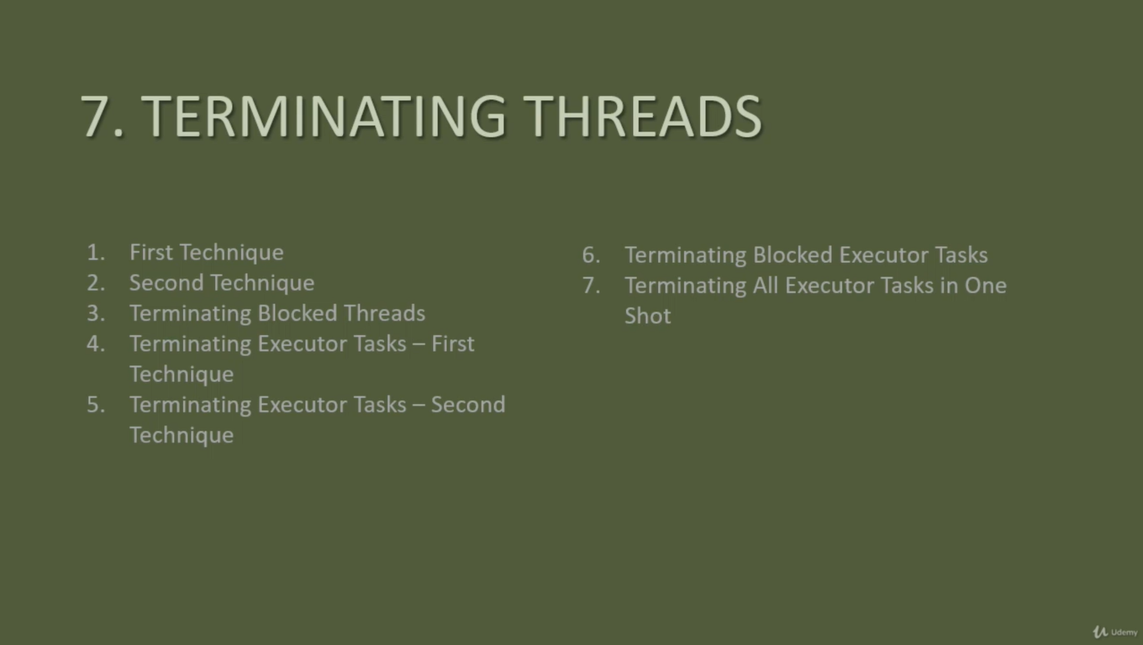

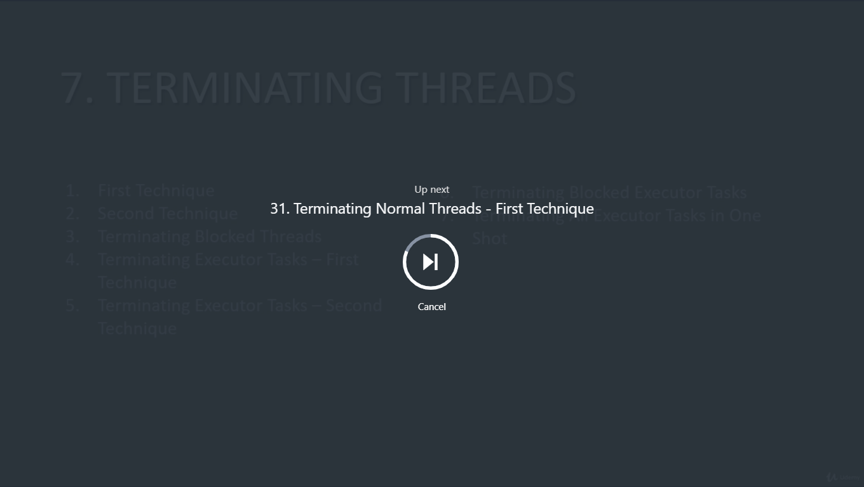

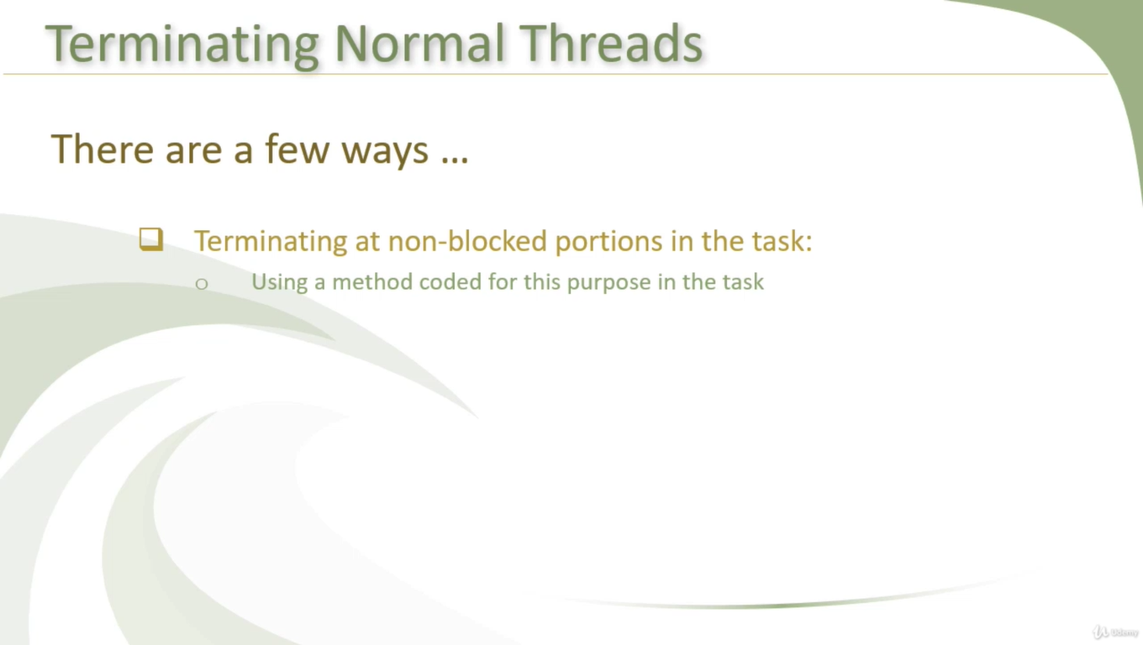

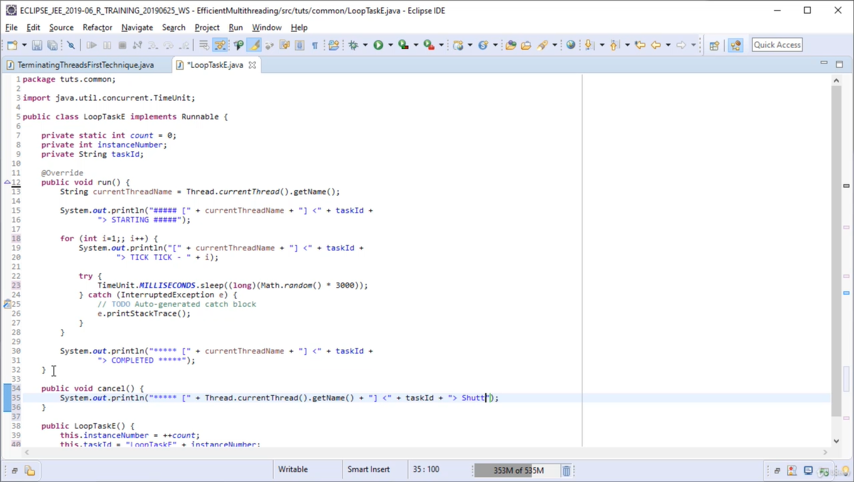

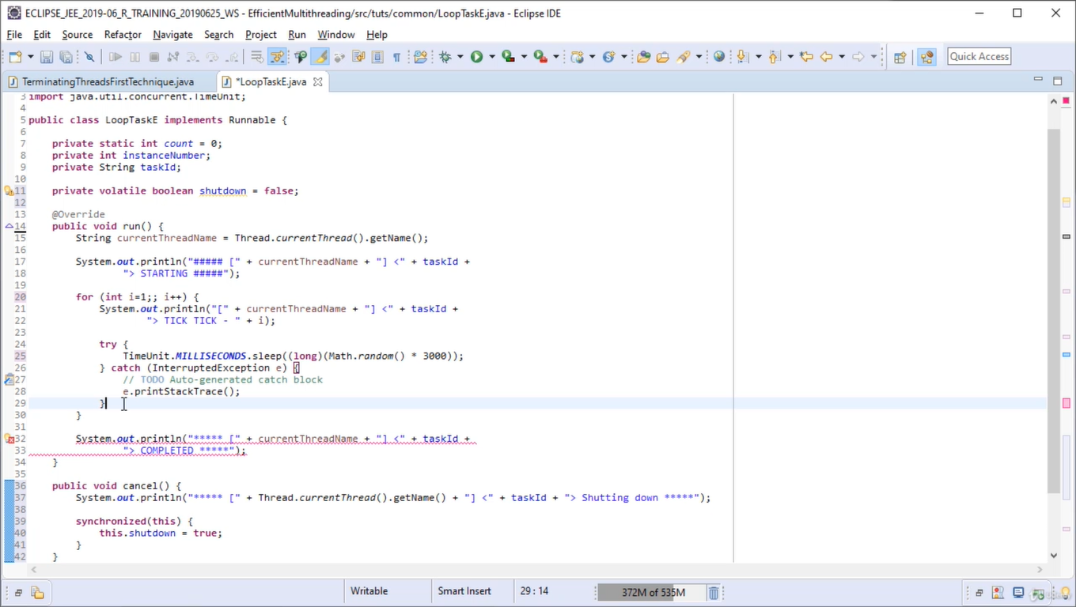\\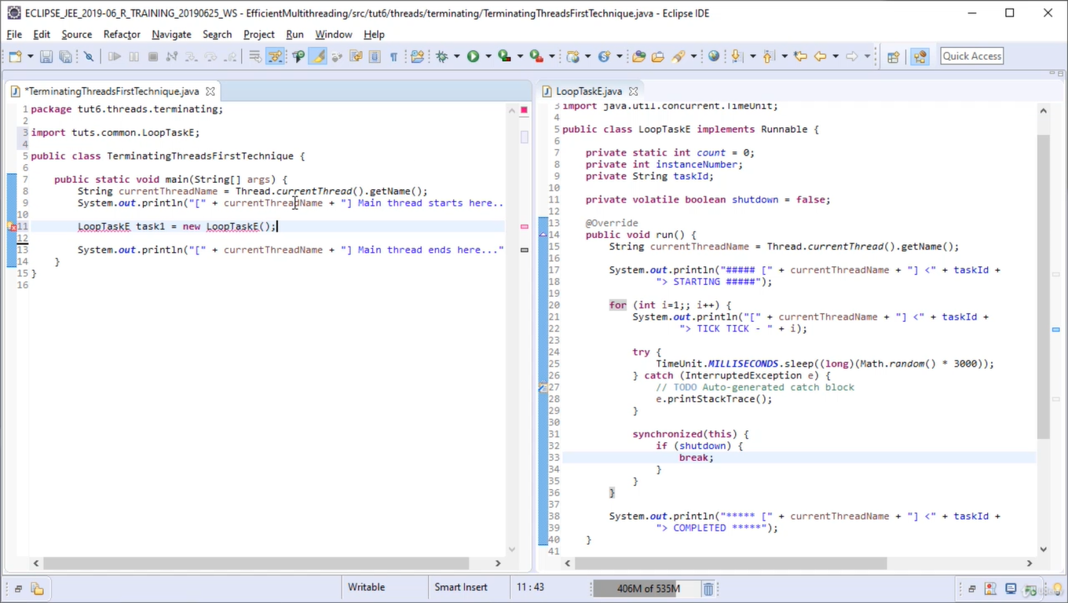

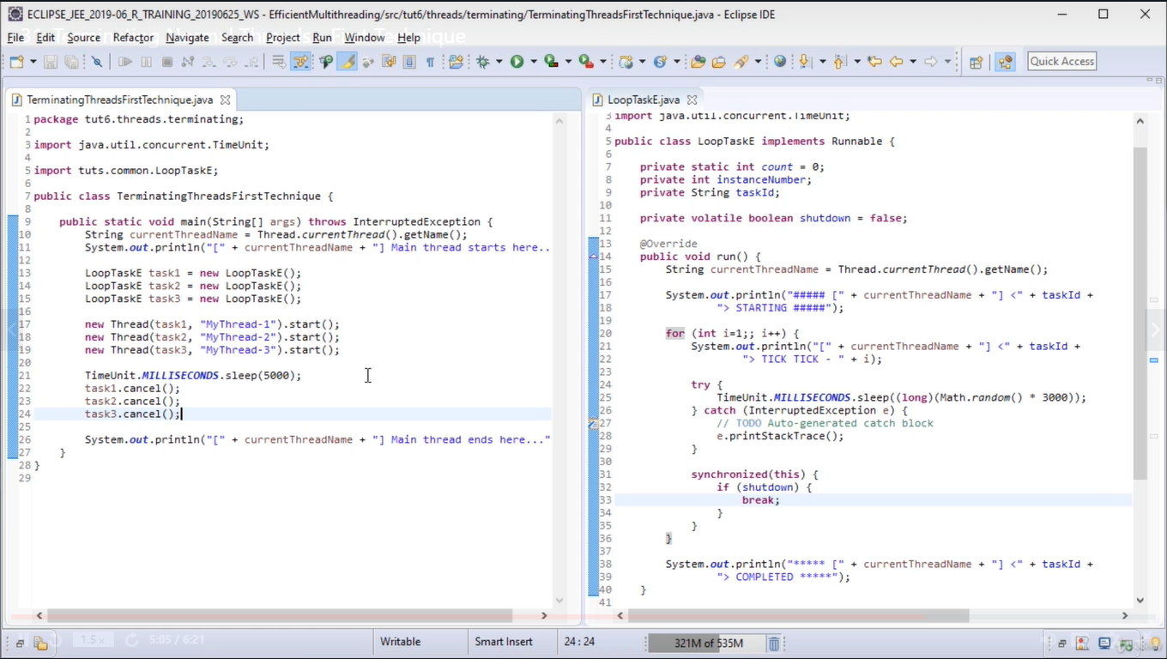

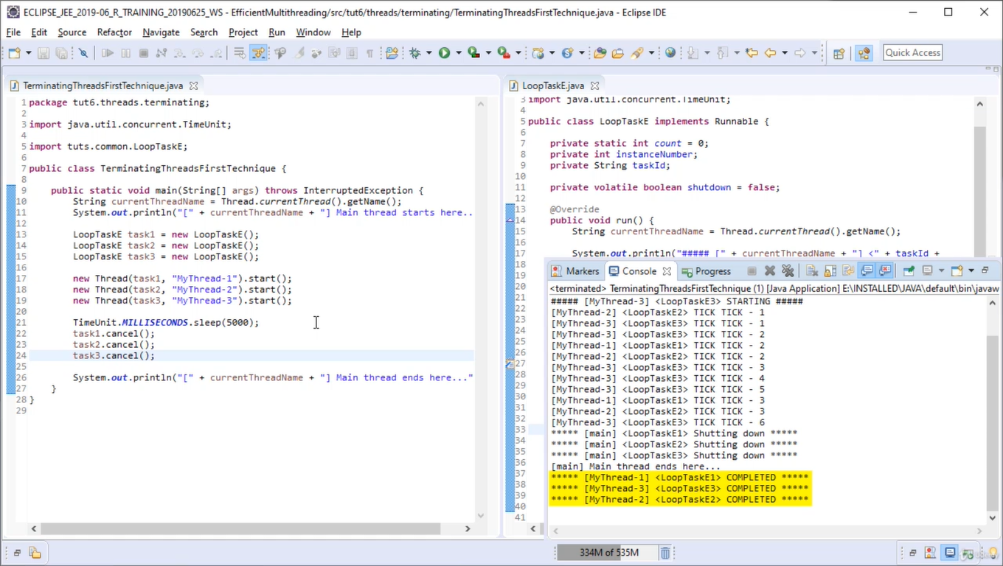

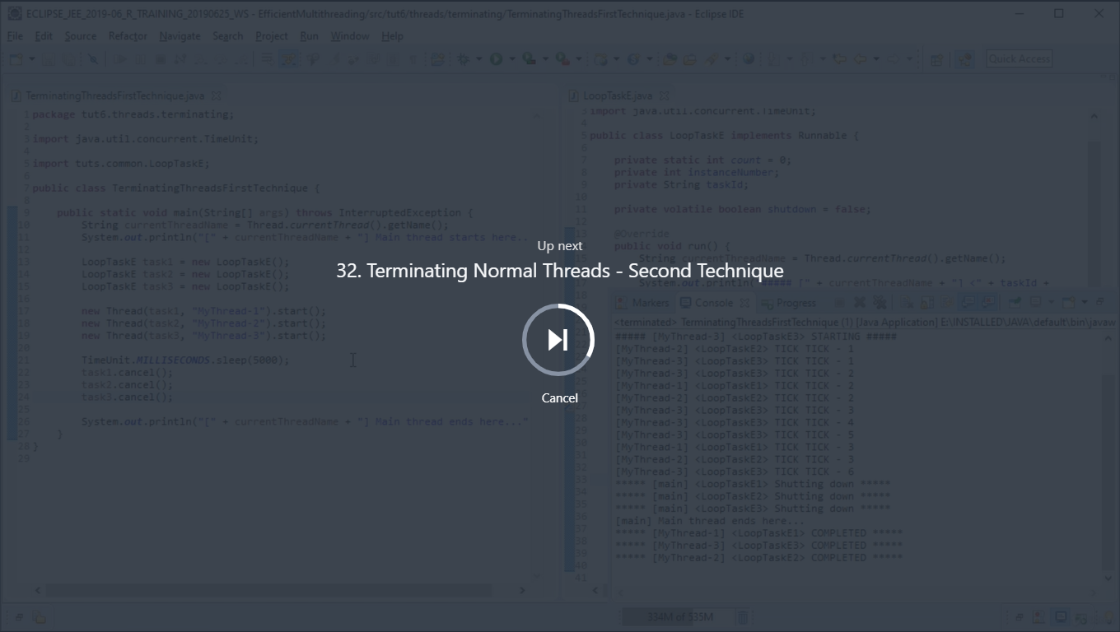

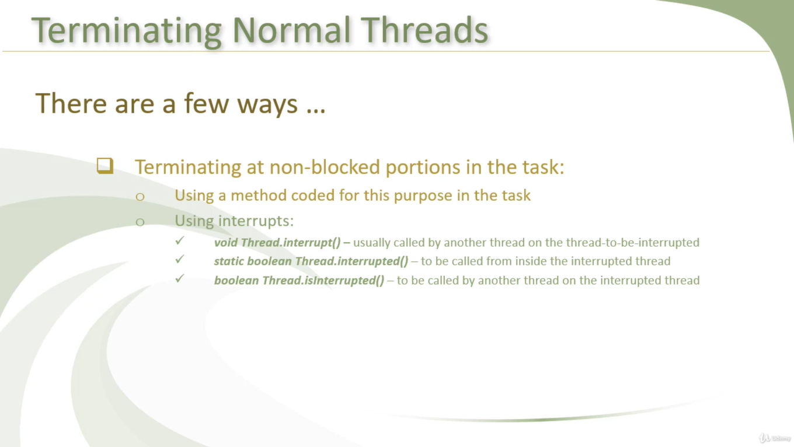

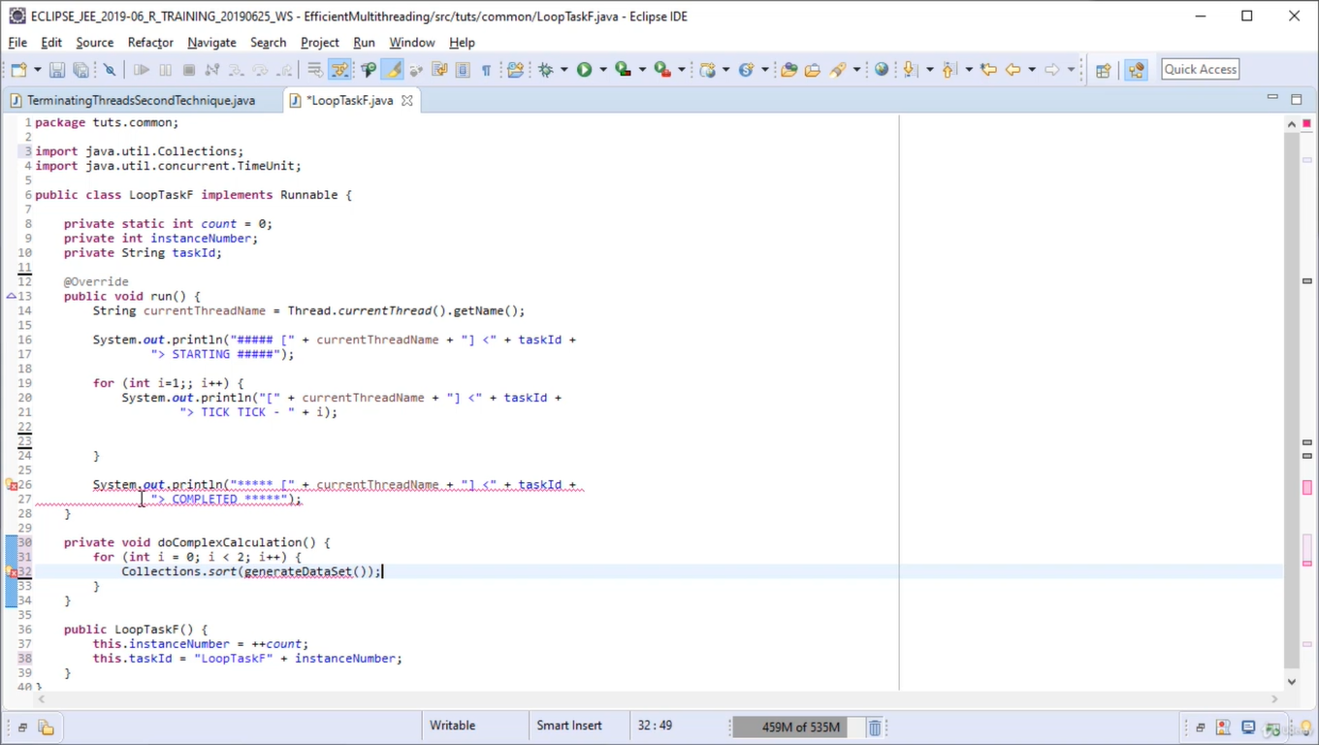

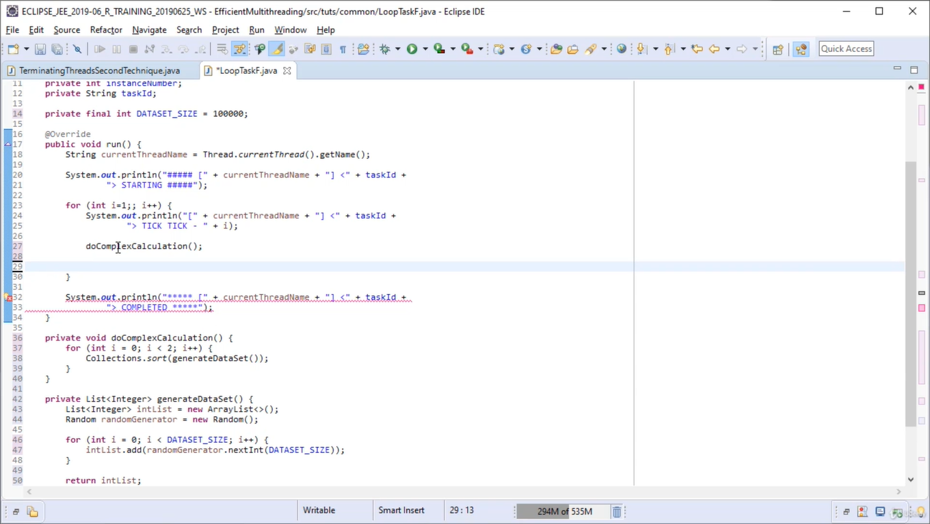

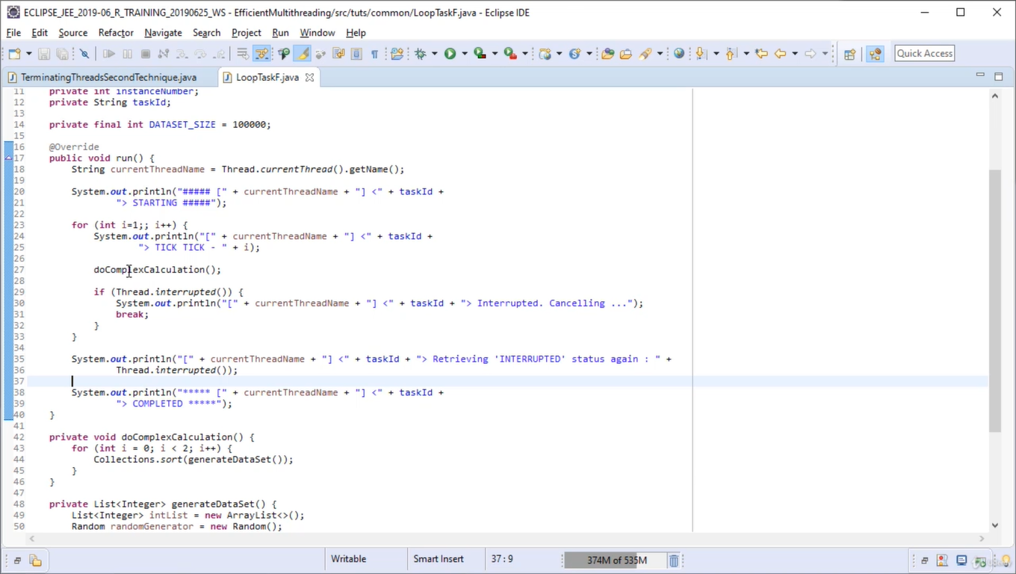

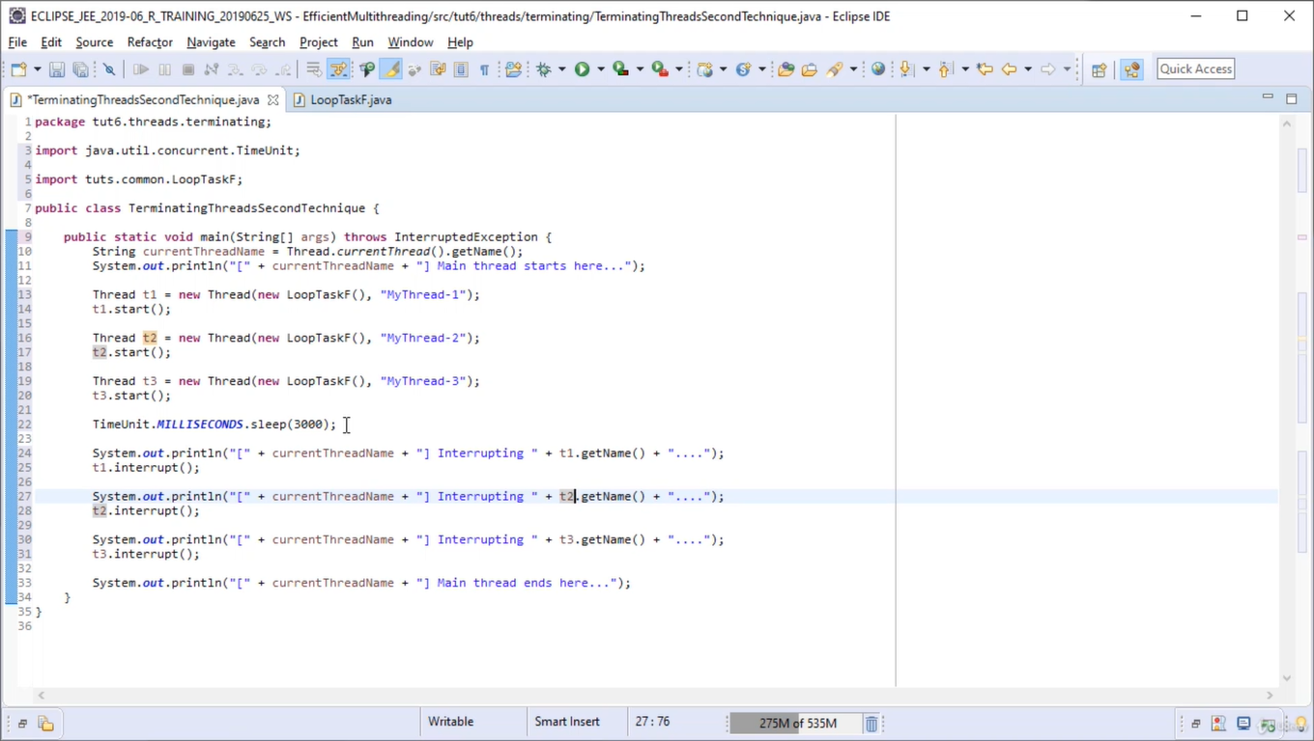

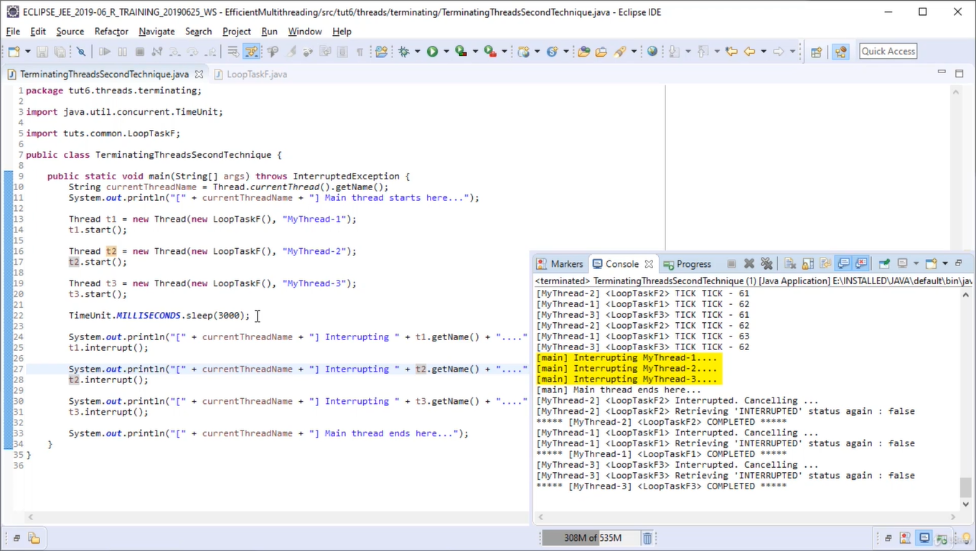

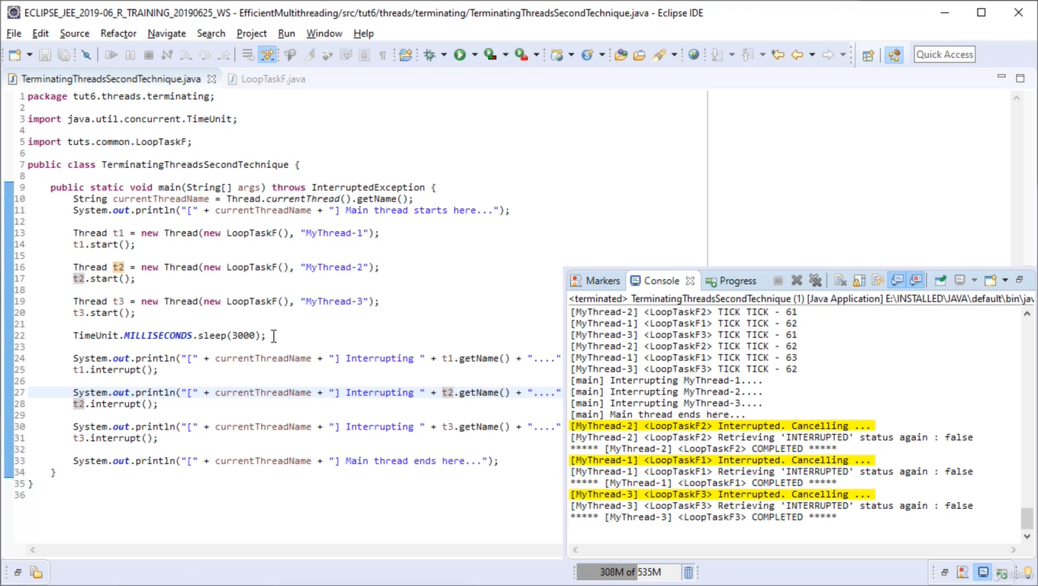

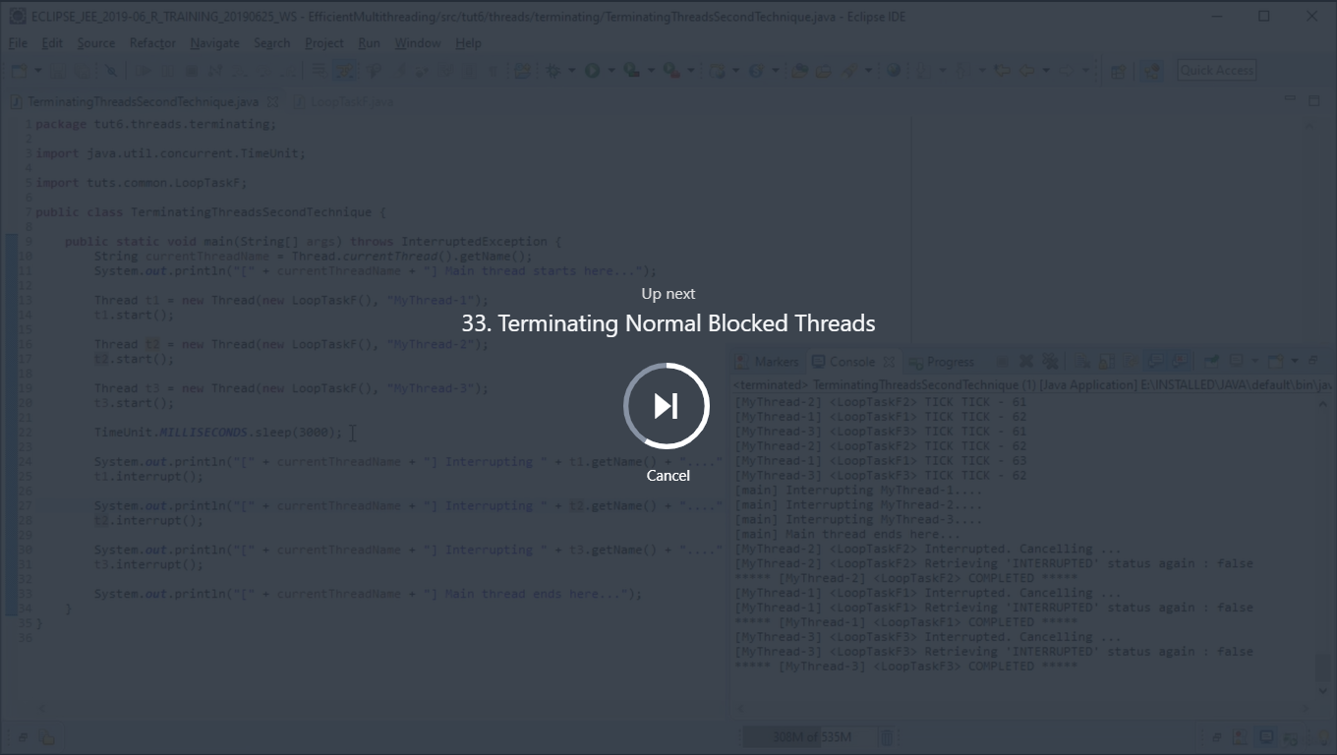

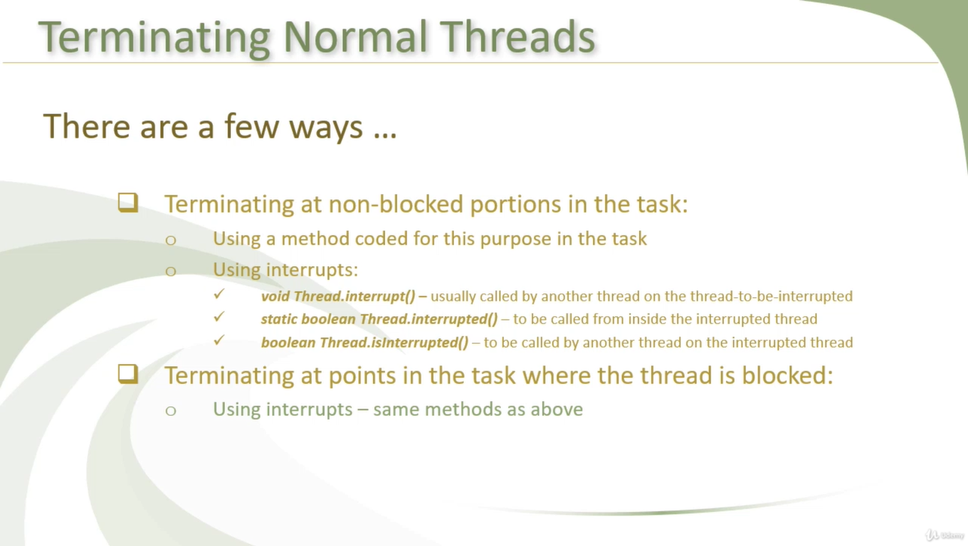

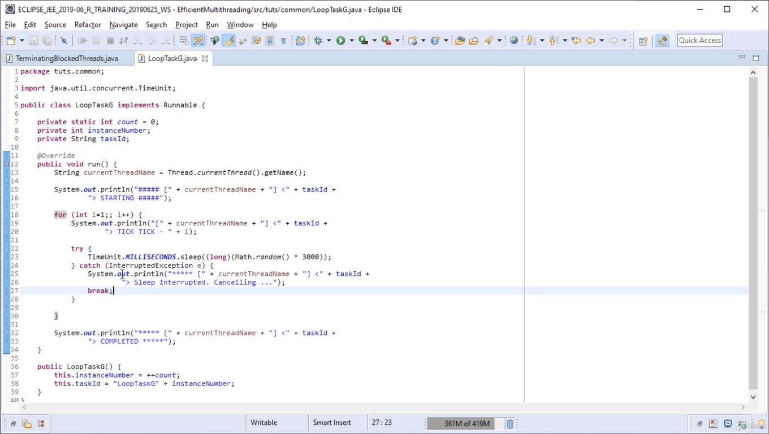

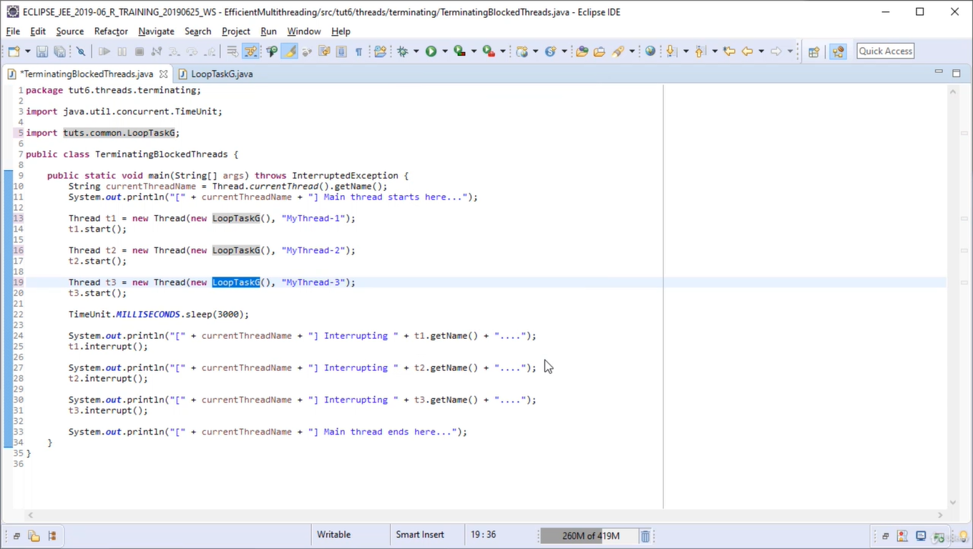

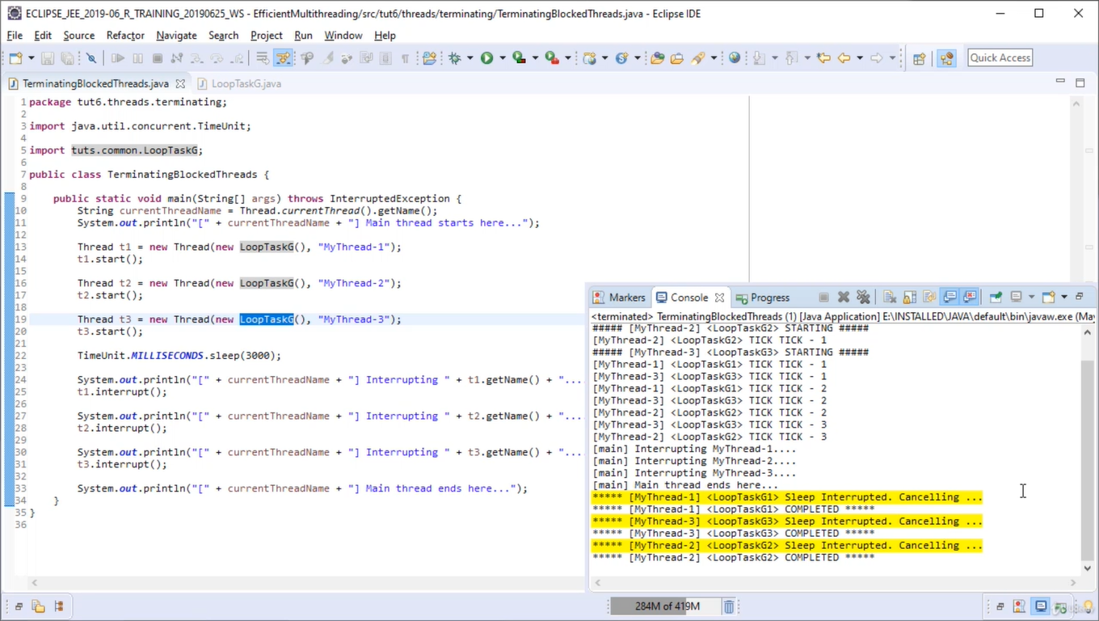

Interrupting a thread but continue with pending work but interrupting at the point where we think thread work is done.

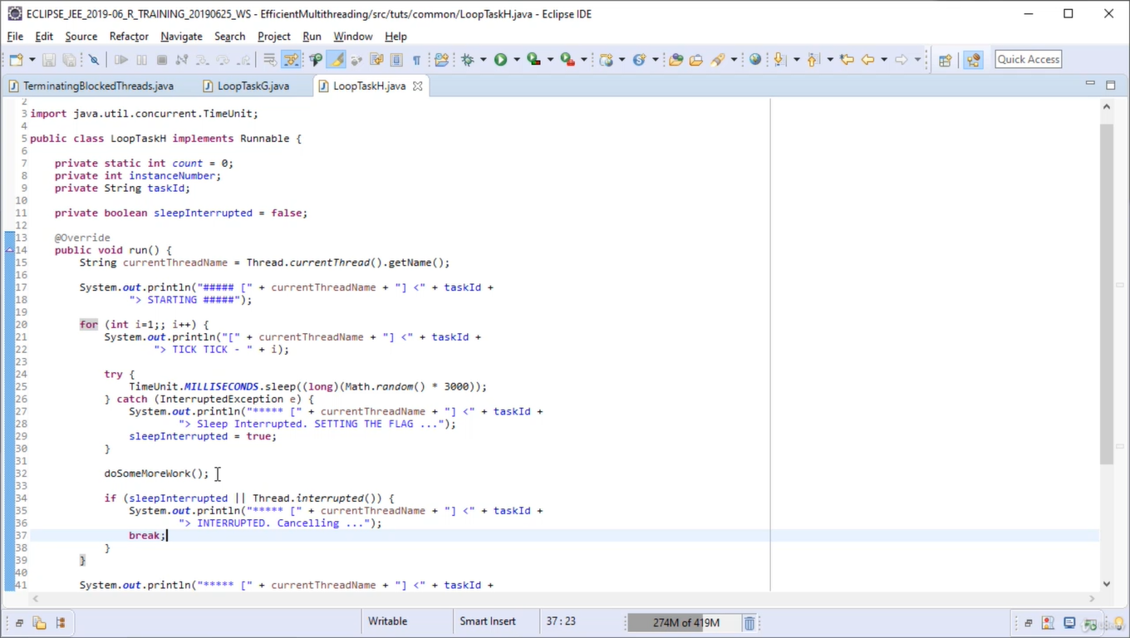

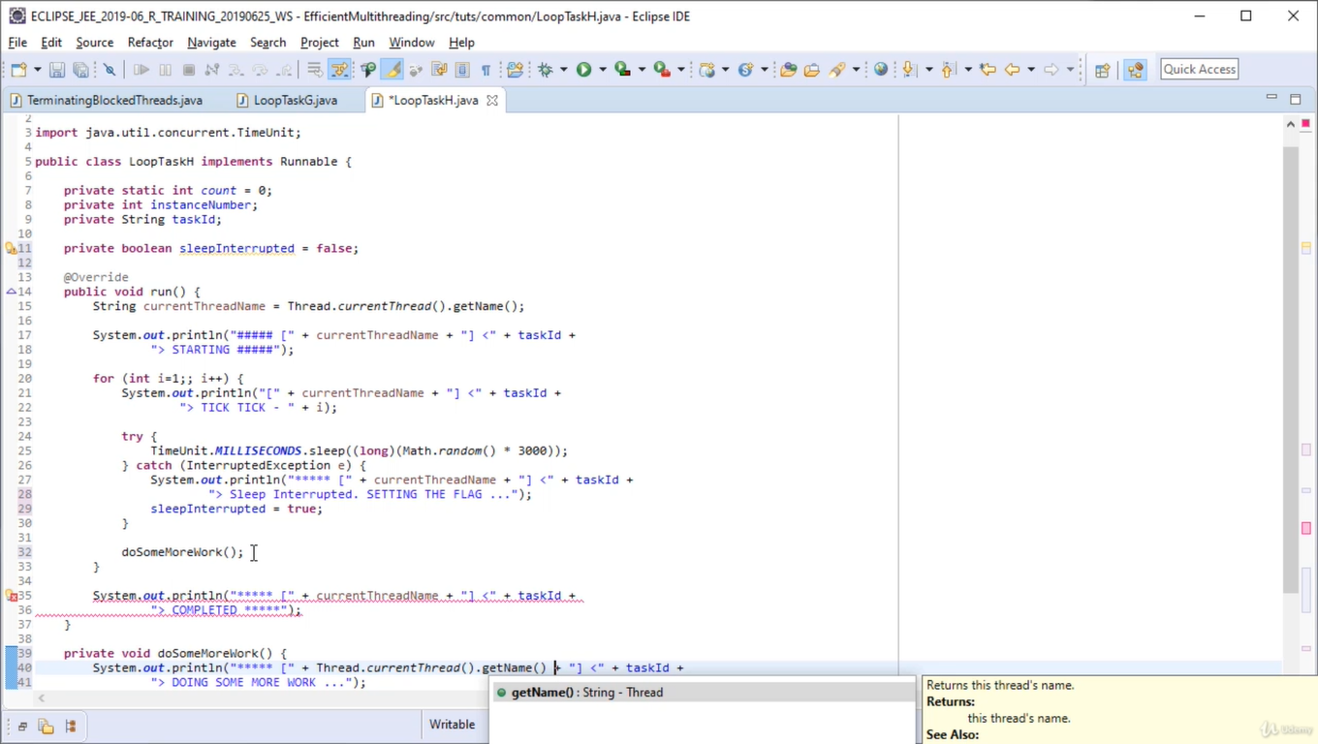

In below screen checking for sleepInterrupted and Thread.interrupted tomake sure interrupt if interrupt happened after the sleep method or doSomemoreWork method.

